2020-2021 EĞİTİM ÖĞRETİM YILI ORTAOKULU
5.SINIFLAR 1.DÖNEM 1.YAZILISI
NAME SURNAME : NO : GRADE : 6 / …

A) Write the words given below under the pictures. (8 x 4 = 32p)
school
toyshop
hospital
pharmacy
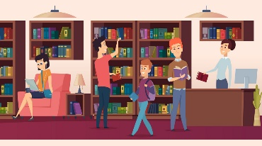
playground
bakery
barber’s
library

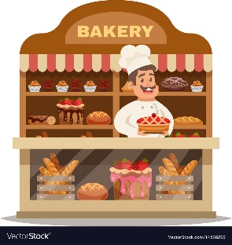

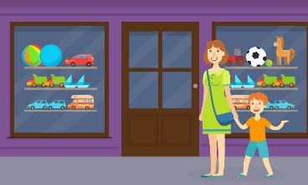

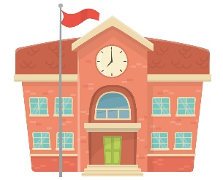
______________ _____________ _____________ _____________


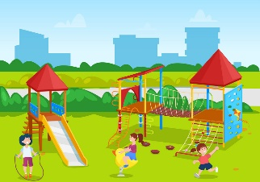

_____________ _____________ _____________ _____________

B) Read the text and fill in the blanks on the table. (6 x 3 = 18p)
Hi! I’m Paloma. I’m from France and I’m French. I am twelve years old. I can speak English, French and German. I like drawing pictures and swimming, but I don’t like doing experiments or solving problems.
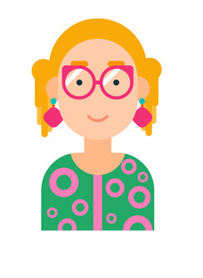
Name
Country
Nationality
Age
Languages
Dislikes

C) Fill in the blanks according to the map. (5 x 4 = 20p)

School

Bookshop
Barber’s

Zoo
Library
Cinema
Butcher’s
Bus Stop
Playground

Theater

1. The school is _______________ the barber’s.
2. The cinema is _______________ the playground and barber’s.
3. The butcher’s is _______________ the bookshop.
4. The theater is _______________ the zoo.
5. The zoo is opposite the _______________ .

D) Match the lessons with the phrases. (5 x 2 = 10p)
1. do an experiment _______ a) maths
2. draw a picture _______ b) physical education
3. solve a problem _______ c) science
4. sing a song _______ d) music
5. do sports _______ e) art

E) Complete the dialogues with the questions below. (4 x 5 = 20p)
What is your name?
Where are you from?
What is your favorite lesson?
What nationality are you?

A: ______________________ A: ______________________
B: I’m James. B: It’s social studies.

A: ______________________ A: ______________________
B: I am Spanish. B: I’m from Germany.
www.eegitimim.com

