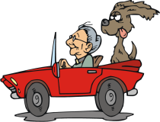
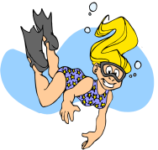
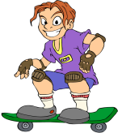
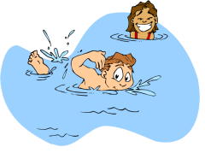
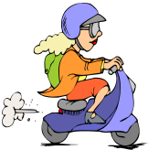
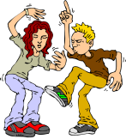

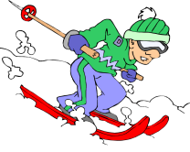
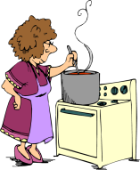
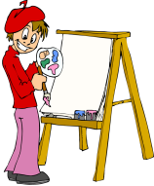
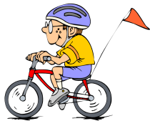

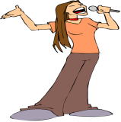
schwimmen tanzen Moped fahren tauchen Auto fahren Skateboard fahren

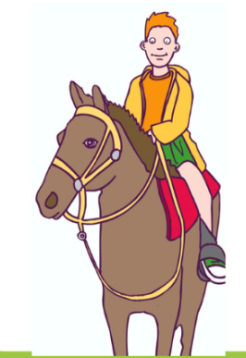

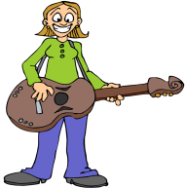
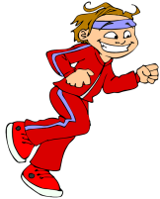
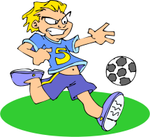
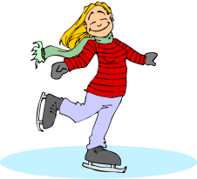
singen am Computer Spielen Schi fahren kochen malen Fahrrad fahren

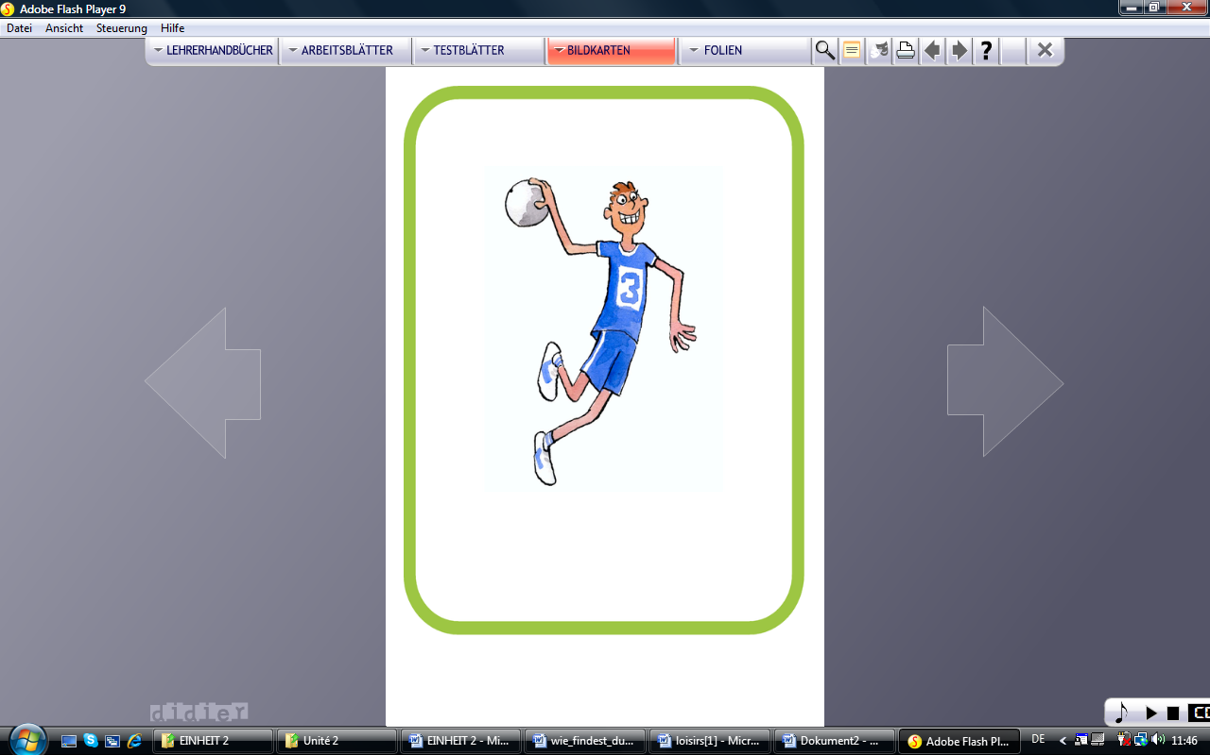
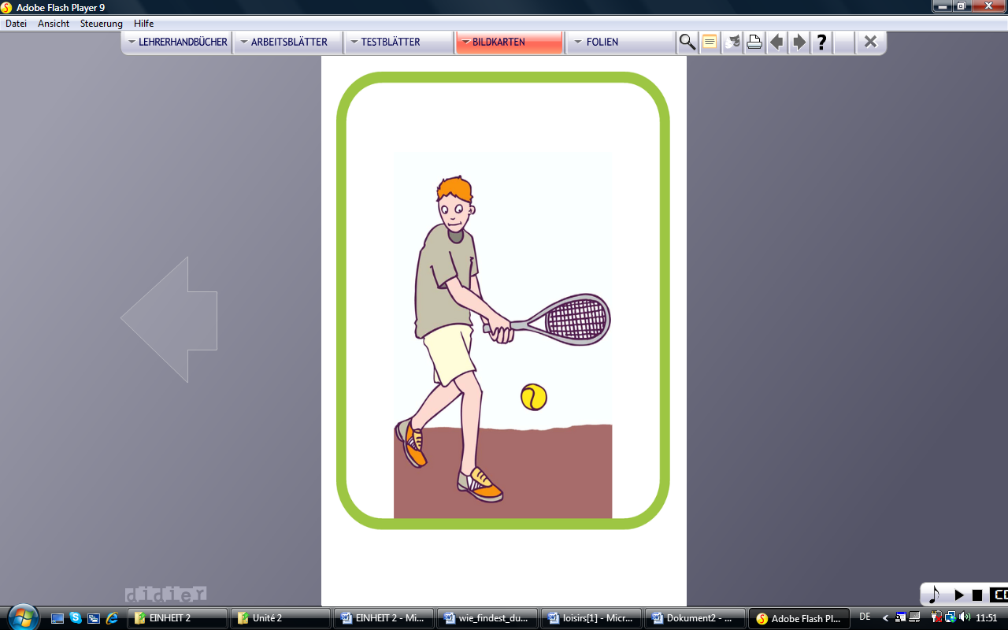
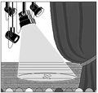

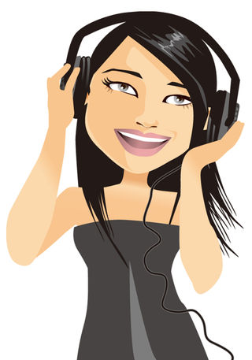
Eis laufen Fußball spielen laufen Gitarre spielen Hausaufgabe machen reiten
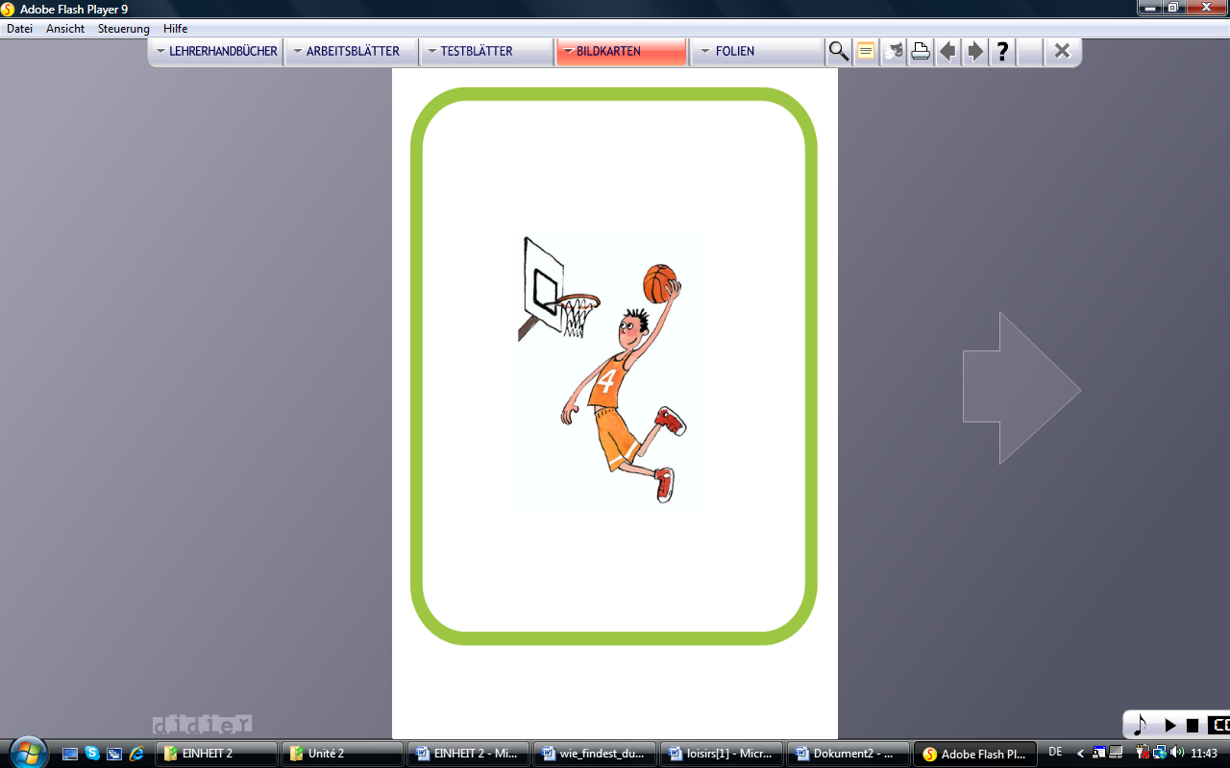
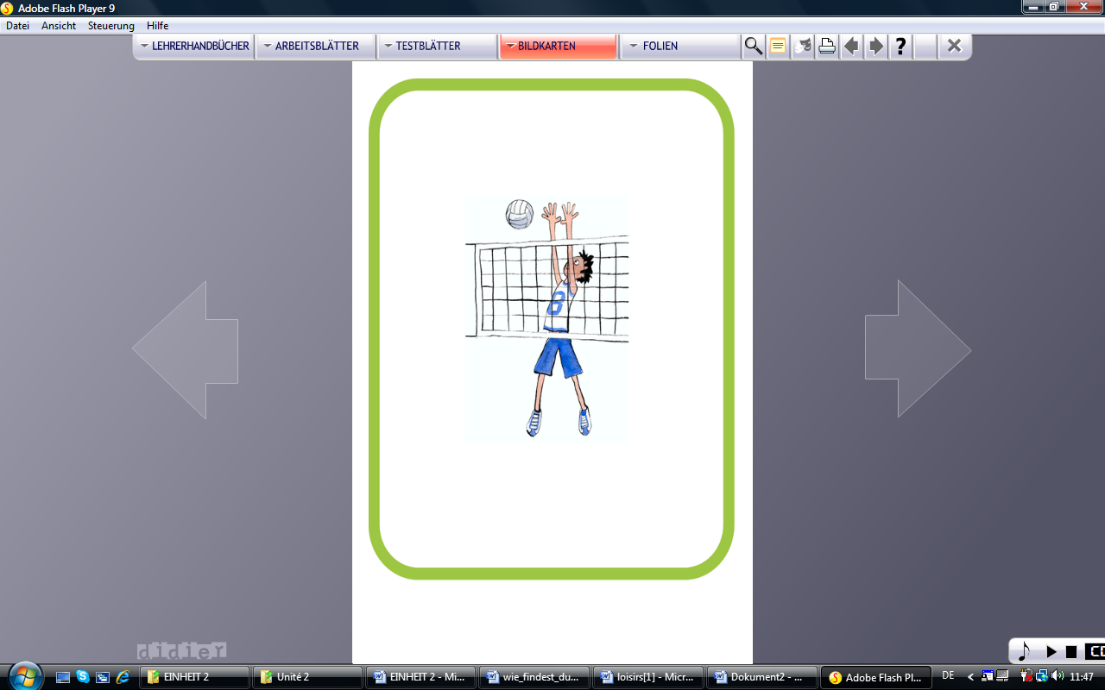
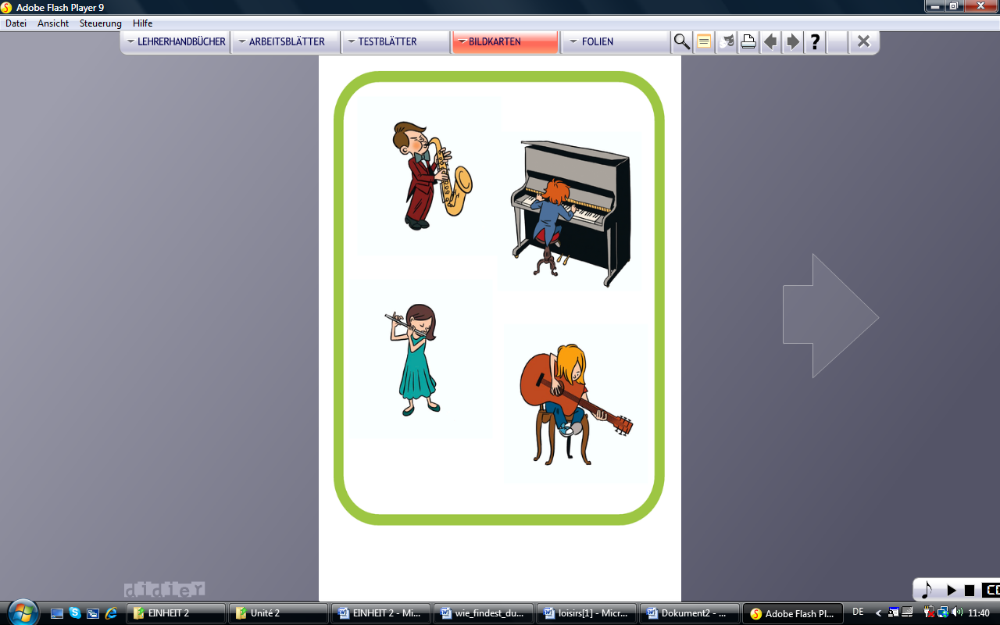
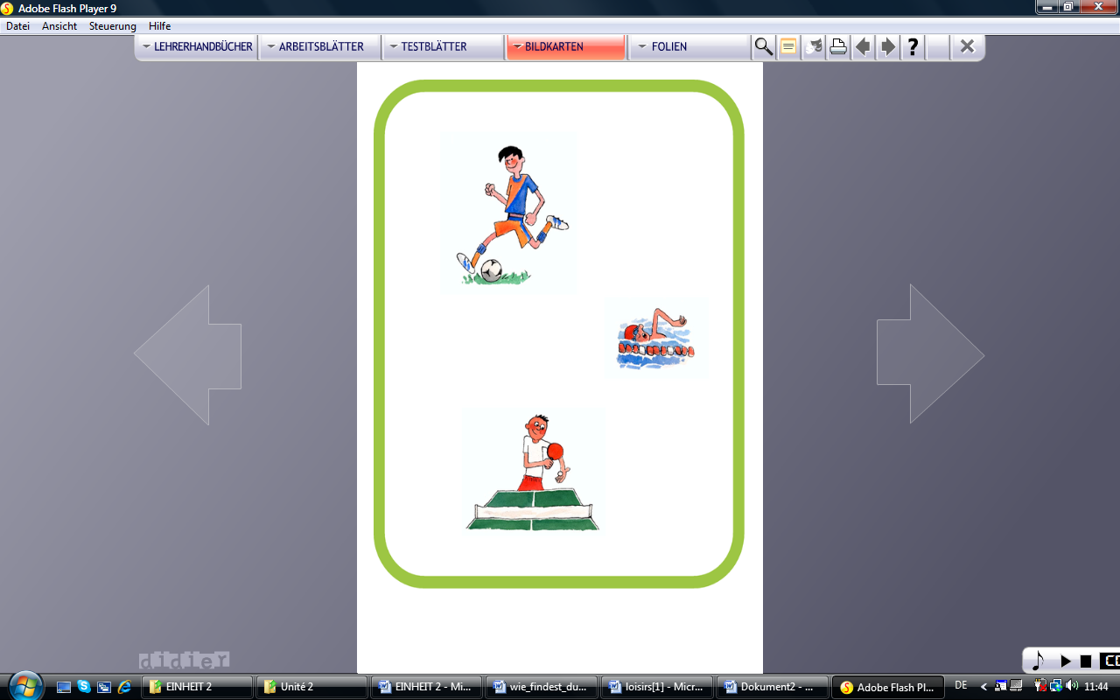
Musik hören Handball spielen Tennis spielen ins Theater gehen ins Kino gehen
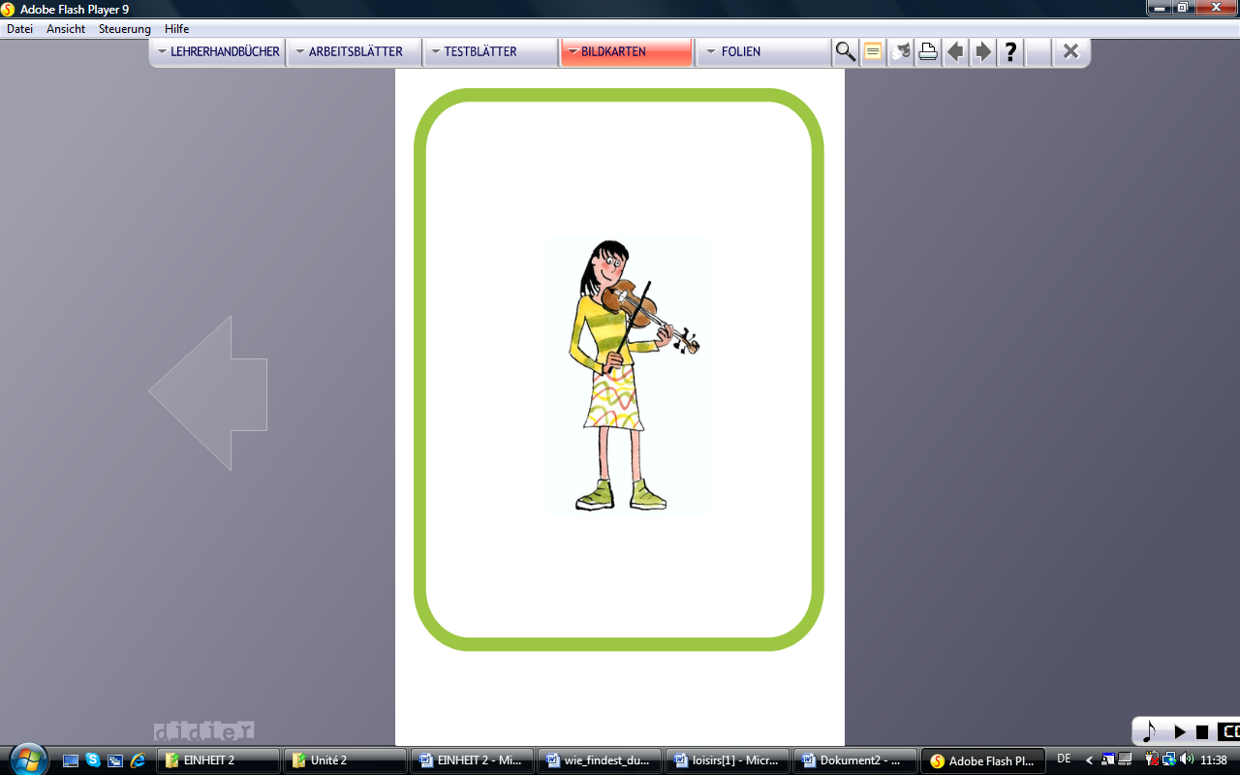

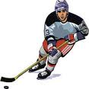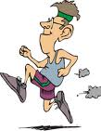
Tischtennis spielen Klavier spielen Volleyball spielen Basketball spielen Geige spielen
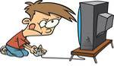
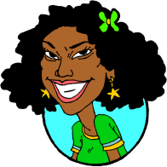
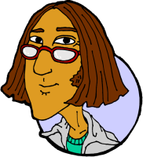
fern/ sehen joggen Hockey

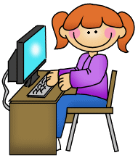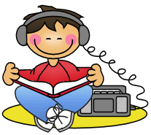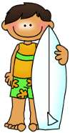

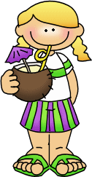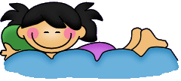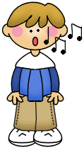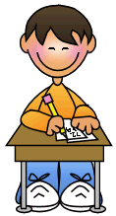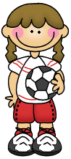7
Was macht Johannes am Wochenende?
Am Wochenende liest er Bücher.
Er hört Musik am Wochenende.
_________________________________________________________
_________________________________________________________
_________________________________________________________
_________________________________________________________
_________________________________________________________
_________________________________________________________
_________________________________________________________
_________________________________________________________
_________________________________________________________
_________________________________________________________
_________________________________________________________
_________________________________________________________
_________________________________________________________
_________________________________________________________
_________________________________________________________
_________________________________________________________
_________________________________________________________
_________________________________________________________
_________________________________________________________
_________________________________________________________
_________________________________________________________
_________________________________________________________
_________________________________________________________
_________________________________________________________
_________________________________________________________
_________________________________________________________

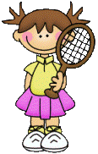

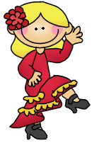

Ich lese gerne
Aber ich tanze lieber
Ich singe am liebsten
_________________________________________________________
_________________________________________________________
_________________________________________________________
_________________________________________________________
_________________________________________________________
_________________________________________________________
_________________________________________________________
_________________________________________________________
_________________________________________________________
_________________________________________________________
_________________________________________________________
_________________________________________________________
_________________________________________________________
_________________________________________________________
_________________________________________________________
_________________________________________________________
_________________________________________________________
_________________________________________________________
_________________________________________________________
_________________________________________________________
_________________________________________________________
_________________________________________________________
_________________________________________________________
_________________________________________________________
_________________________________________________________
_________________________________________________________

