- Grammar
  - Fill in the blanks using he verbs in the correct form (22 pts)
Dear Mum and Dad;
How are you? We...................................... 1(have) a great time here in Thailand. At the moment we are on the beach. Steve ...................................... 2(make) a sandcastle, Paul...................................... 3(play) volleyball with Micheal, and Helen ...................................... 4(swim). There are a lot of people on the beach;all of them...................................... 5(have) fun. They ...................................... 6(enjoy) the good weather.
Our hotel is lovely. Every morning we ...................................... 7(have) breakfast at the hotel restaurant. Then we...................................... 8(go) for a walk around the village. In the evenings we eat at one of the local restaurants. Steve ...................................... 9(not/like) Thai food, so he only eats salads and fruit.
Micheal’s new friend, Kasem, is from Bangkok. He ...................................... 10(go) to boarding-school in England, but at the moment he ...................................... 11(visit) his family for the summer.
We miss you a lot! You must come here next year for your holidays!
See you soon
  - Fill in the blanks with “may – must - mustn’t - don’t have to” ( 10 pts )
      - You …………………….………… (ride) your bicycle in the street.
      - It’s raining heavily. You …………………….………… (take) your umbrella
      - We …………………………………. (not / pick) the flowers in the park.
      - Tomorrow is Saturday. We…………………………………………(not/go) to school.
      - You look ill. You …………………………………………………..(see) a doctor.
  - Fill in the blanks with “my – your – his – her – its – our – their” (10 pts)
      - Jack is at home with _________ family.
      - We are in class. This is _________ teacher.
      - This is Suzan’s aunt and _________ name is Jane.
      - Look at the dog. It’s in _________ kennel.
      - I’ve got a small house and _________ house is in the city.
  - 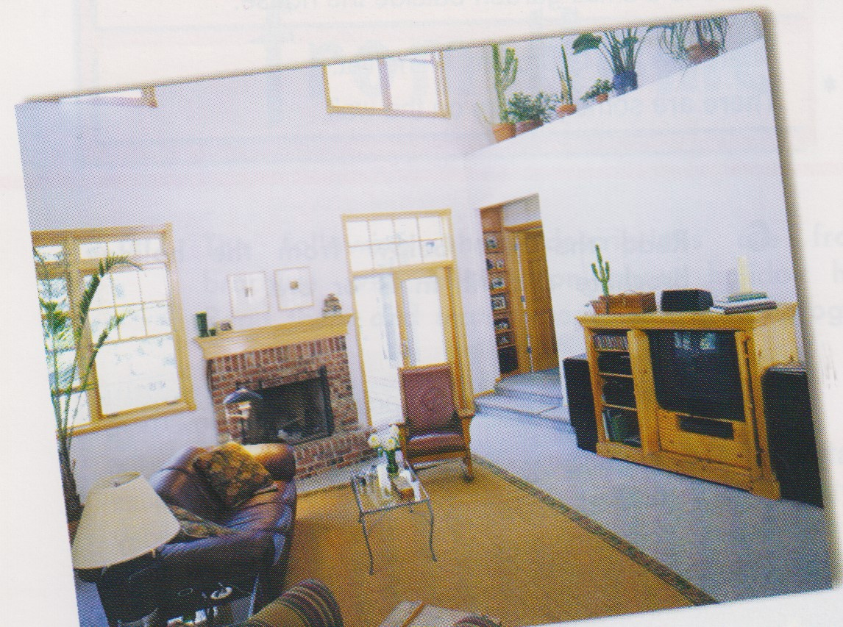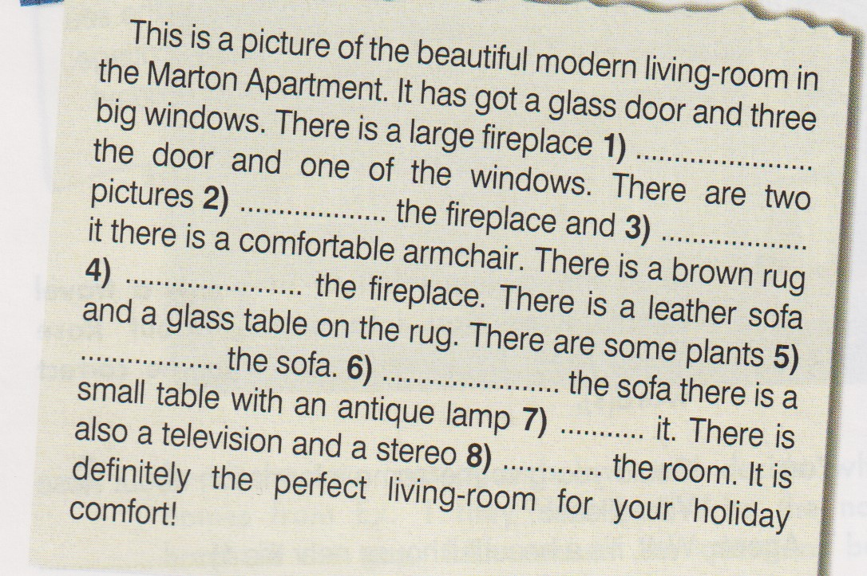Fill in the blanks with “behind – in – on – between – next to – above – beside – in front of” (8 pts)

- 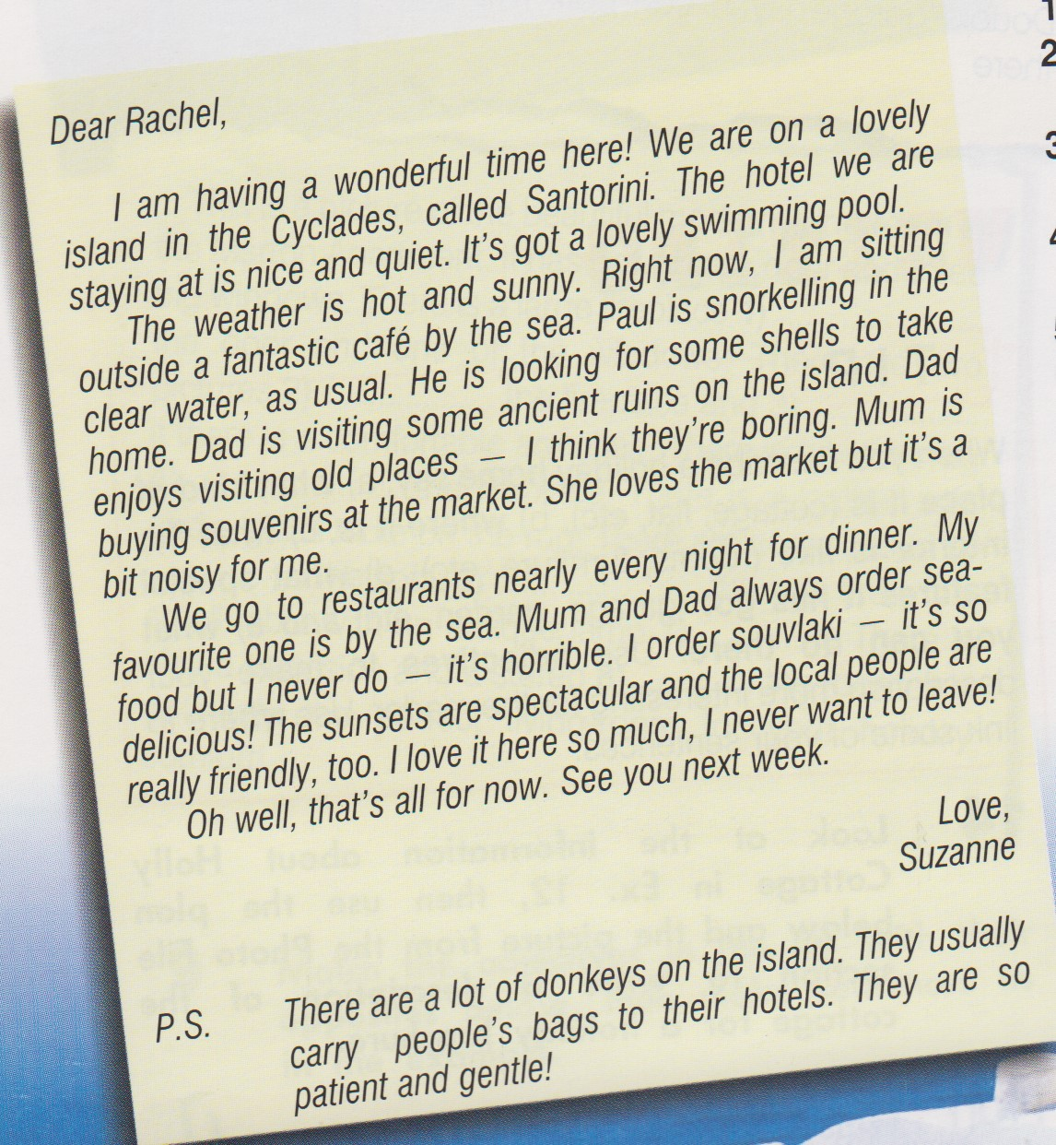Reading
- Write True (T) or False (F) (12pts)
1) Suzanne enjoys her holiday. …………….
2) Suzanne’s dad is snorkelling. …………….
3) They go to restaurants nearly every night. …………….
4) Suzanne hates sea-food. …………….
5) Donkeys carry people to the hotel. …………….
6) Suzanne’s mum is shopping. …………….

B. Answer the questions (8 pts)
- How often do they go to restaurants for dinner?
................................................................
- What is Suzanne doing right now?
................................................................
- What is Paul doing?
..................................................................
- What are the local people like?
..................................................................

- Read the text and choose the correct option. (10 pts)
      - Mum / Dad enjoys visiting old places. 4. The hotel is quiet / noisy.
      - Dad / Suzanne orders souvlaki. 5. Suzanne is at the hotel / café right now.
      - Paul is sitting outside / snorkelling.

- Writing
Look at the information about Tarkan’s day and
compare your day with his. (20 pts)

