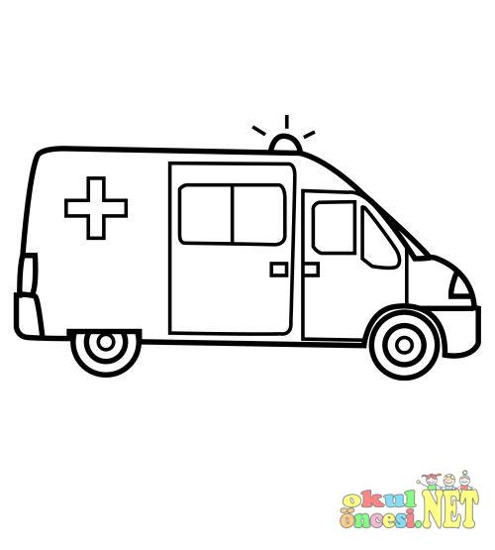

Ambulance
________________________________________________________________________________________________________________________
________________________________________________________________________________________________________________________
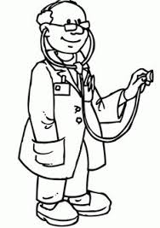

Doctor
________________________________________________________________________________________________________________________
________________________________________________________________________________________________________________________

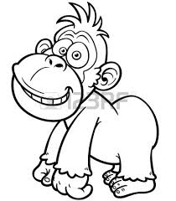
Gorilla

Gorilla
________________________________________________________________________________________________________________________
________________________________________________________________________________________________________________________


Cake
________________________________________________________________________________________________________________________
________________________________________________________________________________________________________________________

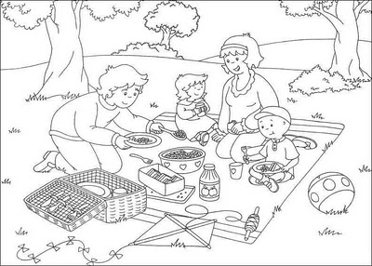

Picnic
________________________________________________________________________________________________________________________
________________________________________________________________________________________________________________________
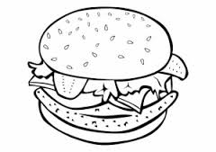

Hamburger
________________________________________________________________________________________________________________________
________________________________________________________________________________________________________________________

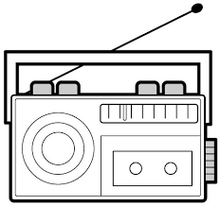

Radio
________________________________________________________________________________________________________________________
________________________________________________________________________________________________________________________
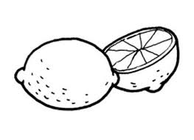

Lemon
________________________________________________________________________________________________________________________
________________________________________________________________________________________________________________________

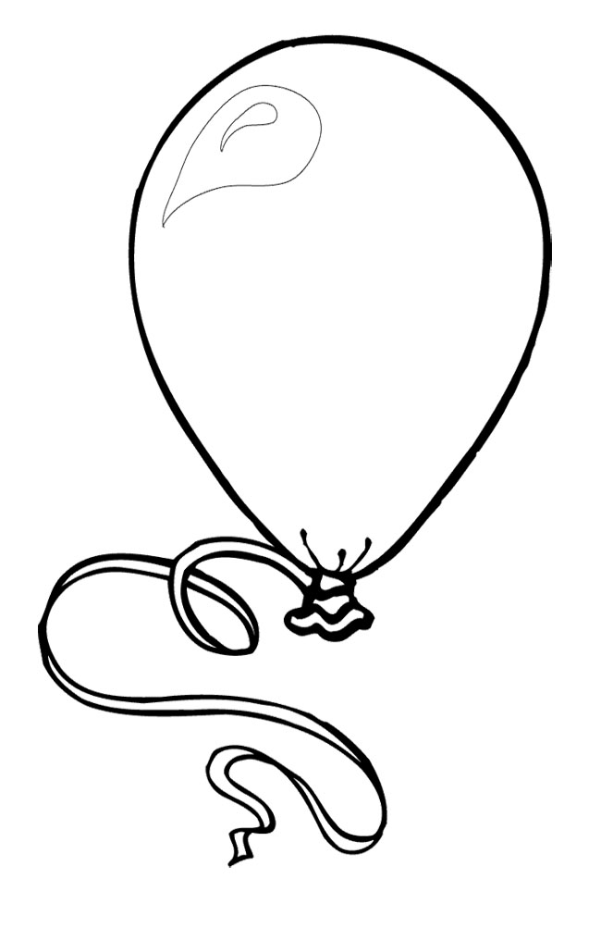

Balloon
________________________________________________________________________________________________________________________
________________________________________________________________________________________________________________________
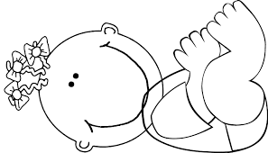

Baby
________________________________________________________________________________________________________________________
________________________________________________________________________________________________________________________

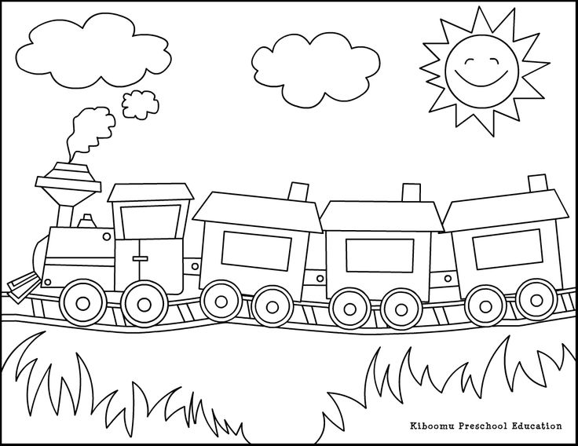

Train
________________________________________________________________________________________________________________________
________________________________________________________________________________________________________________________

Football
________________________________________________________________________________________________________________________
________________________________________________________________________________________________________________________
