1 |   Hello | Me
2 | Hi | Me
3 | How are you? | Na
4 | Fine, thanks and you? | İyiyim, t...
5 | I'm fine. | İyi
6 |   Thanks | Te
7 | Good morning | Gü
8 | Good afternoon | İyi ...
9 | Good evening | İyi ...
10 | Good night | İyi ...
11 | What is your name? | Senin a...
12 | My name is Berat | Be
13 | I'm Nisa. | Ben N...
14 | I am okay. | Ben i...
15 | This is Murat. | Bu M
16 | Great | Ha
17 | You? | Se
18 | 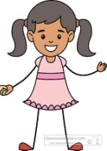  And you? | Ya s...
19 | 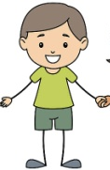  Girls | Kı
20 | Boys | Er
1 | Coffee | K
2 | Salad | S
3 | 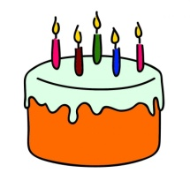  Biscuit | B
4 | Cake | P
5 | Yoghurt | Y
6 | Football | F
7 | Restaurant | L
8 | Cinema | S
9 | 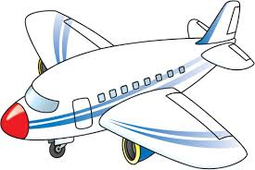  Airport | Ha
10 | Cafe | K
11 | Stop | Du
12 | 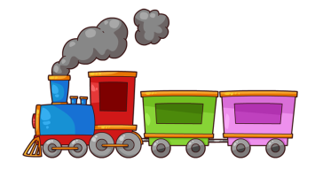  Ambulance | A
13 | Train | Tr
14 | University | Ün
15 | Balloon | B
16 |   Doctor | D
17 | Television | T
18 | 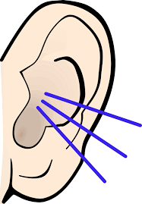  Volleyball | V
19 | Listen | D
20 | Sing | Ş

