Aşağıdaki noktalı kelimelerin üzerinden gidelim, aynısını altına 2’şer defa yazalım.
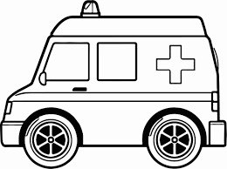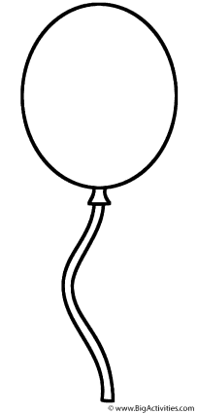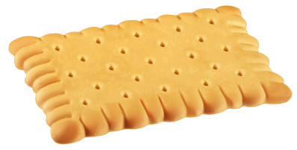
Balloon= balon
…………………………………………………………………………
……………………………………………………………………………
Balloon= balon
…………………………………………………………………………
……………………………………………………………………………
Ambulance= ambulans
……………………………………………………………………………………..
………………………………………………………………………………………

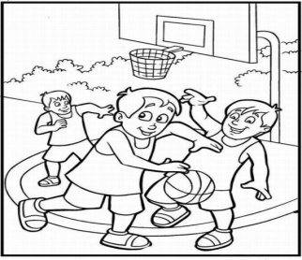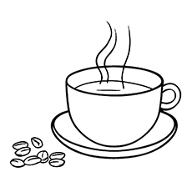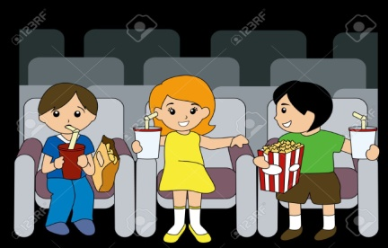
Cinema= sinema
……………………………………………………………………………………..
………………………………………………………………………………………
Coffee= kahve
……………………………………………………………………………………..
………………………………………………………………………………………
Basketball= basketbol
……………………………………………………………………………………..
………………………………………………………………………………………

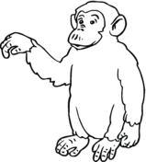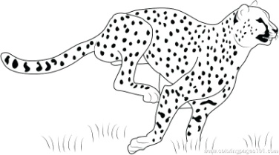
Cheetah= çita
……………………………………………………………………………………..
………………………………………………………………………………………
Chimpanzee= şempanze
……………………………………………………………………………………..
………………………………………………………………………………………
Cake= kek, pasta
……………………………………………………………………………………..
………………………………………………………………………………………

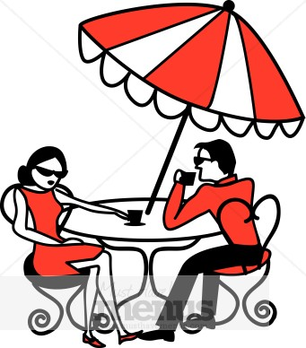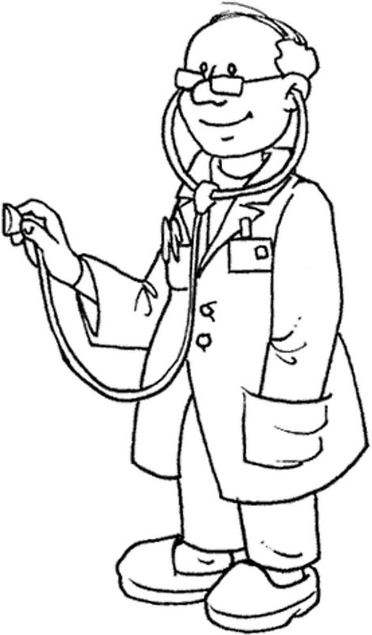
e-mail= e posta
……………………………………………………………………………………..
………………………………………………………………………………………
Doctor= doktor
……………………………………………………………………………………..
………………………………………………………………………………………
Cafe= kafe
……………………………………………………………………………………..
………………………………………………………………………………………
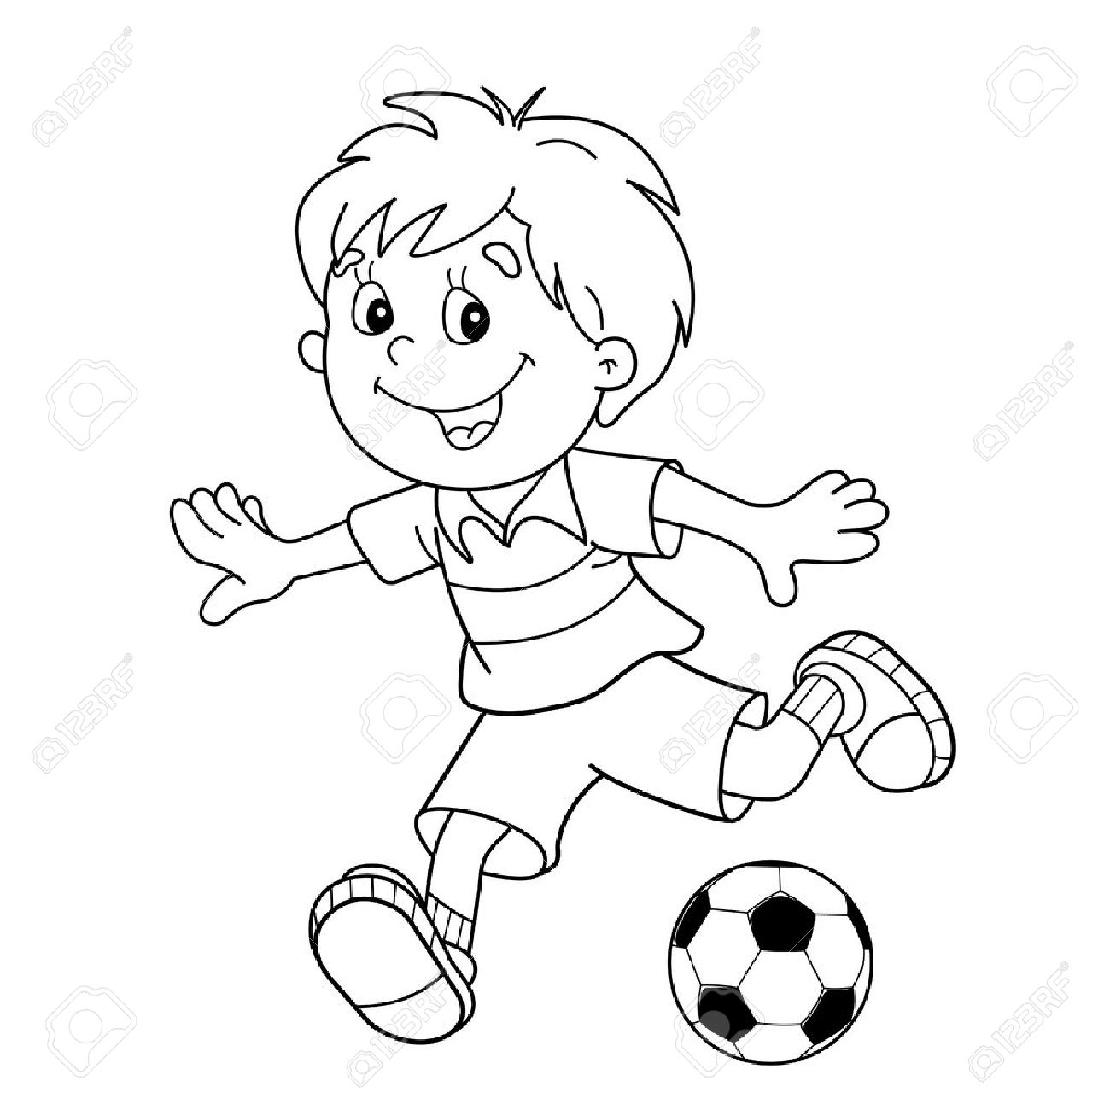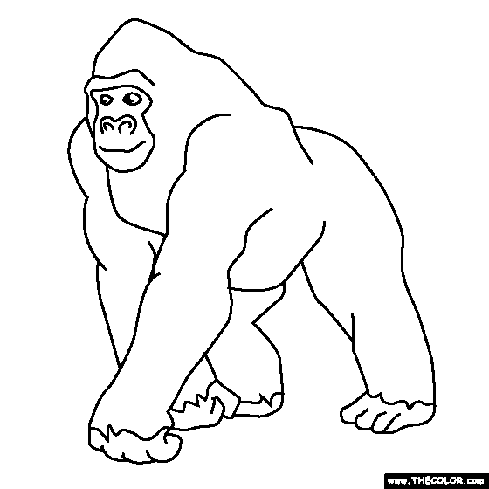
Hotel= otel
……………………………………………………………………………………..
………………………………………………………………………………………
Gorilla= goril
……………………………………………………………………………………..
………………………………………………………………………………………
Football= futbol
……………………………………………………………………………………..
………………………………………………………………………………………

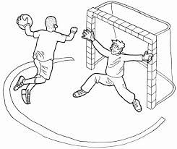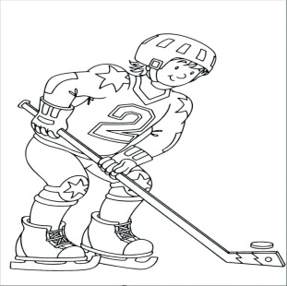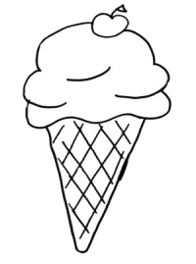
Ice-cream= dondurma
……………………………………………………………………………………..
………………………………………………………………………………………
Hockey= hokey
……………………………………………………………………………………..
………………………………………………………………………………………
Handball= hentbol
……………………………………………………………………………………..
………………………………………………………………………………………

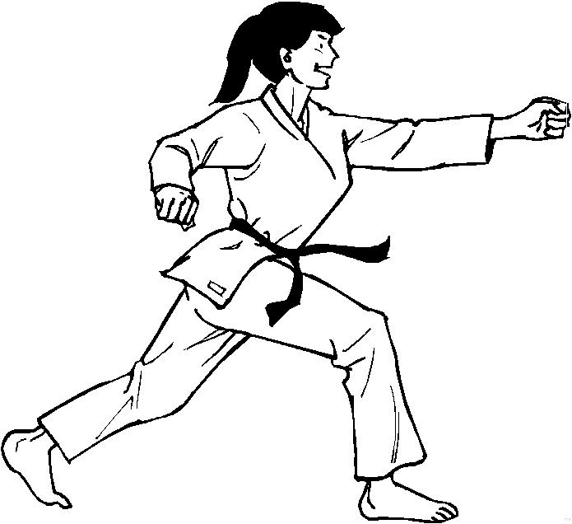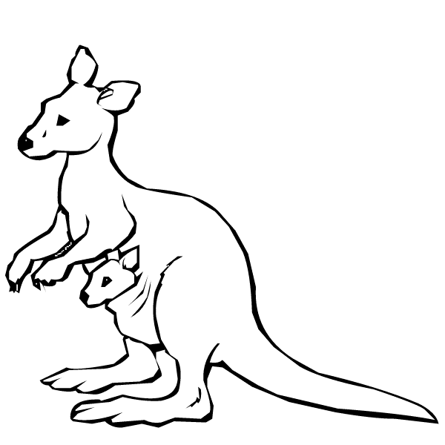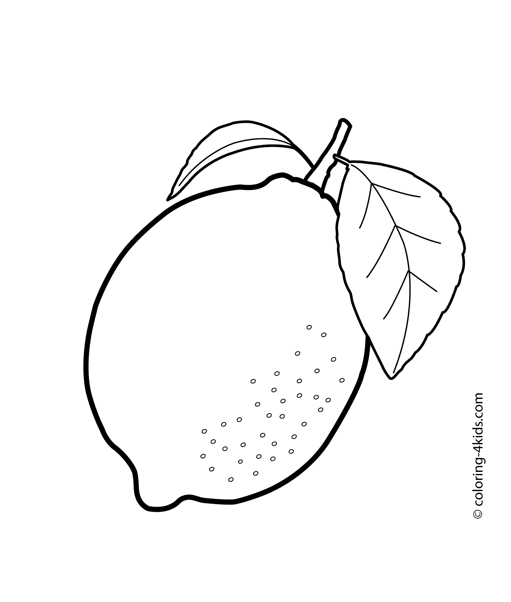
Lemon= limon
……………………………………………………………………………………..
………………………………………………………………………………………
Kangaroo= kanguru
……………………………………………………………………………………..
………………………………………………………………………………………
Judo= judo
……………………………………………………………………………………..
………………………………………………………………………………………

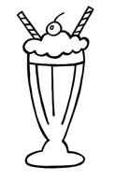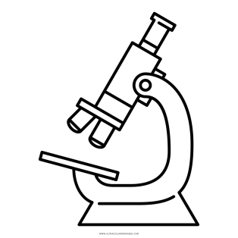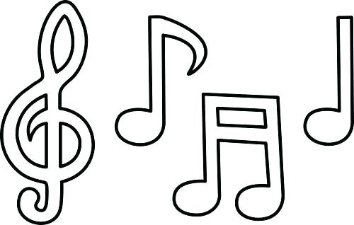
Note= nota
……………………………………………………………………………………..
………………………………………………………………………………………
Microscope= mikroskop
……………………………………………………………………………………..
………………………………………………………………………………………
Milkshake= aromalı süt
……………………………………………………………………………………..
………………………………………………………………………………………

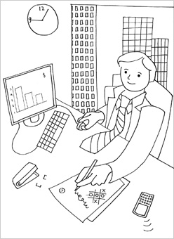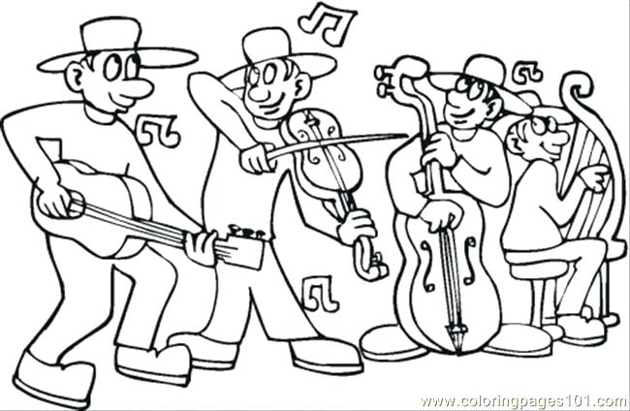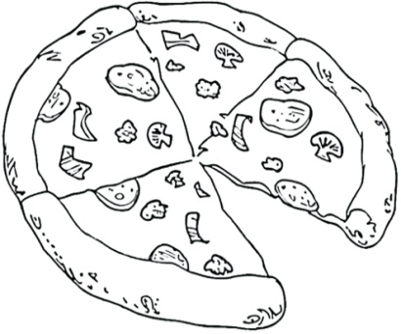
Pizza= pizza
……………………………………………………………………………………..
………………………………………………………………………………………
Orchestra= orkestra
……………………………………………………………………………………..
………………………………………………………………………………………
Office= ofisi iş yeri
……………………………………………………………………………………..
………………………………………………………………………………………

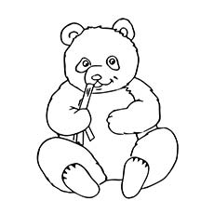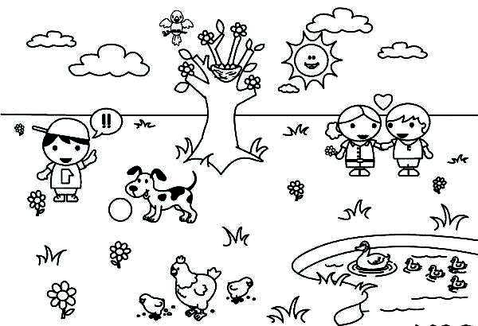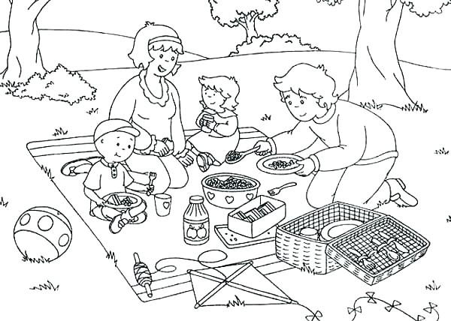
Picnic= picnic
……………………………………………………………………………………..
………………………………………………………………………………………
Park= park
……………………………………………………………………………………..
………………………………………………………………………………………
Panda= panda
……………………………………………………………………………………..
………………………………………………………………………………………

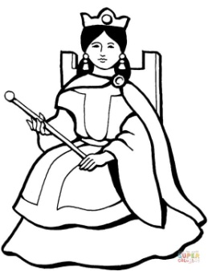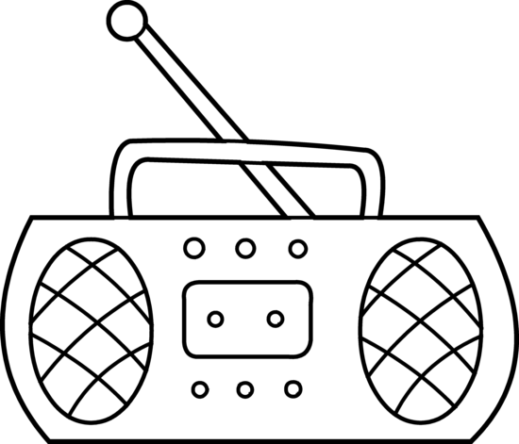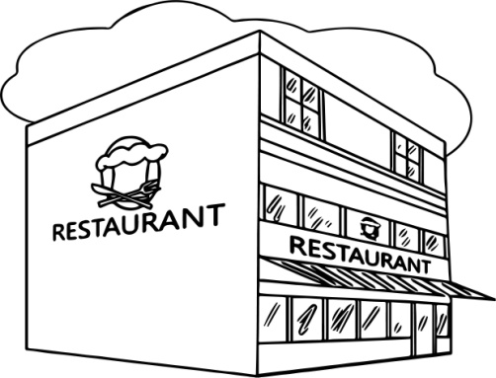
Restaurant= restoran
……………………………………………………………………………………..
………………………………………………………………………………………
Radio= radyo
……………………………………………………………………………………..
………………………………………………………………………………………
Queen= kraliçe
……………………………………………………………………………………..
………………………………………………………………………………………

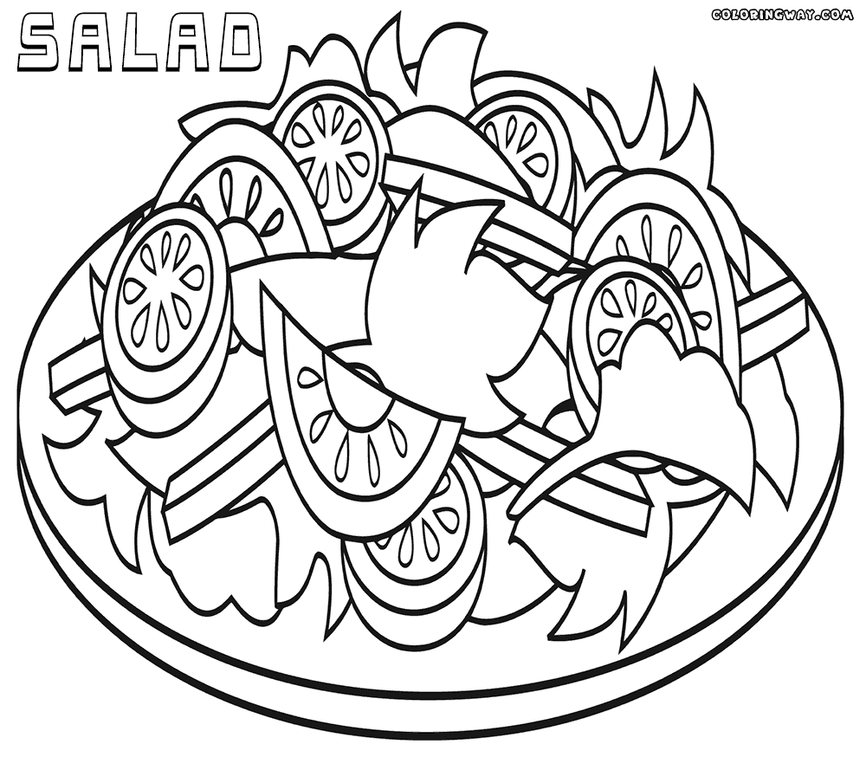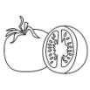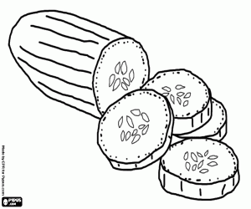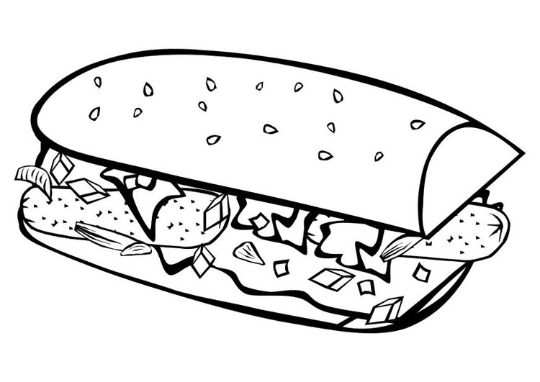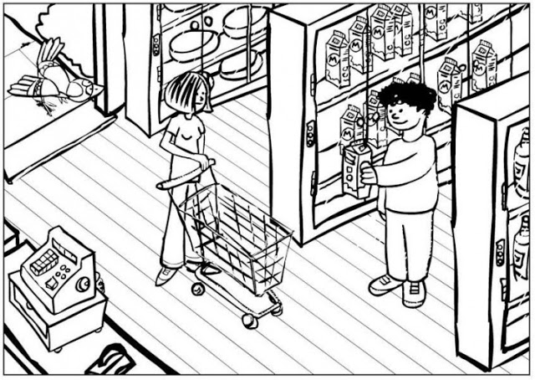
Supermarket= süpermarket
……………………………………………………………………………………………………..
………………………………………………………………………………………………………
Sandwich= sandviç
……………………………………………………………………………………..
………………………………………………………………………………………
Salad= salata
……………………………………………………………………………………..
………………………………………………………………………………………
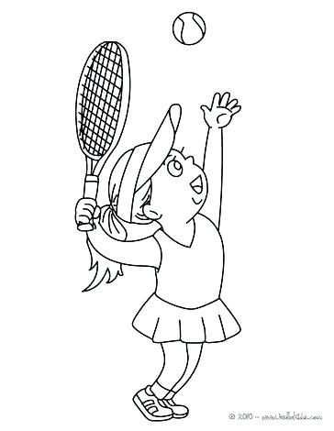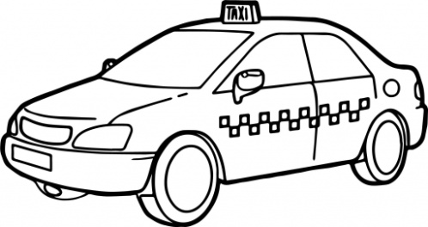
Taxi= taksi
……………………………………………………………………………………..
………………………………………………………………………………………
Tenis= tenis
……………………………………………………………………………………..
………………………………………………………………………………………
Stop= dur
……………………………………………………………………………………..
………………………………………………………………………………………

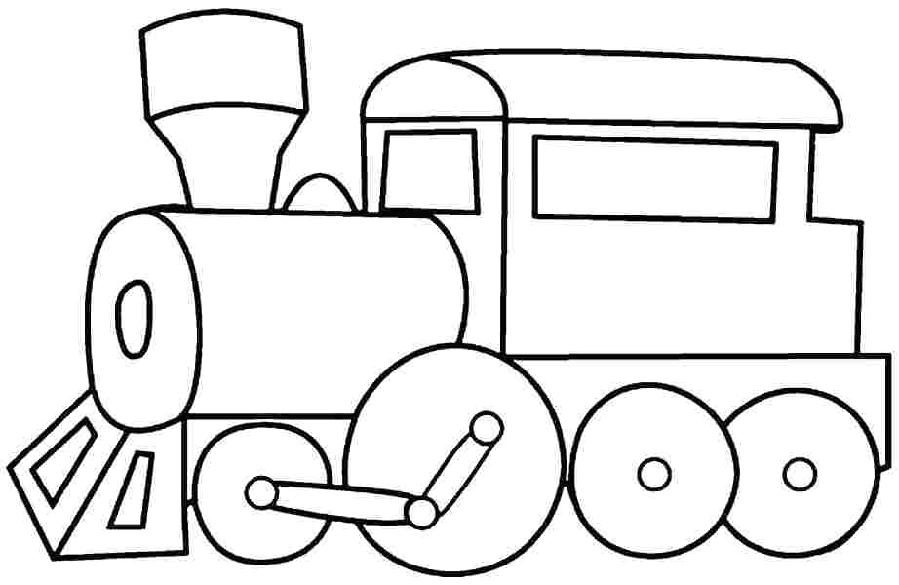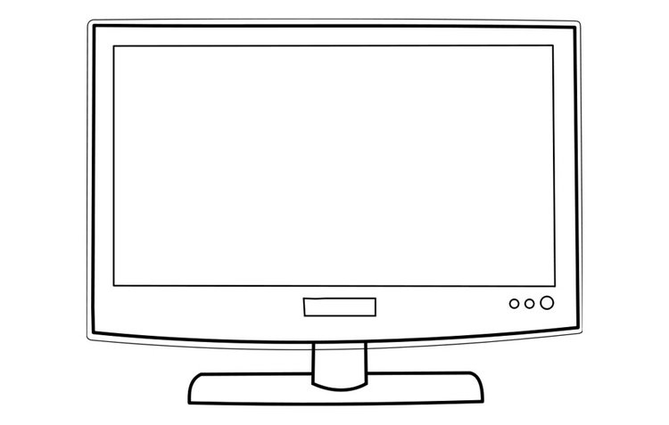
University= üniversite
……………………………………………………………………………………..
………………………………………………………………………………………
Television= televizyon
……………………………………………………………………………………..
………………………………………………………………………………………
Train= tren
……………………………………………………………………………………..
………………………………………………………………………………………

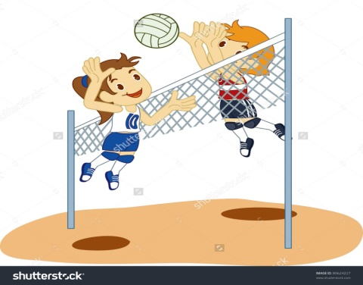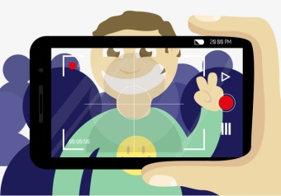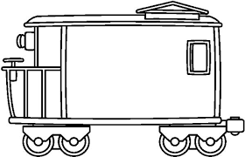
Wagon= vagon
……………………………………………………………………………………..
………………………………………………………………………………………
Video= video
……………………………………………………………………………………..
………………………………………………………………………………………
Volleyball= voleybol
……………………………………………………………………………………..
………………………………………………………………………………………

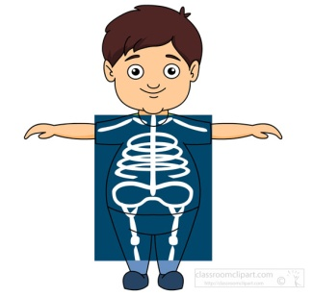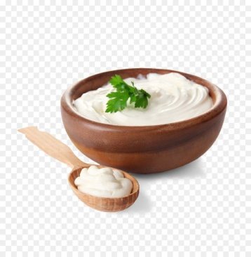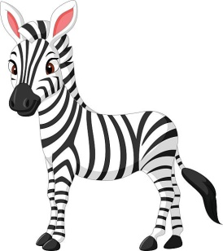
Zebra= zebra
……………………………………………………………………………………..
………………………………………………………………………………………
Yoghurt= yoğurt
……………………………………………………………………………………..
………………………………………………………………………………………
x-ray= röntgen
……………………………………………………………………………………..
………………………………………………………………………………………

