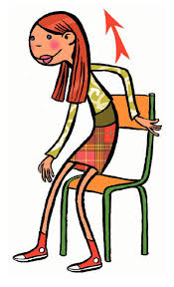
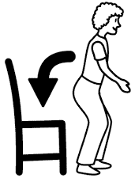
MATCHING 
Sit down
1

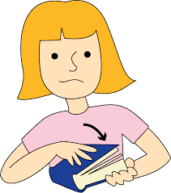
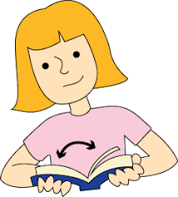
Stand up
2

Open your book

3

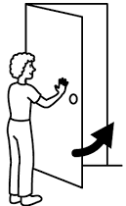
4
Close your book

Open the door

5

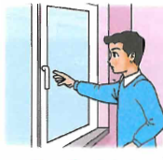
Close the door

6
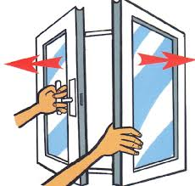
Open the window
7

Close the window

8
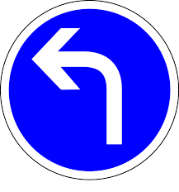
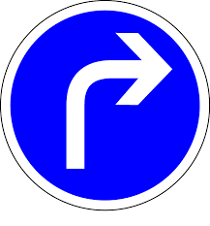
Turn right

9

Turn left

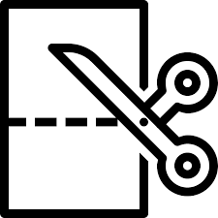
10
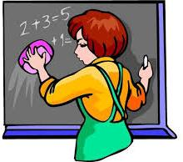
Cut the paper

11

Clean the whiteboard

12
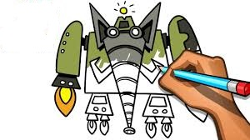
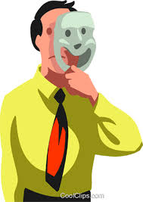
Wear the mask

13

14
Draw the robot

Look-read and circle

a) pencil
1
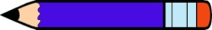
b) book
c) eraser

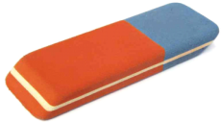
a) Eraser
2
b) Notebook
c ) Desk

a) Paper
3
b) Ruler
c) Schoolbag

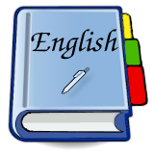
a) Book
4
b) Sharpener
c) Table

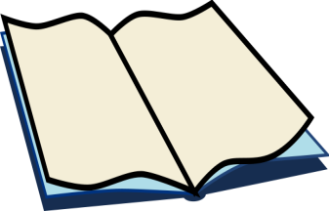
a) Notebook
5
b) Crayon
c) Pencilcase
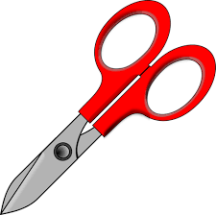

a) Scissors
6
b) Pen
c) Eraser

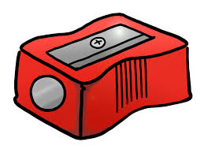
a) Sharpener
7
b) Whiteboard
c) Ruler

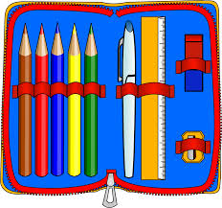

a) Pencilcase
8
b) Pencil
c) Pen

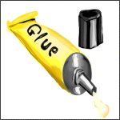
a) Glue
9
b) Book
c) Desk

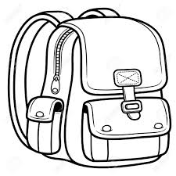
a) Schoolbag
10
b) Ruler
c) Table

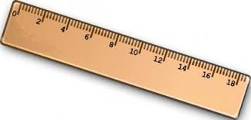
a) Ruler
11
b) Eraser
c) Paper
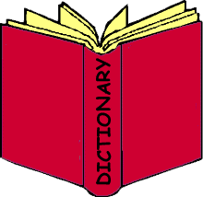

a) Book
12
b) Notebook
c) Dictionary

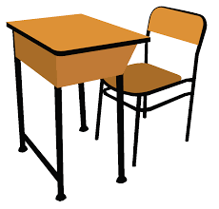
a) Desk
13
b) Book
c) Glue

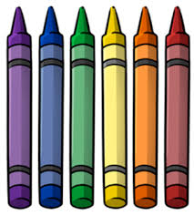
a) Crayon
14
b) Scissors
c) Pencil
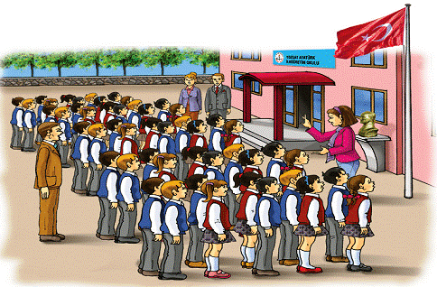

a) School
15
b) Desk
c) Table


a) Whiteboard
16
b) Ruler
c) Pencilcase

www.eegitimim.com

