What is this?

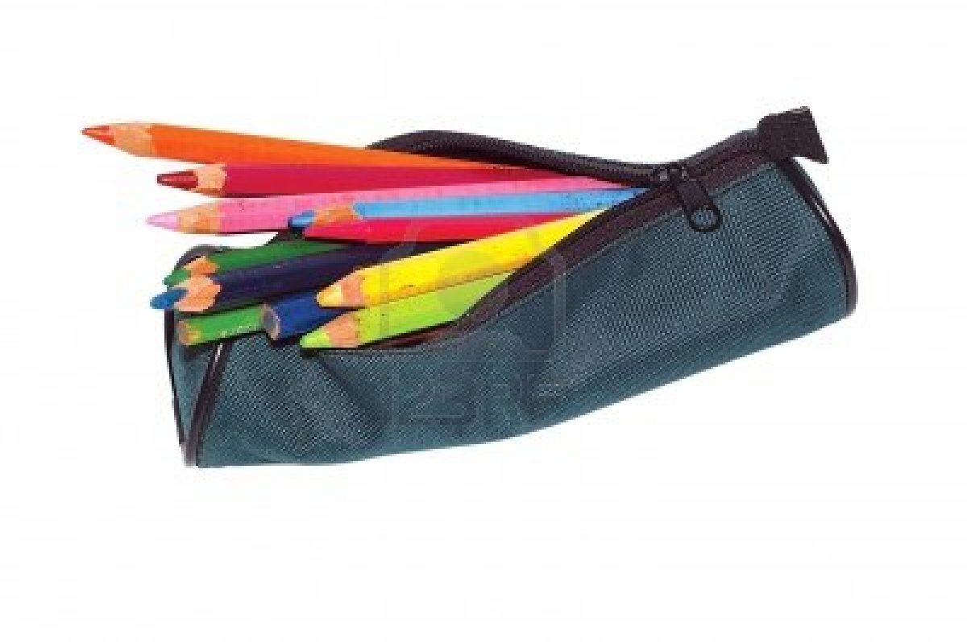

This is a ………………………

What is this?

This is a ………………………
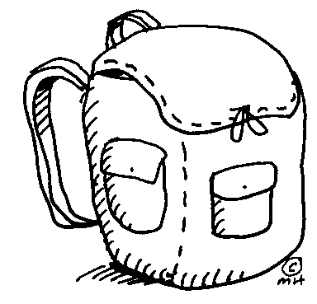
What is this?

This is a ………………………

What is this?

This is a ………………………

What is this?

This is a ………………………

What is this?

This is an ………………………

This is a ………………………
What is this?

That is a ………………………

That is a ………………………

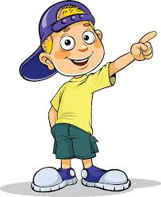

What is that?

That is a ………………………

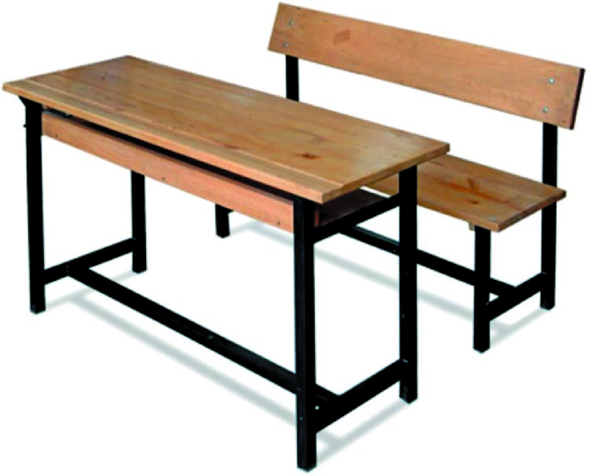
That is a ………………………

That is a ………………………

English Language Teacher

