MATHEMATICAL PROCESSES
EXERCISES
A)Add the Numbers up in Words
1) 3+5=---------
2) 1+6=---------
3) 4+5= --------
4) 7+3= --------
5) 9+2 =--------
B) Count them and write in words

----- +----------- = ----------



---------- + ---------- =-------------



----------- + ---------- =---------

---------- + --------- = -------

6) 8+5 =----------
7) 1+2=-----------
8) 6+8=---------
9) 7+5=----------
10) 6+9=---------
11) 2+3=----------




--------- + ------ =--------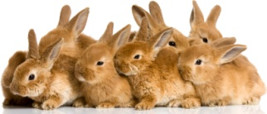 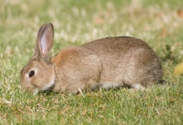 ----------- +---------- =--------
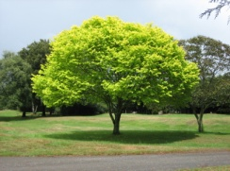
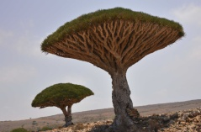
------------- + ---------- =-------

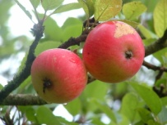
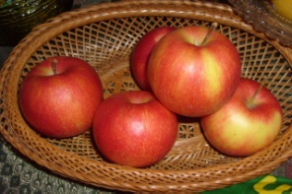
-------- + ---------- = -------

Lütfiye TIN

