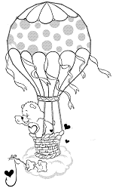
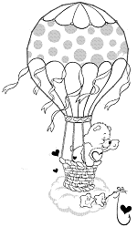
The ____________ balloon is number _____________
The ____________ balloon is number _____________
The ____________ balloon is number _____________
The ____________ balloon is number _____________
The ____________ balloon is number _____________
The ____________ balloon is number _____________
The ____________ balloon is number _____________
The ____________ balloon is number _____________
The ____________ balloon is number _____________
The ____________ balloon is number _____________

