Unit 8-Pets
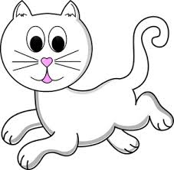cat-cat-cat-cat-cat-cat-cat-cat-cat
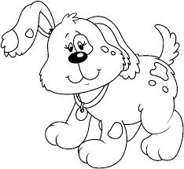dog-dog-dog-dog-dog-dog-dog-dog
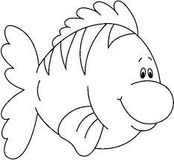fish-fish-fish-fish-fish-fish-fish-fish
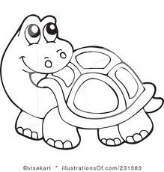turtle-turtle-turtle-turtle-turtle-turtle
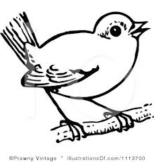bird-bird-bird-bird-bird-bird
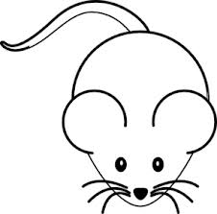mouse-mouse-mouse-mouse-mouse

