Exercise 2 : Resimlerle kelimeleri eslestiriniz.
C
A
B

Cat…………..
Dog…………
Turtle………
Rabbit………
Bird………….
Fish………….
Hamster…….

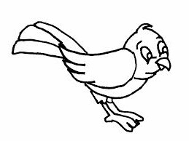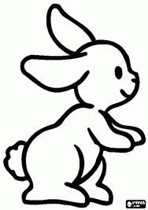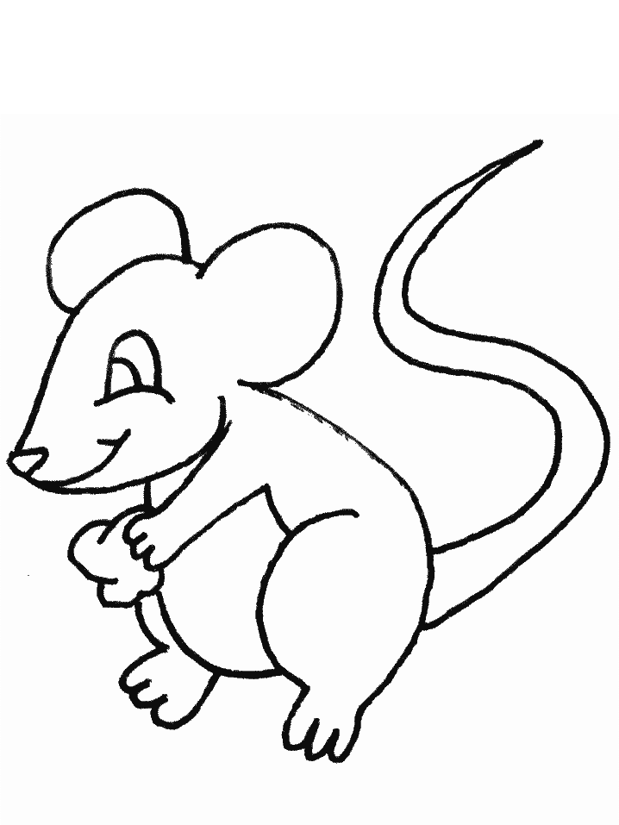

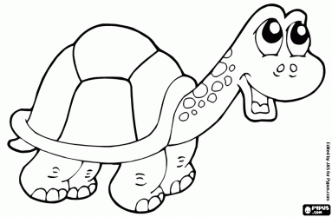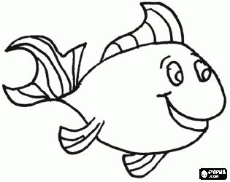

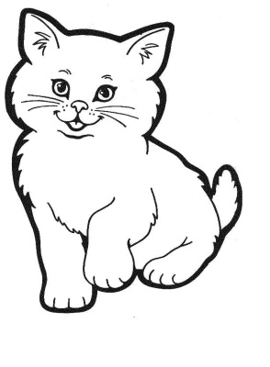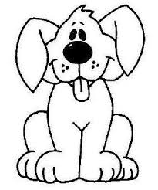

E
D

F
G

Exercise 3 : Boşluklara doğru kelimeleri yazınız.

- This is a……………………… 4) This is a……………………….

- This is a………………………. 5) This is a……………………….

- This is a………………………. 6) This is a……………………….

