Clues
- Something you can use to type on and go online on.
- Where you find countries on.
- What a student sometimes wear to school.
- What you do at school.
- What you write with.
- What American people call the break between two lessons.
- What you have to see how well you have studied.
- You read in them.
- A period away from school.
- What you use to write on the blackboard.
- A student sits at this.
- Books are made up of these.
- What students shouldn’t make!
- You use it in Maths.
- What is “Bend It Like Beckham”? A ………..!
- What you should take during lessons.
- American for rubber.
- You find many of these in books.
- It is white and comes in sheets.
- What students often ride to get to school in America.
- Another word for a group of friends.
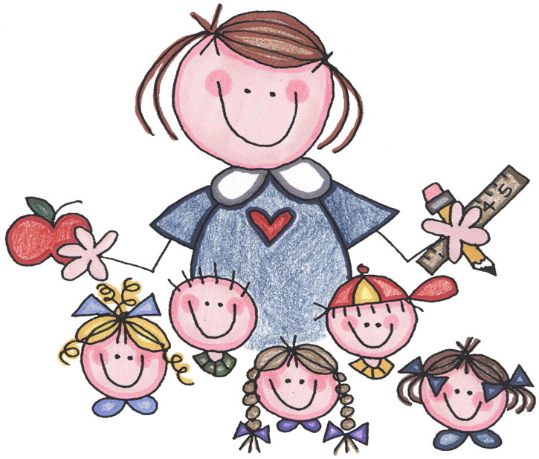

Mia: “I think we need a new teacher”
Mum: “Why is that?”
Mia: “Our teacher doesn’t know anything she keeps……”

1
4

8
3

5

12

14

7
______________________________________________________
21

20

19

18

17

15

13

11

10

9

6

2

16

