**…………………… EDUCATION ………………………………… HIGH SCHOOL 1ST TERM 10TH GRADE 2ND EXAM  
Name and Surname: Class:**   
  
  
  
  
  
  
  
  
  
  
  
  
  
  
  
  
  
  
  
  
  
  
  
  
  
  
  
  
  
  
  
  
**D. What time is it? 16 points**

**F) Match the jobs with their Turkish. (5 points) (Meslekleri Türkçeleri ile eşleştirin.)**1) reporter: ____ a) avukat  
2) hairdresser: ____ b) işsiz  
3) lawyer: ____ c) yönetmen  
 4) director: ____ d) muhabir  
 5) unemployed: ____ f) kuaför

**E)Answer the questions below. (Aşağıdaki soruları cevaplayın.) (12 points)**  
1) What day is it today?  
2) What month is it now?  
3) What is the date today?  
4) When is your birthday?  
5) What do you do?  
6) What do you want to be?  
7) Can you ride a bike?  
8) Can you play tennis?  
9) Can your sister sing a song?  
10) Can a bird fly?  
11) Are you good at swimming?  
12)What are you bad at?

**C)Match the ordinal numbers with their written forms. (16 points)** (Sıra sayılarını yazılı şekilleriyle eşleştirin.)  
a) 12th _____ 1) twentysecond  
b) 16th _____ 2) thirteenth  
c) 3rd _____ 3) thirtyfirst  
d) 20th _____ 4) twelfth  
e) 22nd _____ 5) twentyfifth  
f) 31st _____ 6) third  
g) 25th _____ 7) twentieth  
h) 13th _____ 8) sixteenth

**A)Complete the days of the week. (8 points) B)Complete the monts of year. (12 points)**   
 (Haftanın günlerini tamamlayınız.) (Yılın aylarını tamamlayınız.)  
1)Sunday 1) January 7)July  
2)_____________ 2) ____________ 8) _______________  
3)_____________ 3) March 9)September  
4)Wednesday 4) April 10)October  
5)Thursday 5)______________ 11) _______________  
6)______________ 6) _____________ 12)________________  
7)______________

**D)Write the years. (20 points) (Yazılı olarak verilen yılları rakam olarak, rakam olarak verilen yılları yazı ile yazın.)**1) 1659:  
2) 1370:  
3) 1206:  
4) 1400:  
5)2002:  
6) fifteen-eightysix :  
7) nineteen- ninetytwo:  
8) twelve-oh-one:  
9) twenty-fifteen:  
10) eighteen hundred:

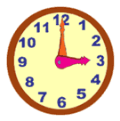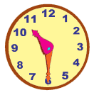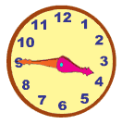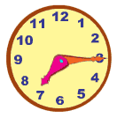**G) What time is it? 16 points**

1)_______________ 2)________________ 3)_______________ 4)_______________  
________________ _________________ ________________ ________________

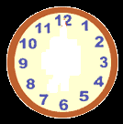     
5)It’s five past nine. 6) It’s twentyfive to six. 7)It’s half past eleven. 8)It’s twenty past twelve.  
  
**H) Write the phrases under the pictures.(5 points) (Söz öbeklerini resimlerin altına yazın.)**

|  |  |  |  |  |
| --- | --- | --- | --- | --- |
| Don’t eat junk food | Obey the rules | Be careful | Exercise regulary | Don’t smoke |

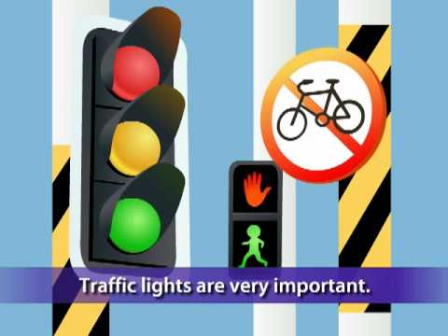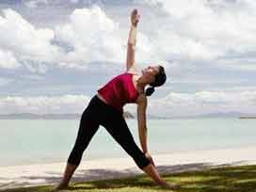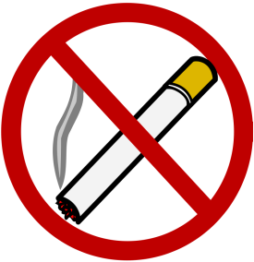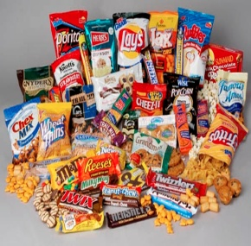  
1)_____________2)_____________3)_____________4)______________5)_________________________ ______________ ______________ _______________ ___________  
  
**I) Write sentences as for the chart. (6 points) ( Tabloya bakarak kişilerin yapabildiği ve yapamadığı eylemler ile ilgili cümleler yazın.)**

|  |  |  |
| --- | --- | --- |
|  | a) cook | b)ski |
| 1)Melis | √ | × |
| 2)Çağlar | × | √ |
| 3)They | √ | × |

1) a) Melis ___________________ 2) a) Çağlar _______________________  
 b) _______________________ b) _______________________  
  
3) a) They ____________________  
 b) ________________________