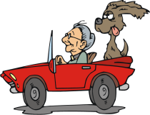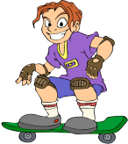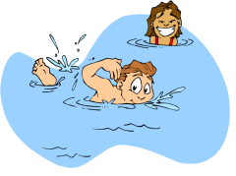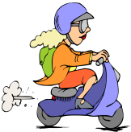

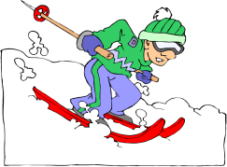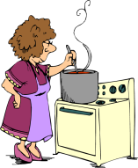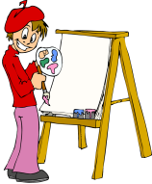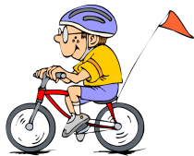   
 **schwimmen tanzen Moped fahren tauchen Auto fahren Skateboard fahren**

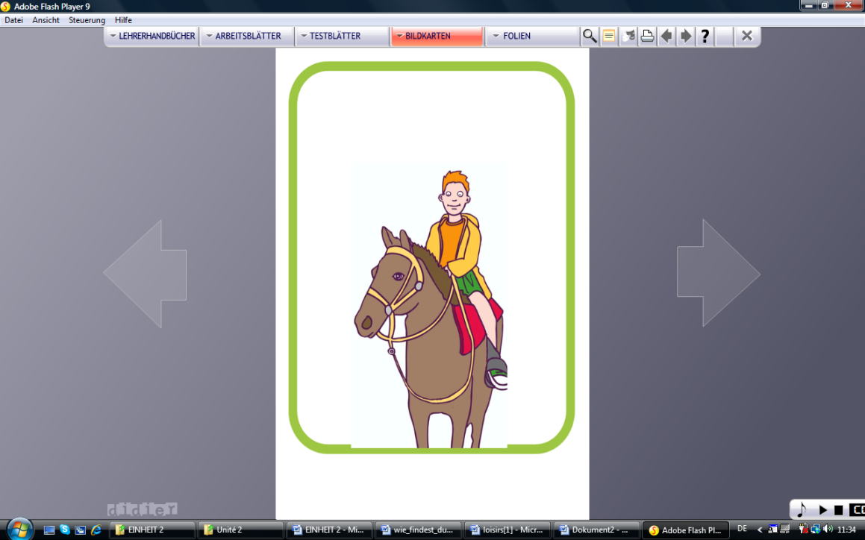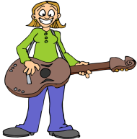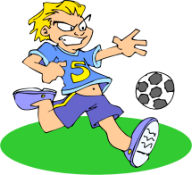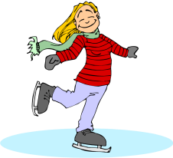 **singen am Computer Spielen Schi fahren kochen malen Fahrrad fahren**

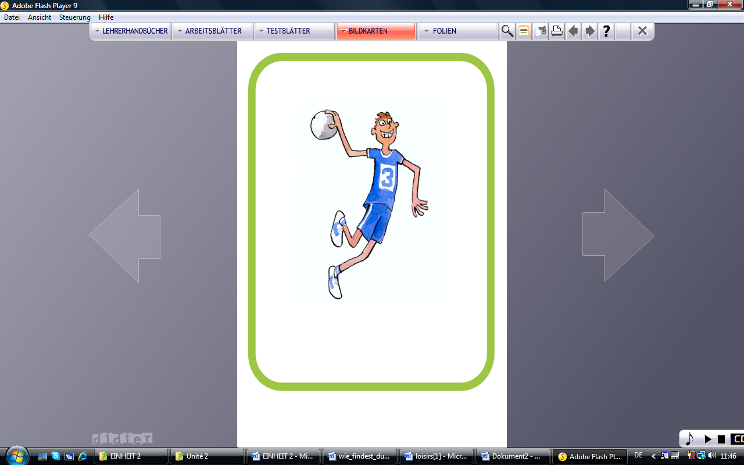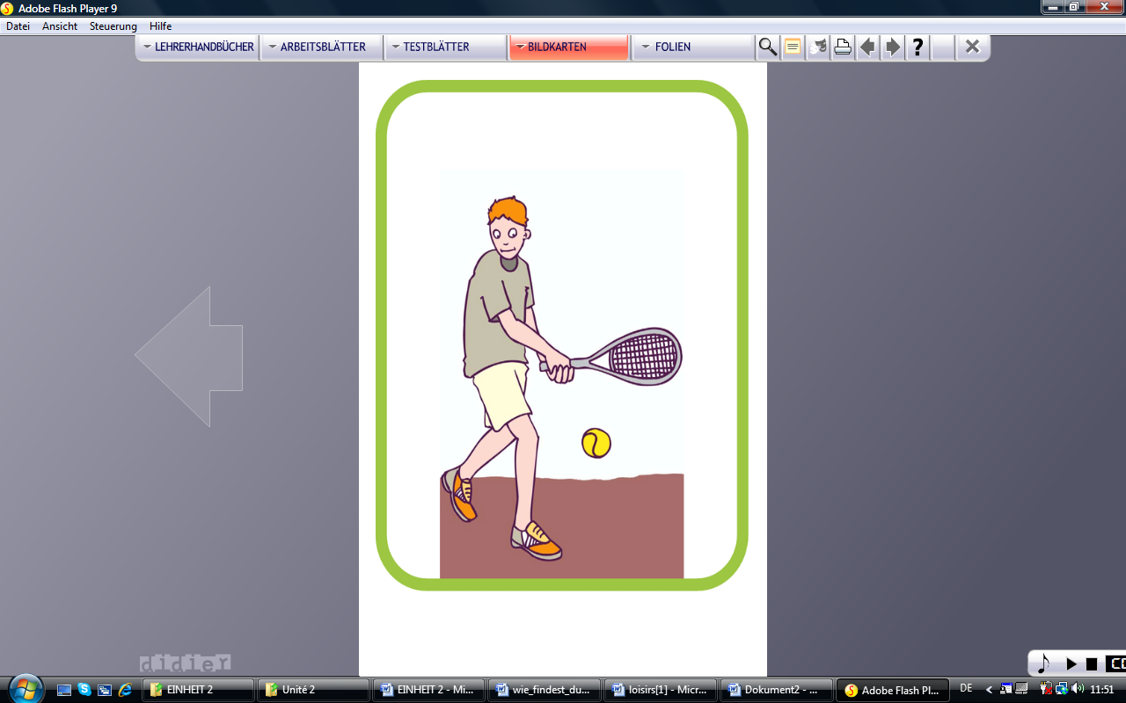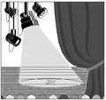  
  
   
 **Eis laufen Fußball spielen laufen Gitarre spielen Hausaufgabe machen reiten**

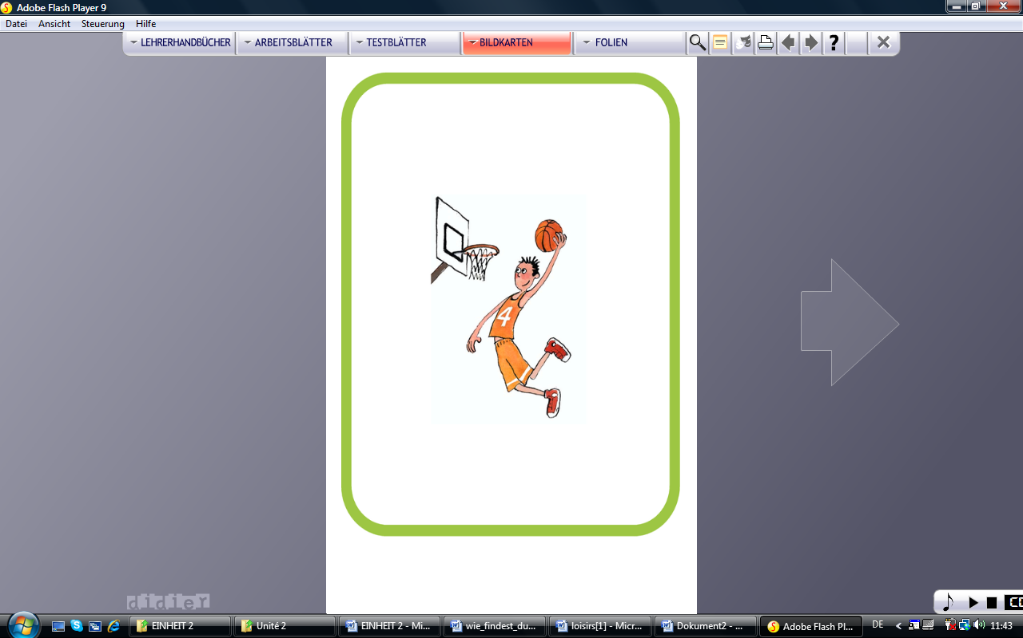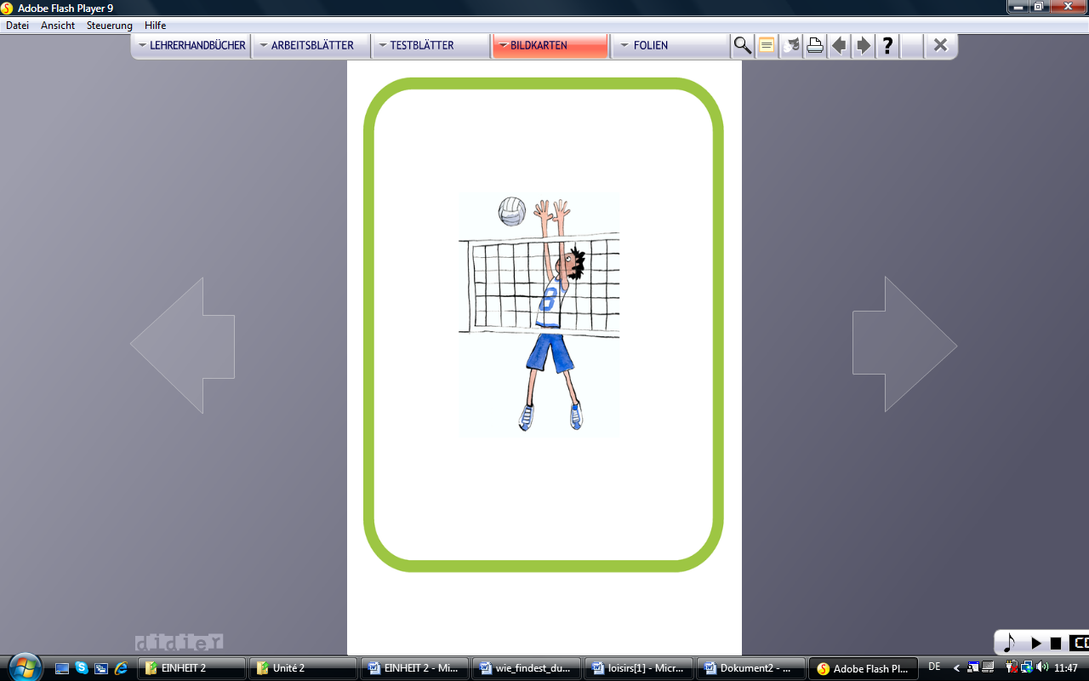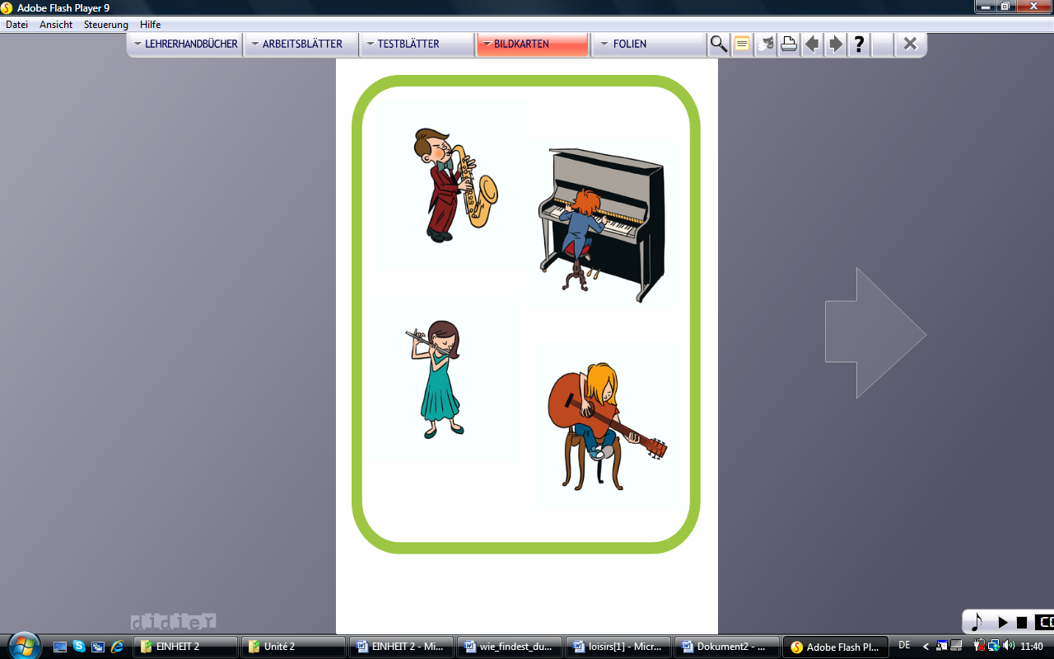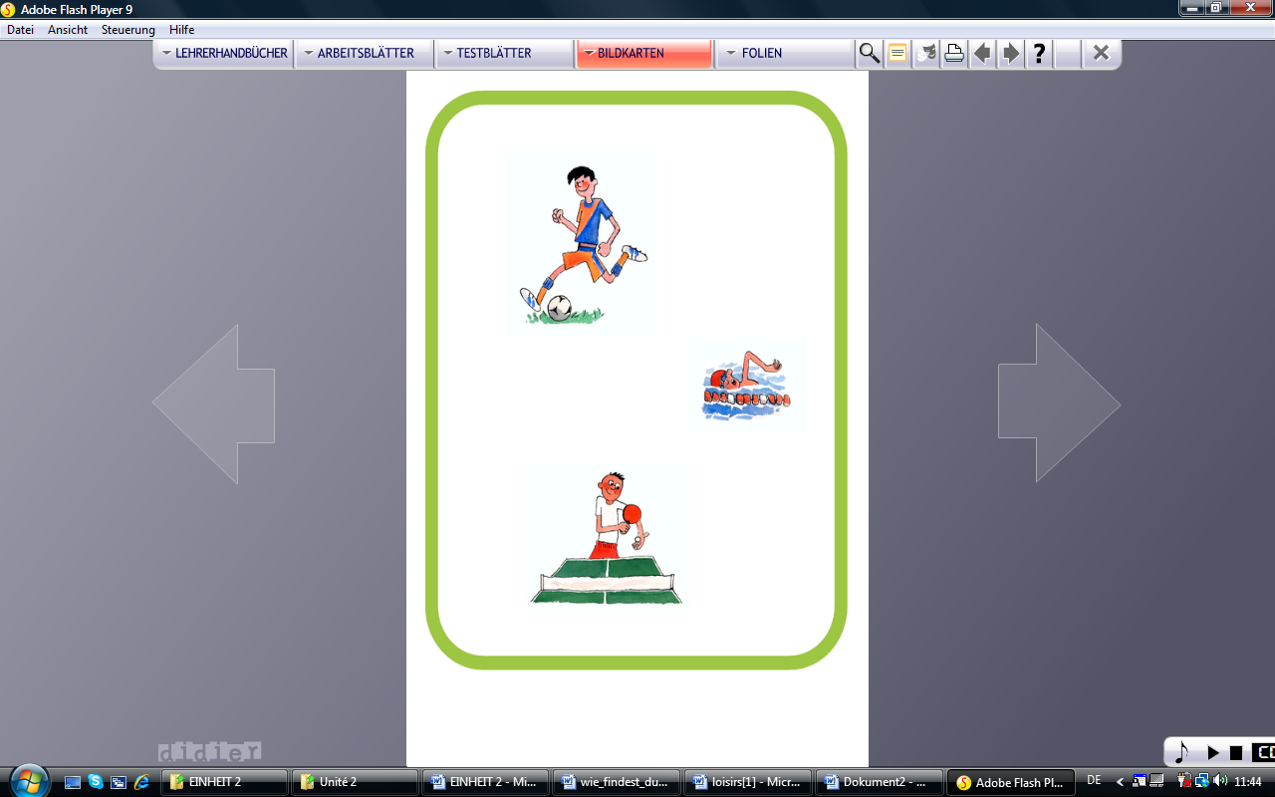 **Musik hören Handball spielen Tennis spielen ins Theater gehen ins Kino gehen**

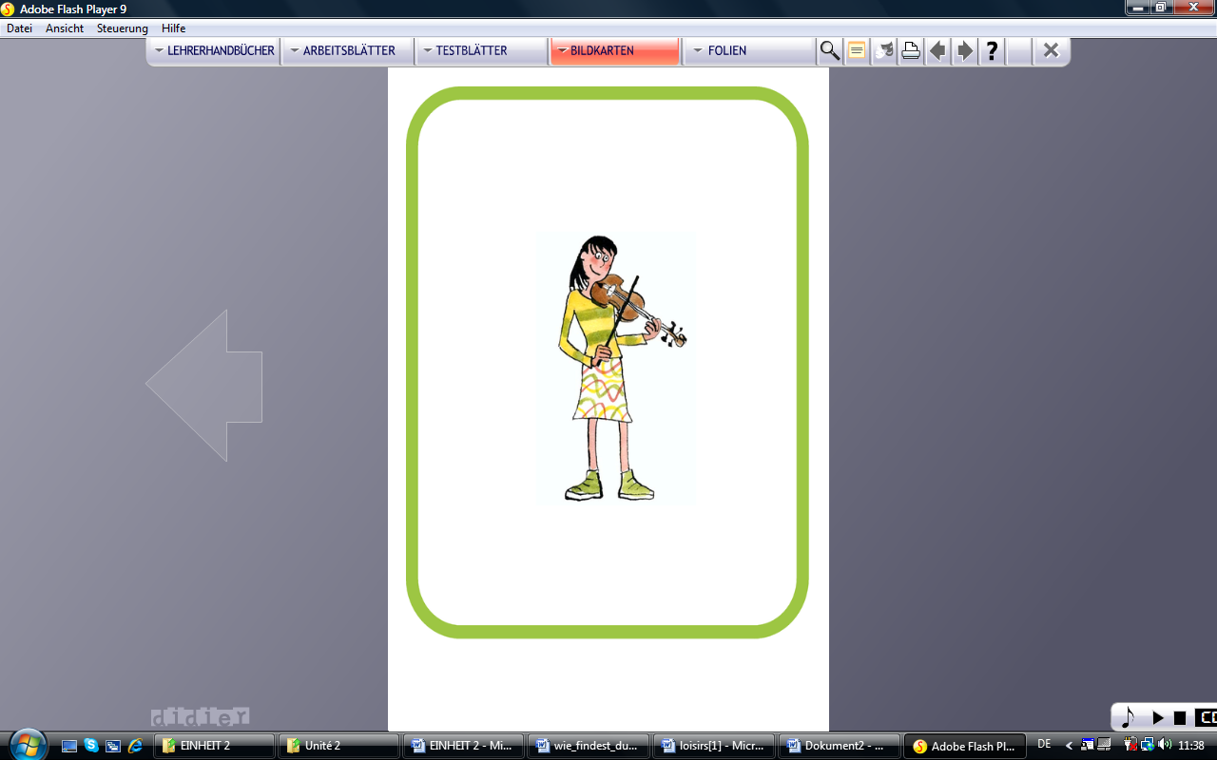

**Tischtennis spielen Klavier spielen Volleyball spielen Basketball spielen Geige spielen**

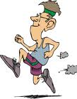



**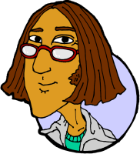   
 fern/ sehen joggen Hockey**



**7**

Was macht Johannes am Wochenende?  
Am Wochenende liest er Bücher.  
Er hört Musik am Wochenende.  
_________________________________________________________  
_________________________________________________________  
_________________________________________________________  
_________________________________________________________  
_________________________________________________________  
_________________________________________________________  
_________________________________________________________  
_________________________________________________________  
_________________________________________________________  
_________________________________________________________  
_________________________________________________________  
_________________________________________________________  
_________________________________________________________  
_________________________________________________________  
_________________________________________________________  
_________________________________________________________  
_________________________________________________________  
_________________________________________________________  
_________________________________________________________  
_________________________________________________________  
_________________________________________________________  
_________________________________________________________  
_________________________________________________________  
_________________________________________________________  
_________________________________________________________  
_________________________________________________________



Ich lese gerne  
Aber ich tanze lieber  
Ich singe am liebsten  
_________________________________________________________  
_________________________________________________________  
_________________________________________________________  
_________________________________________________________  
_________________________________________________________  
_________________________________________________________  
_________________________________________________________  
_________________________________________________________  
_________________________________________________________  
_________________________________________________________  
_________________________________________________________  
_________________________________________________________  
_________________________________________________________  
_________________________________________________________  
_________________________________________________________  
_________________________________________________________  
_________________________________________________________  
_________________________________________________________  
_________________________________________________________  
_________________________________________________________  
_________________________________________________________  
_________________________________________________________  
_________________________________________________________  
_________________________________________________________  
_________________________________________________________  
_________________________________________________________