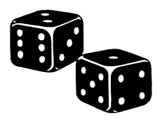

**Travel agent complaint Dice Game**

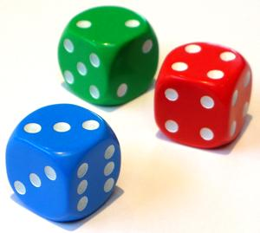

G

A

1. Well, I’ll make a note of it and pass it on to my boss.

2. I’ll look into this personally. I can’t apologise enough.

3. I’ll make sure that is taken care of right away.

4. If you don’t mind waiting a few days we could look into the matter for you.

5. OK. I’ll let my supervisor know and get back to you ASAP.

6. I’m very sorry to hear that. We’ll look into it right away.

1. Hello, Trip’s Travel. Terry speaking.

2. Good morning, Trip’s Travel. This is Terry

3. Trip’s Travel, Terry here. Can I help you?

4. Trip’s Travel, Terry here. What can I do for you?

5 Trip’s Travel. You are through to Terry. How may I help?

6. This is Terry at Trip’s Travel. How can I be of service?

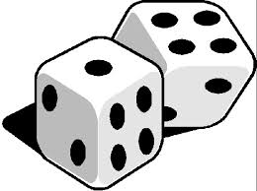

B

1. Does that mean we’ll get our money back?

2. Will we get a refund?

3. I trust we are entitled to a full refund?

4. Thank you. I hope I can count on a refund.

5. I appreciate that. Will we get our money back?

6. Good. I expect a full refund.

H

1. Hi! My name is John Stevens. I’m phoning about the holiday you sold me last month.

2. This is John Stevens. I need to speak to you about the holiday we just had.

3. Hello, my name is John Stevens. You sold me a holiday last month.

4. John Stevens speaking. I don’t know if you remember me but we bought a holiday from you last month.

5 John Stevens here. I'd like to speak to you about that holiday you sold us.

6. Good morning. John Stevens. I’d like a word or two about the holiday you sold us last month.

I

1. I couldn’t say. But we take this kind of thing very seriously. We have your details and we’ll contact you when a course of action has been decided.

2. Once we know all of the details, we’ll contact you to inform you of our decision.

3. I can’t comment on that at the moment but we will get back to you as soon as the matter has been dealt with.

4. I’ll let you know of our actions regarding this matter once all the details are known.

5. I can’t say but we’ll be in touch very soon.

6. We’ll phone you back once we have looked into it.

C

1. Was there a problem?

2. Was everything OK?

3. Yes, Mr Stevens, we did. Did you have a nice time?

4. Yes, I remember. How was your holiday?

5. OK. Was everything all right?

6. Of course, Mr Stevens. What’s on your mind?



D

J

Select two speakers, one orange and the other green. They throw a dice first and then speak the line that corresponds with the number. The speakers move through the list alphabetically. After they finish, another couple start. When everyone has finished, compare how different the conversation was in content but how similar in context. Different numbers should be used for different pairs

1. Firstly, the hotel you sent us to, was still being built. Secondly, the staff were incredibly rude.

2. The hotel was still under construction and the staff were all very rude.

3. Well, first of all, the hotel wasn’t finished. And the people working there were extremely impolite.

4. The staff were the rudest people I have ever met and the hotel was still being built.

5. The hotel wasn’t even finished and the staff working there is the worst and rudest I have ever seen.

6. For a start, the hotel wasn’t finished and if that wasn’t enough the staff were unspeakably rude.



F

E

1. I’m sorry to hear that. What exactly was the problem?

2. That is unfortunate. What was the nature of the problem?

3. I’m very sorry to hear that. What exactly went wrong?

4. Really? I’m sorry to hear you say that. What happened?

5. Is that right? Please, tell me more.

6. Oh, that is bad news. What happened?

1. Problem isn’t the word. It was the worst holiday we ever had.

2. Everything was not OK. It was awful.

3. No we did not. It was the worst holiday ever!

4. I can safely say it was the worst holiday I have ever been on.

5. No it wasn’t. It was terrible, and that’s putting it lightly!

6. We have just had the worst holiday ever!

1. OK. I expect to hear from you very soon. Bye.

2. Well, in that case I look forward to hearing from you very soon. Goodbye.

3. I will expect to hear from you before the end of the week. Good morning.

4. The sooner the better, please. Goodbye.

5. All right. Thank you for your time. Goodbye.

6. I’ll be waiting. Goodbye.

1. Thank you for calling Mr Stevens.

2. Thank you for your call. We’ll be in touch.

3. We’ll be in touch shortly. Thank you for bringing this to our attention.

4. Goodbye Mr Stevens. Thank you for calling.

5. Goodbye. We’re very sorry for the inconvenience.

6. We’ll be in touch Mr Stevens. Good morning.



K

