••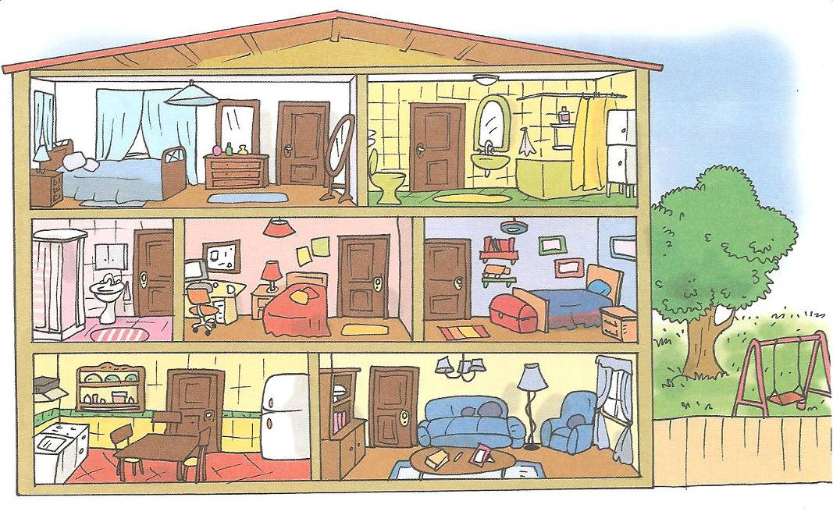

BADEZIMMER

DACH

GARTEN



Garten•  
Keller  
•Küche  
•Schlafzimmer  
•Badezimmer •Esszimmer  
•Wohnzimmer  
•Arbeitszimmer•  
Kinderzimmer•  
Dach•  
Flur•  
Toilette•

WOHNZIMMER

KÜCHE

ARBEITSZIMMER

KINDERZIMMER

BADEZIMMER

SCHLAFZIMMER

•Oturma Odası  
•Mutfak  
•Giriş,Hol,Koridor  
•Yatak Odası  
•Çalışma Odası  
•Tuvalet  
•Bahçe  
•Çocuk Odası  
•Banyo  
•Çatı  
•Kiler,depo  
•Yemek Odası

•kitchen•office

•bedroom

•toilet

•garden

•bathroom

•corridor

•living room •dining room  
•roof  
•Cellar  
•…………

Wo macht was?

kochen im Schlafzimmer

schlafen im Badezimmer

arbeiten im Esszimmer

essen in der Küche

fernsehen im Wohnzimmer

duschen im Arbeitszimmer

spielen im Garten

Wortsalat  
zbsermeitArmi ücehK erGtna

---------------------- ---------------------- ----------------------

emafcSizmrlh rulF etileTto

---------------------- ---------------------- ----------------------  
  
reinKmizredrm leerKl omerWhminz  
  
---------------------- ---------------------- ----------------------

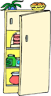





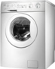

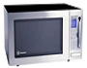



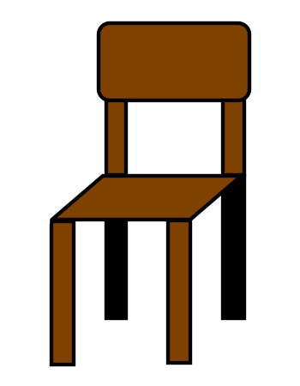

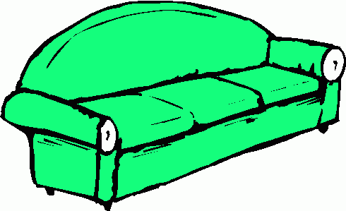

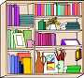

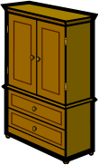

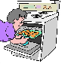





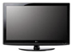

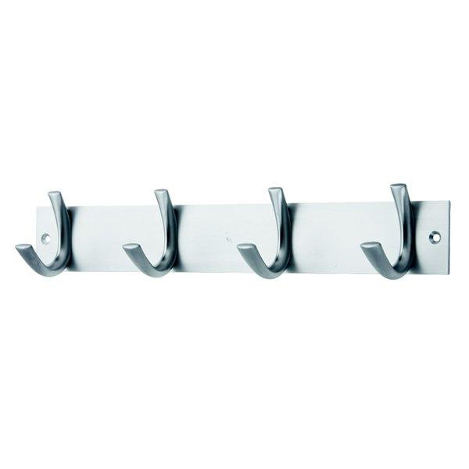

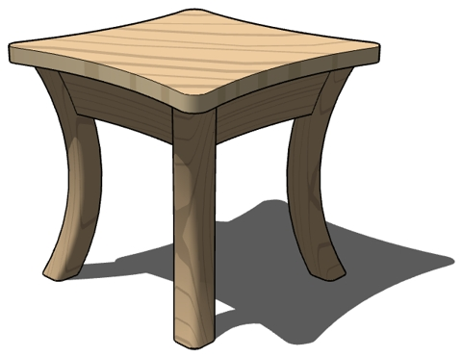

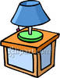

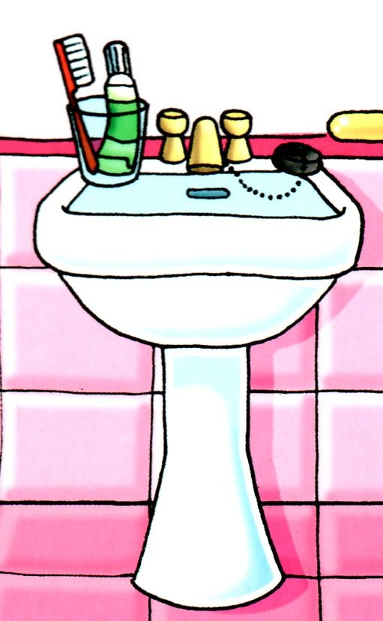

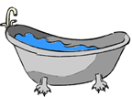

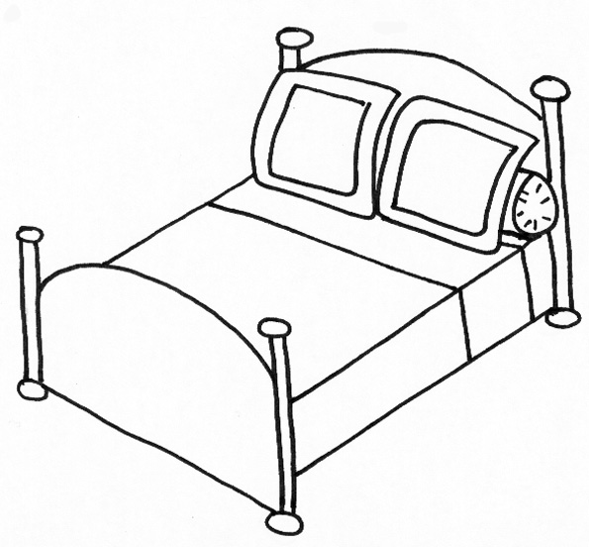

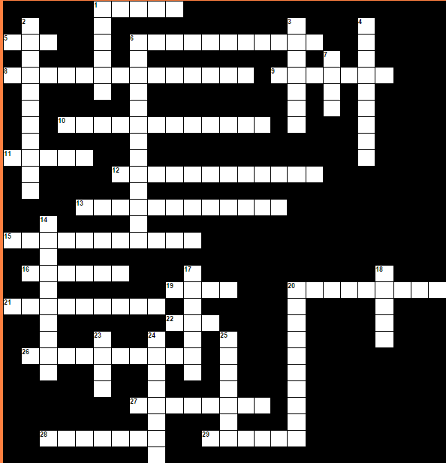

|  |  |  |  |  |  |  |  |  |  |  |  |  |  |  |  |  |  |  |  |  |  |  |  |  |  |  |  |  |  |  |  |  |  |  |  |  |  |  |  |  |  |  |  |  |  |  |  |  |  |  |  |  |  |  |  |  |  |  |  |  |  |  |  |  |  |  |  |  |  |
| --- | --- | --- | --- | --- | --- | --- | --- | --- | --- | --- | --- | --- | --- | --- | --- | --- | --- | --- | --- | --- | --- | --- | --- | --- | --- | --- | --- | --- | --- | --- | --- | --- | --- | --- | --- | --- | --- | --- | --- | --- | --- | --- | --- | --- | --- | --- | --- | --- | --- | --- | --- | --- | --- | --- | --- | --- | --- | --- | --- | --- | --- | --- | --- | --- | --- | --- | --- | --- | --- |
| |  |  | | --- | --- | | **Yatay:** | | | **1.** | **Sandelye** | | **5.** | **Kapı** | | **6.** | **Küvvet,Lavabo** | | **8.** | **Elbise dolabı** | | **9.** | **Ayna** | | **10.** | **Bulaşık makinesi** | | **11.** | **Lamba** | | **12.** | **Yazı masası** | | **13.** | **Askı(lık** | | **15.** | **Kitaplık** | | **16.** | **Duş** | | **19.** | **Kanepe,koltuk (birden fazla kişi)** | | **20.** | **Çöp kovası** | | **21.** | **Televizyon** | | **22.** | **Saat** | | **26.** | **Çeşme** | | **27.** | **Bilgisayar** | | **28.** | **Komidin** | | **29.** | **Merdiven** | | |  |  | | --- | --- | | **Dikey:** | | | **1.** | **Koltuk (tek kişilik)** | | **2.** | **Buz dolabı** | | **3.** | **Halı,kilim** | | **4.** | **Banyo küveti,duş teknesi** | | **6.** | **Çamaşır makinesi** | | **7.** | **Yatak** | | **14.** | **Ayakkabılık** | | **17.** | **Perde** | | **18.** | **Masa** | | **20.** | **Mikrodalga** | | **23.** | **Ocak** | | **24.** | **Fırın** | | **25.** | **Pencere** | |

•Teppich (1)

• Sofa (2)

•Spiegel (3)  
• Herd (16)

•Mikrowelle (4)

• Stuhl (5)  
• Stehlampe (20)

•Bett (6)  
• Fernseher (17)

• Badewanne (7)  
• Waschmaschine (18)

• Kühlschrank (8)

•Tisch (9)

• Kleiderschrank (10)  
• Bücherregal (19)

• Waschbecken (11)

•Kommode (12)

• Dusche (13)

• Kleiderhaken (14)  
• Sessel (15)