|  |  |  |  |
| --- | --- | --- | --- |
| ***Name :***  ***Surname :***  ***Number :***  ***Class :*** | *http://www.meb.gov.tr/webmaster/mebwebmaster/meblogo8.gif* | ***PAZAR 10 MART HIGH SCHOOL 2018 2019 ACADEMIC YEAR FIRST TERM SECOND EXAM FOR 11th GRADES*** | ***MARK:*** |

1. WRITING (25 PTS) Write a biography about Michael Jackson.

KING OF POP : MICHAEL JACKSON

|  |
| --- |
| **Michael Jackson was an Afro-American pop singer, song**  **writer, composer, musician and dancer.**  …………………………………………………………...........  …………………………………………………………………  …………………………………………………………………  …………………………………………………………………  …………………………………………………………………  …………………………………………………………………  …………………………………………………………………  …………………………………………………………………  …………………………………………………………………  …………………………………………………………………  …………………………………………………………………  …………………………………………………………………  ………………………………………………………………….  …………………………………………………………………  …………………………………………………………………  …………………………………………………………………  ………………………………………………………………….  …………………………………………………………………  …………………………………………………………………  …………………………………………………………………  …………………………………………………………………  …………………………………………………………………  …………………………………………………………………  ………………………………………………………………… |

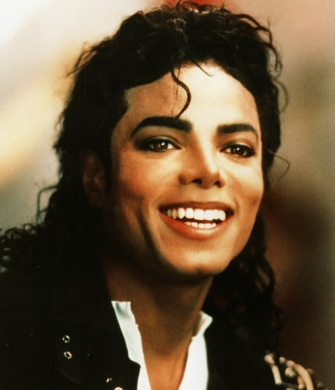 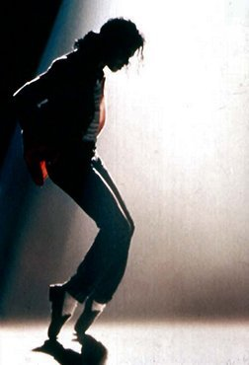

**MICHAEL JACKSON**

Be born in America on 29 August 1958

Start his music career at the age of six

Establish ‘’The Jacksons’’ music group with his brothers

Make so many singles and albums

Have a dance abilty

Take American Music Awards in 1980

Win Grammy Awards in 1981

Leave ‘’The Jacksons’’music group in 1982

Have an accident

Burn his face and hair

Have an illness called ‘’Vitiligo’’

His face and body become white in time

Have [aesthetic operation](https://www.seslisozluk.net/to-have-aesthetic-operation-nedir-ne-demek/)

Take part in social projects

Get married with Lisa Marry in 1994

Divorce with Lisa Marry eighteen months later

Get married with Deborah Jeanne Rowe in Sydney

Have three children

His albums sell one hundred millions in the World.

Enter Guinness World Records with albums selling

Become Muslim in 2004

Move to Bahreyn in 2005

Come back to Los Angeles in 2006

Decide to give concerts in London

Die because of heart attack on 25 June 2009

1. ***LISTENING (25 pts)***

***Listen to Thilda and Patrick talking about scientist Marie Curie. Tick the information you hear about her.***

|  |
| --- |
|  |

1. She had a difficult childhood.

2. She was the best student in her secondary school.

3. Girls didn’t go to university in Poland.

4. Marie and her sister had to make money for their education.

5. She studied Physics in France.

6. She became a professor at the University of Paris.

7. Her husband, Pierre Curie, was a scientist, too.

8. Their daughter, Irene Curie, was also a Nobel Prize winning scientist.

***Listen again and match the events.***

1. Marie’s family were poor ......... a. she was having a hard time.

2. While Marie was earning money, ......... b. she was exposed to radiation.

3. When Marie was a physics student at university, ......... c. when she was a little girl.

4. Marie and her husband made great discoveries ......... d. while they were working in their lab.

5. She was a young woman with two children ......... e. Bronya was attending university.

6. While she was doing experiments, ......... f. when her husband died

1. ***WRITING (25 PTS)***

***1) Insert the topic sentences into the paragraphs. One is extra.***

A. difficulty is learning disability

B. physical disability may seem to be a big problem to become a sports person

C. racism can bring misery to the lives of many people

D. poverty is one of the obstacles that you can face while fighting for success

|  |
| --- |
|  |

………………………………... Jim Carrey, for instance, had to suffer from financial problems. When his father lost his job, Jim was only a teenager. After the family fell on hard times with four children, they had to leave their home and live in a caravan. In order to make ends meet, Jim worked eighthour shifts at a factory after school. At the age of 15 he started to work at comedy clubs in the evenings. Eventually, he had to drop out of school to pursue his dream of becoming a comedian. Poverty didn’t stop him and now he’s one of the most well-known comedians.

|  |
| --- |
|  |

………………………………….. For example, Albert Einstein wasn’t a promising child at primary school because he had dyslexia, disability of reading or writing. Most of his teachers even thought that he was just an anti-social loser boy. However, he continued his education and became a very successful physicist. He developed the theories of relativity and won the Nobel Prize in 1921. He showed all the world that one can overcome anything with hard work despite learning problems.

|  |
| --- |
|  |

……………………………………Marla Runyan, a blind American athlete won five gold medals at the Paralympic Games. When she was in the fourth grade, she was diagnosed to be blind with Stargardt disease. Before her illness, she was fond of soccer and gymnastics. She had to give up soccer because she couldn’t see the ball anymore. At first, she felt like she hit rock bottom but she trained very hard in her track career and won numerous medals. Her success story continues to inspire many disabled people to do what they want. In conclusion, there is a silver lining in each difficult situation. We mustn’t lose our hope or let obstacles stop us from reaching our goals.

***2) Read the sample challenges and write the names of the people in the essay .***

1. ............................ kept up training although he / she was physically handicapped.

2. ............................ continued his / her education despite having problems at school.

3. ............................ worked long hours at a young age to support his / her family.

***3) Read the essay again and answer the following questions.***

1. Why did Jim Carrey become an unsuccessful student?

2. Why did Einstein have difficulty at primary school?

3. How did Marla become a successful athlete?

4. Why did Marla have to give up soccer ?

5. What is the common personality trait of these three people?

1. ***SPEAKING (25 PTS)***
2. ***Talk about the following topics.***

What would your dream job be; part-time or full-time? Why ?

How would you act in a job interview; confident or shy?

At work or on holiday? How would you spend your summertime? Why?

Working alone or with a team? Which one would you give a try? Why?

What are your hobbies that make you feel refreshed?

Do you think that you’re aware of your capabilities?

How do you think hobbies free us from getting stressed?

Do you believe it is possible to grow our abilities?

How can hard times help us get stronger?

Is it easy to deal with problems or is it a nightmare?

When you fail, do you feel like you can’t go any longer?

Or do you believe there is hope everywhere?

Where should we look for the key to success?

In the lives of great people or in childhood dreams?

How do you think some people took it to extremes?

What made some people so memorable, can you guess?

If you had a chance, which person would you want to become ? Why?

|  |  |  |  |  |  |
| --- | --- | --- | --- | --- | --- |
| ***Comprehension 5pts.*** | ***Vocabulary***  ***5pts.*** | ***Pronounciation***  ***5pts.*** | ***Accuracy***  ***5pts.*** | ***Fluency***  ***5pts.*** | ***Total***  ***25pts.*** |
|  |  |  |  |  |  |

***Mr.Şahan***