- READING (10x3=30 points)
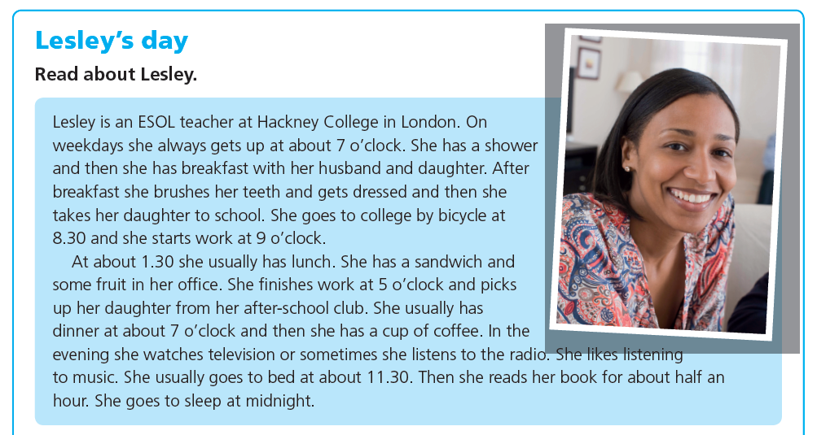
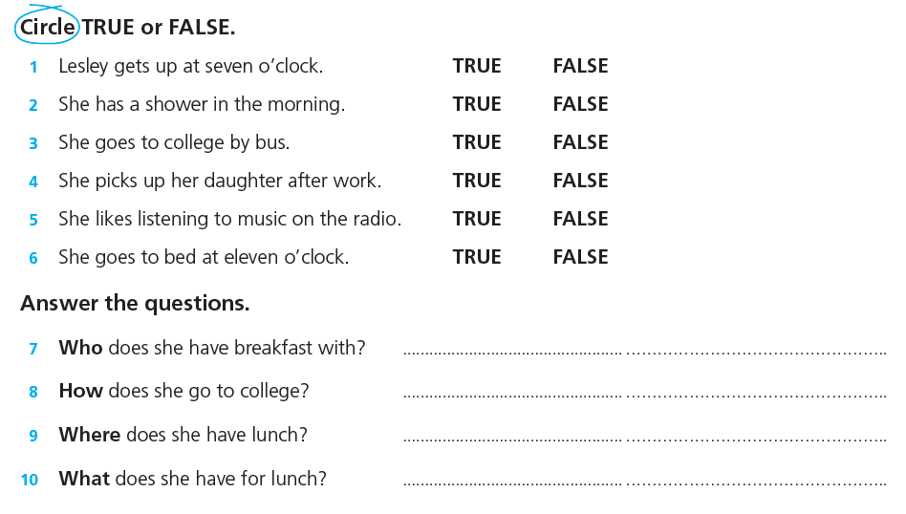
- WRITING ( 4x5= 20 points)

Write 4 sentences by using “prefer” and “would rather”
( 2 tane would rather, 2 tane prefer kalıplarını kullanarak toplam 4 tane cümle yazınız )

1. 3.
2. 4.

- LISTENING (10X3=30 points)

Giovanni is a professional cook. He’s the chef at his own (1)_______. He enjoys eating ant creating new dishes. He has a (2)_______ routine. He always goes to be at 5.00 a.m. and gets up at 1.00p.m. He never has a big breakfast. He (3)_______ has some cookies and orange juice. He gets work at 2.00 p.m. First he makes recipes. Then he prepares (4)_______ with the other cooks. He doesn’t cut the vegetables. His assistants do it. He often (5)_______ all the tables and sometimes puts (6)_______ on them. He makes people happy and his customers love him and his food very much. He finishes his (7)_______ at 2.00 a.m. and arrives at home 2.30a.m. He takes a shower and often studies (8)_______ on the Net because he has lots of Japanese (9)_______. He rarely feels tired at the end of the day (10)_______ he loves his job.

- SPEAKING (5x4=20 points)

FLUENCY | ACCURACY | GRAMMAR | VOCABULARY | COMMUNICATIVE ABILITY | TOTAL

