1. **Grammar** 
   1. **Fill in the blanks using he verbs in the correct form (22 pts)**

Dear Mum and Dad;

How are you? We...................................... 1(have) a great time here in Thailand. At the moment we are on the beach. Steve ...................................... 2(make) a sandcastle, Paul...................................... 3(play) volleyball with Micheal, and Helen ...................................... 4(swim). There are a lot of people on the beach;all of them...................................... 5(have) fun. They ...................................... 6(enjoy) the good weather.

Our hotel is lovely. Every morning we ...................................... 7(have) breakfast at the hotel restaurant. Then we...................................... 8(go) for a walk around the village. In the evenings we eat at one of the local restaurants. Steve ...................................... 9(not/like) Thai food, so he only eats salads and fruit.

Micheal’s new friend, Kasem, is from Bangkok. He ...................................... 10(go) to boarding-school in England, but at the moment he ...................................... 11(visit) his family for the summer.

We miss you a lot! You must come here next year for your holidays!

See you soon

* 1. **Fill in the blanks with “*may – must - mustn’t - don’t have to*” ( 10 pts )**
     + 1. You …………………….………… (ride) your bicycle in the street.
       2. It’s raining heavily. You …………………….………… (take) your umbrella
       3. We …………………………………. (not / pick) the flowers in the park.
       4. Tomorrow is Saturday. We…………………………………………(not/go) to school.
       5. You look ill. You …………………………………………………..(see) a doctor.
  2. **Fill in the blanks with “my – your – his – her – its – our – their” (10 pts)**
     + 1. Jack is at home with _________ family.
       2. We are in class. This is _________ teacher.
       3. This is Suzan’s aunt and _________ name is Jane.
       4. Look at the dog. It’s in _________ kennel.
       5. I’ve got a small house and _________ house is in the city.
  3. **Fill in the blanks with “behind – in – on – between – next to – above – beside – in front of” (8 pts)**

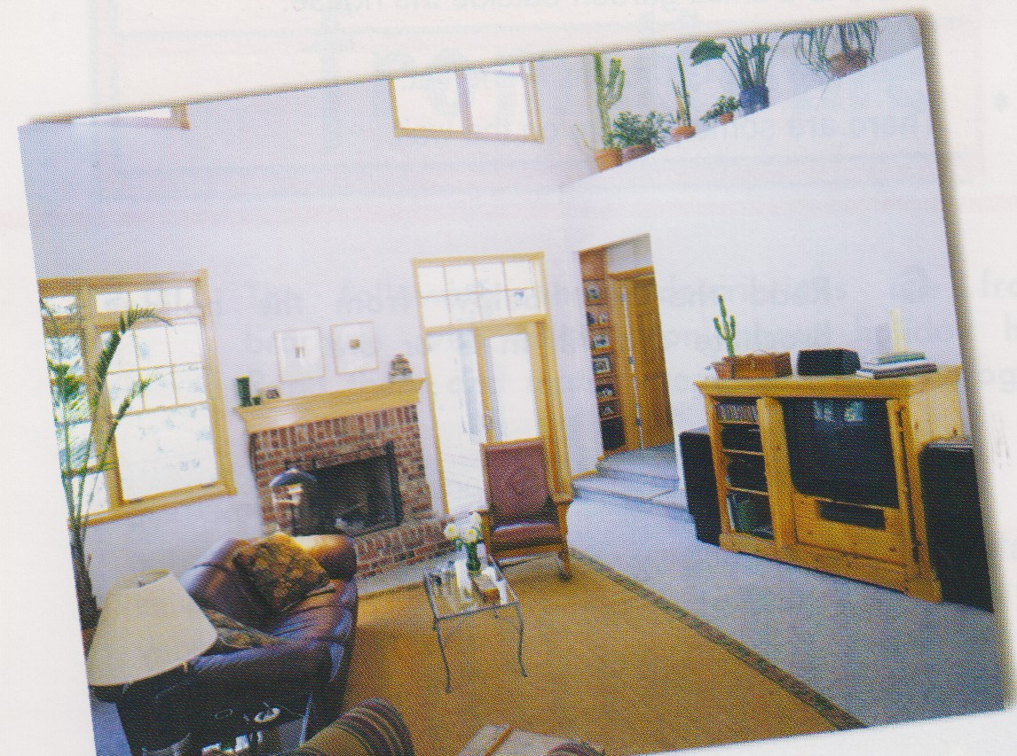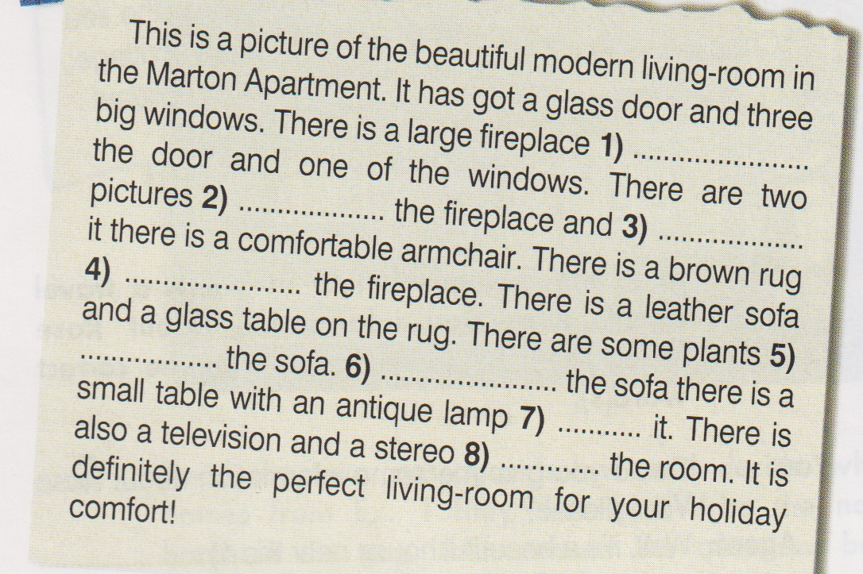

1. **Reading**

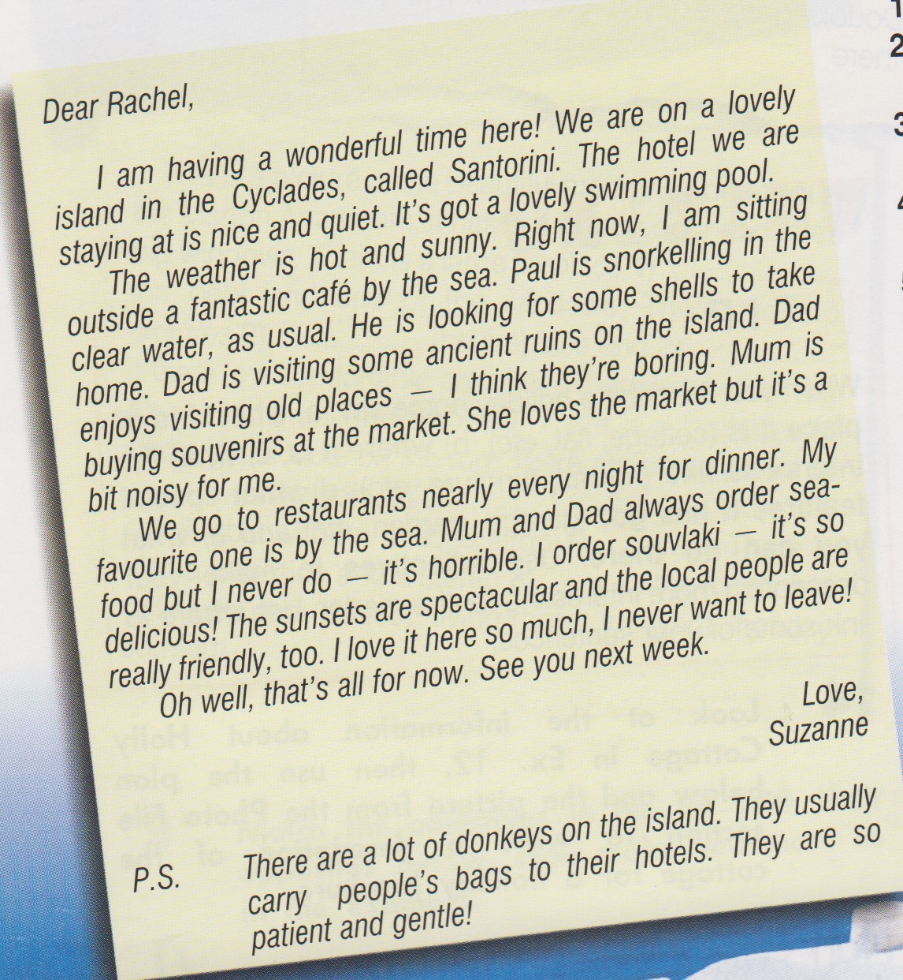

1. **Write True (T) or False (F) (12pts)**

**1)** Suzanne enjoys her holiday. …………….

**2)** Suzanne’s dad is snorkelling. …………….

**3)** They go to restaurants nearly every night. …………….

**4)** Suzanne hates sea-food. …………….

**5)** Donkeys carry people to the hotel. …………….

**6)** Suzanne’s mum is shopping. …………….

**B. Answer the questions (8 pts)**

1. How often do they go to restaurants for dinner?  
   ................................................................
2. What is Suzanne doing right now?  
   ................................................................
3. What is Paul doing?  
   ..................................................................
4. What are the local people like?  
   ..................................................................
5. **Read the text and choose the correct option. (10 pts)**
   * + 1. **Mum / Dad** enjoys visiting old places**.**  **4.** The hotel is **quiet / noisy**.
       2. **Dad / Suzanne** orders souvlaki**.** **5.** Suzanne is at the **hotel / café** right now**.**
       3. Paul is **sitting outside / snorkelling.**



1. **Writing**

**Look at the information about Tarkan’s day and**

**compare your day with his. (20 pts)**