

НАЧАЛО







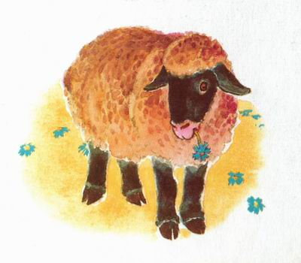

MCj04414110000[1]

**животные**

C:\Users\user\AppData\Local\Microsoft\Windows\Temporary Internet Files\Content.IE5\A0NH9V8Q\MC900435280[1].wmf



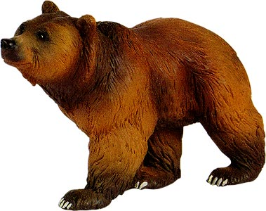









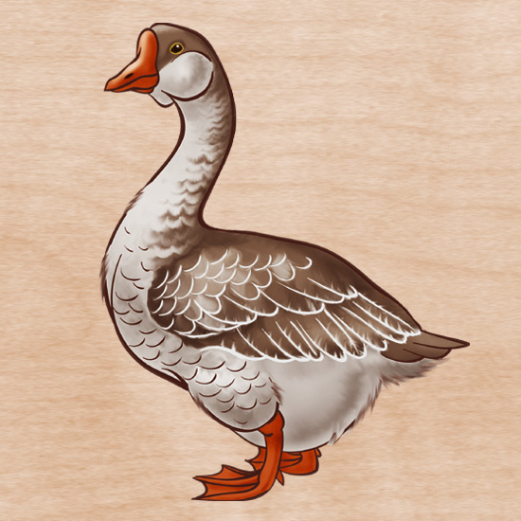







**КОНЕЦ**



C:\Users\user\AppData\Local\Microsoft\Windows\Temporary Internet Files\Content.IE5\DXJCVH9D\MC900215498[1].wmf

C:\Users\user\AppData\Local\Microsoft\Windows\Temporary Internet Files\Content.IE5\PGDUC2G3\MC900345794[1].wmf

**Иди вперёд**

**5**













C:\Users\user\AppData\Local\Microsoft\Windows\Temporary Internet Files\Content.IE5\C37XU15Z\MC900326488[1].wmf

C:\Users\user\AppData\Local\Microsoft\Windows\Temporary Internet Files\Content.IE5\PGDUC2G3\MC900215228[1].wmf

C:\Users\user\AppData\Local\Microsoft\Windows\Temporary Internet Files\Content.IE5\6TDOMGJ1\MC900441398[1].wmf

C:\Users\user\AppData\Local\Microsoft\Windows\Temporary Internet Files\Content.IE5\UGLP21SJ\MC900215495[1].wmf

C:\Users\user\AppData\Local\Microsoft\Windows\Temporary Internet Files\Content.IE5\MCOCHRIB\MC900215227[1].wmf

**Пропусти ход**

**C:\Users\user\AppData\Local\Microsoft\Windows\Temporary Internet Files\Content.IE5\ZOJKDTB5\MC900437980[1].wmf**

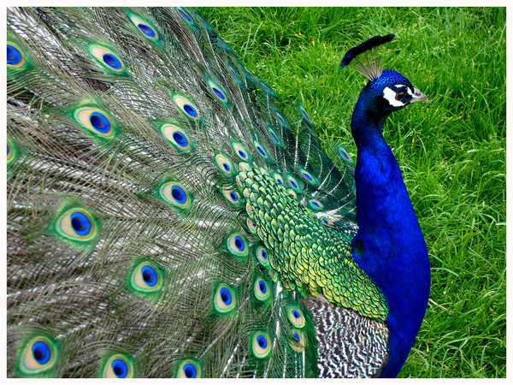

C:\Users\user\AppData\Local\Microsoft\Windows\Temporary Internet Files\Content.IE5\PGDUC2G3\MC900424130[1].wmf





C:\Users\user\AppData\Local\Microsoft\Windows\Temporary Internet Files\Content.IE5\2CV9I0FG\MC900406080[1].wmf

C:\Users\user\AppData\Local\Microsoft\Windows\Temporary Internet Files\Content.IE5\A0NH9V8Q\MC900199655[1].wmfC:\Users\user\AppData\Local\Microsoft\Windows\Temporary Internet Files\Content.IE5\UGLP21SJ\MC900404611[1].wmf

сюрприз

C:\Users\user\AppData\Local\Microsoft\Windows\Temporary Internet Files\Content.IE5\I09BUHH5\MC900434981[1].wmf

C:\Users\user\AppData\Local\Microsoft\Windows\Temporary Internet Files\Content.IE5\UZHJ6J46\MC900197880[1].wmf



ПОПАЛ в ЯМУ

(Следуй за стрелкой)

**Иди назад 5C:\Users\user\AppData\Local\Microsoft\Windows\Temporary Internet Files\Content.IE5\F16N923P\MC900434391[1].wmf**