NAME SURNAME: _________________ NO: _______________ CLASS____

1. Kelimelerin türkçe anlamını yaznınz.(26*2=52)

|  |
| --- |
| Bagel- relaxing-  Cereals- skyscraper-  Fruit- traffic jam-  Vegetable- degrees-  Honey- anxious  Egg- emotion-  Milk- lightining-    Butter- feel-  Busy- upset-  Building- sleepy-  Crowded- stormy-  Downtown- weather-  Queue- plane - |

**B )AŞAĞIDAKİ KELİMELERİN ŞIKLARINI RESİMLERDEKİ KUTUCUKLARA DOĞRU OLARAK YAZINIZ.(2x9=18)**

a)partly cloudy b)snowy c)rainy d)freezing e)sunny f)windy

g)hot h)stormy i)foggy

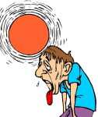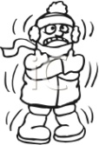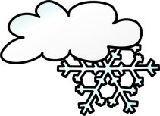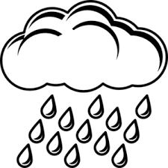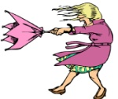

**C) HAVA TAHMININE GORE HAVA DURMUNU YAZIN. (15 P)**

1. What is the weather like in London?

**London**  **10 C**

**Rome**  **32 C**

**Kiev**  **-5 C**

**……………………………………………….**

1. What is the temperature in Rome?

**……………………………………………….**

1. What is the weather like in Kiev?

**………………**

1. **AŞAĞIDAKİ CÜMLELERİ DOĞRU ŞEKİLDE SIRALAYINIZ.(3x5=15 PUAN)**
2. What/like/is/today/the weather/?/
3. Ankara /rainy/on Friday/is/./
4. The temperature/is/minus 5/Ankara/in/./
5. The temperature/what/in Mardin/is/?/
6. is/how/the weather/?/

Good luck

……………………