Name :

Surname :

Number : .

Class :

**…………………………………………………….. HIGH SCHOOL THE FIRST EXAM OF THE FIRST TERM OF 10th CLASSES**

**Group: B**

1. **READING: Read the passage and answer the following questions according to the passage. (5X2=10)**

Hi, I’m Martin. I’m sixteen years old. I have got a big family. My mother’s name is Maria. She is fortyone. She has got brown hair and green eyes. She is a nurse.My father’s name is George. He is fortyfive. He has got fair hair.He is a dentist. I have got one brother and one sister. My sister’s name is Sandy and my brother’s name is Tim. Lord is our cat. It is very cute. Michael and Kate are my grandparents. They are seventy. They have got grey hair. I have got an aunt. Her name is Jane. Mike is her husband. They have got a son. His name is David.

1.What has Maria got? __________________________________________________________

2. Who is George’s wife?______________________________________________________________

3. Has Martin got any cousin? _________________________________________________________

4. How old is George? _____________________________________________

5. What is George’s job?-----------------------------------------------------------

1. **VOCABULARY Complete the sentences with the suitable words form the box. (5X1=5)**

|  |
| --- |
| Egyptian / Pencilcase / Calendar / Listen /Scientist |

* 1. There is a …………………….. .in his room.
  2. Her teacher is from Egypt..She is a ………………….
  3. The …………….. ………is an important person.
  4. The ……………………is on the wall.
  5. …………………………to your friend ,please.

**II. Write Turkish or English** of **the words (4x2=8)**

1.“Take care” 3. “Sonra görüşürüz”

2. “Nice to meet you” 4. “Have a nice weekend”

C: **GRAMMAR:**

**I. Answer the following questions.(10X2=20)**

1**.** Where is your friend from?

1. Is Barbara from Cyprus? (India)
2. What have you got in your room?
3. What is Philp’s nationality? (Bulgarian)
4. How old is Micheal? (47)
5. Are you Spanish?
6. Has your mother got any son or daugther?
7. Is your grandfather forty-two years old?
8. What is your uncle’s job?
9. Are you a tailor?

**II.Find the 7 more mistakes and correct them as in the example.** ( 7 X 2 = 14 )

“ Hello! My name ***are***  Funda. I is from Turkey. I’m a student. I am fiveteen years old. He is my best friend Elif.

**is**

Our are classmates. She isTurkish too. My favourite subject are English. I father is an engineer .His is tall.

1. **Rewrite “Subject Pronouns” / “Possessive Adjectives” for the underlined words. (4X2=8)**
2. Ayşe and I are at the cafe now.
3. You and Tom’s lessons are very difficult.
4. Tim’s dog is very clever.
5. Sally’s husband is an artist.
6. **Complete the sentences wıth the words gıven.** ( 10 X 1 = 10 )

your

my

his

her

She is

our

We’re

their

He is

They’re

1. Maria’s eyes are brown and ………………… hair is blonde.
2. I’ve got two cousins. ………………… names are Bob and Steve.
3. My parents are fifty four. …………… doctors.
4. My brother’s name is Martin. …………. a student.
5. I have got an uncle. ………….. name is Charles.
6. My mother’s name is Sue. ………………… a teacher.
7. My brother and I are twins. …………………. eleven years old.
8. We are students. …………….. teacher is Mr Smith.
9. Are you Nick? Are …………. Parents Ann and Tom?
10. …………….. name is Emma. I have got blue eyes.

# V. COMPLETE THE SENTENCES ACCORDING TO FAMILY TREE. ( 5 X 1 = 5 )

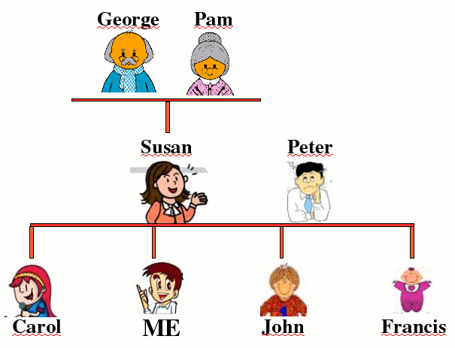

**1.** George is Susan’s……………………..

**2.** …………… is Carol’s father.

**3.** Susan is …………….…..’s wife.

**4.** Peter is Susan’s………………………..

**5.** John is Susan’s…………………………..

**VI.Fill in the blanks with “am / is / are / isn’t / aren’t / am not” (4X2=8)**

1. Our garden ……………. very small. It ……………….very big.
2. You and your mother……………… from England. You ……………from Turkey.
3. The notebooks………………..under the table. They …………………on the table.

4. Ankara………….a very small city. İt ……………. a very big city.

**D .WRITING :I.Complete the following sentences with the sayings of Atatürk (3x2=6)**

1.Turk! …………………………………………………

2.Science ……………………………………………….

3.Armies!................................................................

**II. Write three principals of Atatürk(3X2=6)**

**1……………………2………………………..3……………………**

G O O D L U C K

Note: total 100 points /

Duration: 40 minutes Teachers of English