NAME/SURNAME:
CLASS/NUMBER:

2nd TERM 2nd ENGLISH TEST EXAM FOR GRADES 3

A.Resime uygun olan kelimeyi yuvarlak içine alınız. (4’er puan)

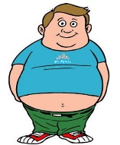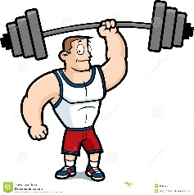
fat / slim weak / strong

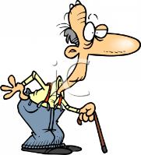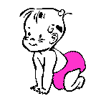
young / old old / young

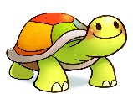
fast / slow fast / slow

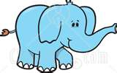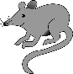
big / small small / big

B.Resimlerin altına uygun olan kelimeyi yazınız. (4’er puan)

C. Doğru seçeneği işaretleyiniz. (2’şer puan)

1. 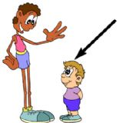 Tom is ……………
a) short b) tall c) thin

2. 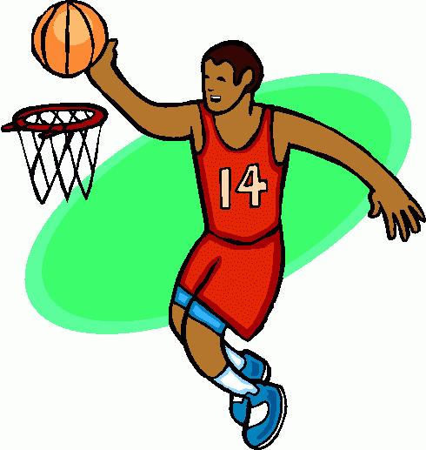He is ……….. He can play basketball.
a) fat b) short c) tall

3. 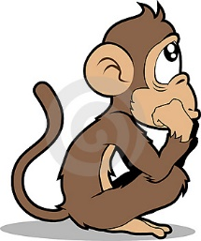 It is a ……………..
- sad monkey b) happy hippo c) angry goat

4. 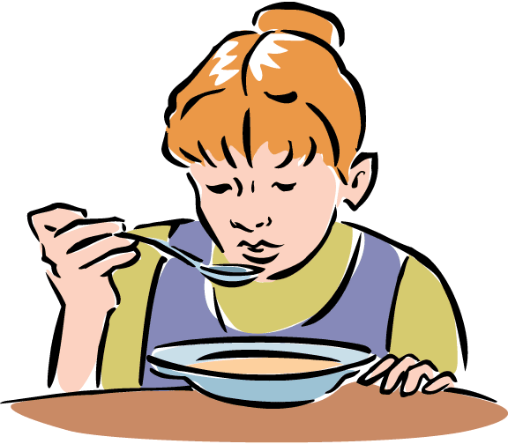 What is she doing?
a) She is singing b) She is eating c) She is studying

5. 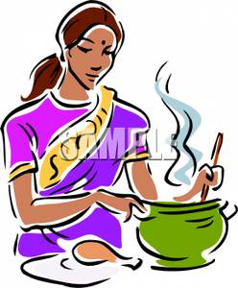 What is she doing?
a) She is cooking b) She is dancing c) She is singing

6. 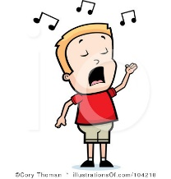What is he doing?
a) He is crying b) He is singing c) He is dancing

7. 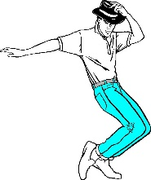He is ………….
a) dancing b) cooking c) running

8. 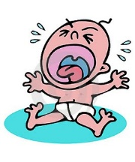 The baby is ………….
a) crying b) swimming c) sleeping

9. 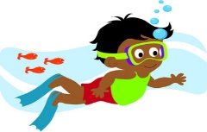 He is ……………
a) dancing b) singing c) swimming

10. 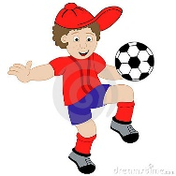 He is …………… football now.
a) playing b) walking c) riding

11. 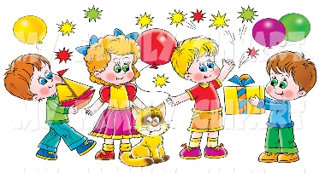 They are at the ………
a) school b) birthday party c) house

12. 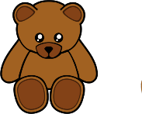 What is this?
a) It is a ball. b) It is a doll. c) It is a teddy bear

13. 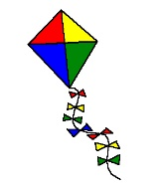 What is this?
a) It is a doll b) It is a kite c) It is a robot

14. 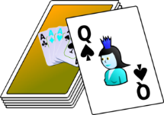 These are …………..
a) playing cards b) blocks c) board game

15. 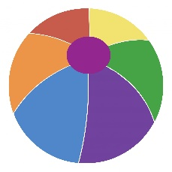 It is a ……….
a) block b) ball c) button

16. 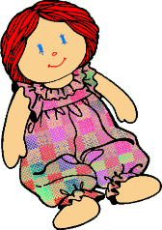 It is a …………….
a) ball b) kite c) doll

17. These are ………….
a) kite b) blocks c) board game

18. 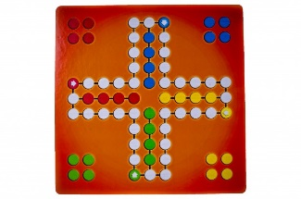It is a …………….
a) board game b) doll c) card

BEST OF LUCK

ENGLISH TEACHER

