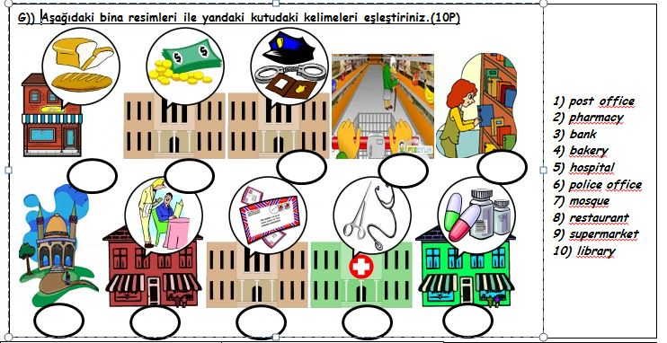

**PREPARED BY BAHADIR SAĞLAM**

**J)) Aşağıdaki aktivitelerden sağlığımız için iyi olanların yanına “good” kötü olanların yanına “bad” yazınız.**

1- I havebreakfasteverymorning. ……………….

2- I playcomputergamesmuch. ……………….

3- I eatfastfoodandjunkfood. ……………….

4- I do sportseveryday. ………………

5- I brushmyteetheveryday. ……………….

6- I gotobedlate at night. ……………….

7- I eatfruitandvegetables. ……………….

8- I don’twashmyhands. ……………….

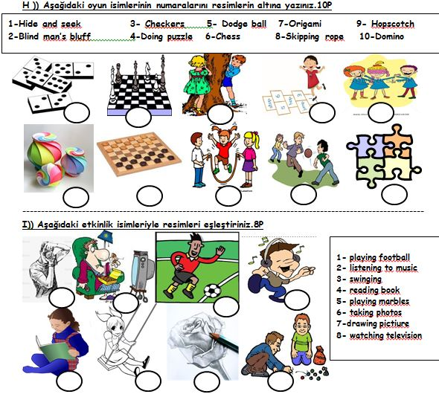

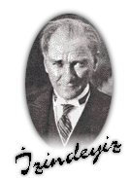

**1-Turkish2-Physical Education3-Music 4-English**

**5-Social Sciences 6-Science 7-Maths 8-Computer9-Art**

**E)) Resimlerin altına ders isimlerinin numaralarını yazınız. (9P)**



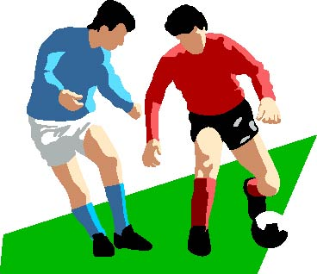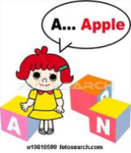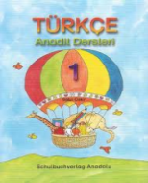

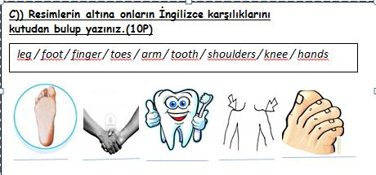

**F)) Verilen hastalığa hangi tavsiye verilirse onu işaretleyiniz (5P)**

|  |  |  |  |
| --- | --- | --- | --- |
| 1 | headache | a) b) | Youshouldgoto a dentist.  Youshouldhave a rest. |
| **2** | **backache** | **a) b)** | **Youshouldn’tplayfootball.**  **Youshouldplayfootball.** |
| 3 | flu | a) b) | Youshouldgoout.  Youshouldgoto a doctor. |
| **4** | **stomachache** | **a) b)** | **Youshouldgotoschool**  **Youshouldsee a doctor.** |
| 5 | sorethroat | a) b) | Youshoulddrink hot drinks.  Youshoulddrinkcoldwater. |

**D))**

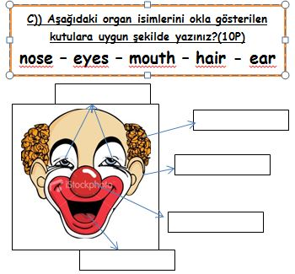

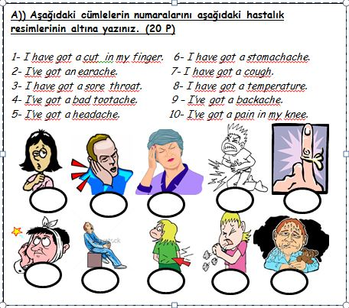

**B))İlk kutudaki sorularla altlarındaki cevapları eşleştiriniz. (10P)**

1) Whereareyoufrom? …………….

2) Whatnationalityareyou?…………….

3) What is thematterwithyou?…………….

4) What is thecapitalcity of Germany?.........

5) What time is it?…………….

*a) It is Berlin.*

*b) It is 5 p.m.*

*c) I’m from Çanakkale.*

*d) I’m English.*

*e) I havegot a toothache.*

**SECONDARY SCHOOL   
2014-2015 EDUCATION YEAR 1st TERM 5TH CLASSES ENGLISH LESSON 2nd EXAM QUESTIONS**

Name:…………………………………Surname:………………………….. Class:……………………….……Number:………………………………Score: