Name:……………………………….…...... Surname:.................................... Number:………………………………….

Score:……………………………………..



**GAZİ SECONDARY SCHOOL 2014-2015 EDUCATION YEAR 1st TERM 6/B CLASS ENGLISH LESSON 2nd EXAM QUESTIONS**

**A)) Aşağıdaki resimleri ifade eden doğru kelimeyi altlarından bulup işaretleyiniz.12P**

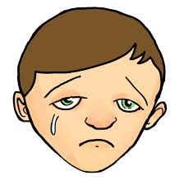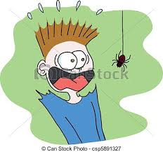

a) upset a) happy a) upset a) anxious a) upset a) moody

b) sleepy b) sleepy b) scared b) sleepy b) moody b) scared

c) scared c) moody c) happy c) happy c) happy c) sleepy

**B)) Aşağıda bulunan kutudaki kelimeleri resimlerin altına doğru gelecek şekilde yazınız.14P**

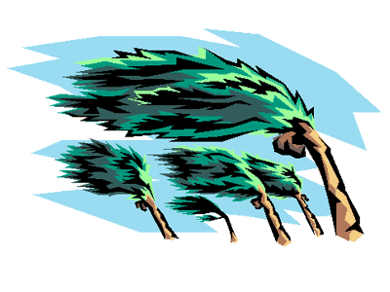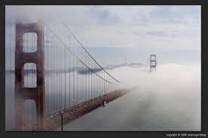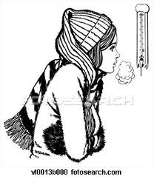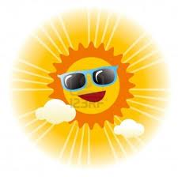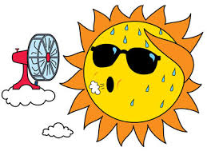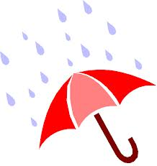

………………… ………………… ……………………… ……………………… ………………… ………………… ………………… …………………

…………………

…………………

**windy - foggy – hot – rainy – sunny - snowy - cold**

**C)) Aşağıda bulunan kutudaki kelimeleri resimlerin altına doğru gelecek şekilde yazınız.10P**

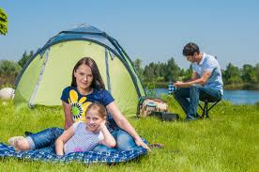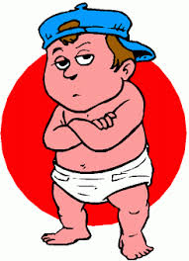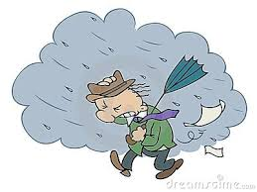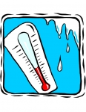

**cool storm freezing lightning warm**

**D)) Yandaki hava durumu raporundaki boşlukları kutudaki kelimelerle haritaya bakarak doldurunuz.10P**

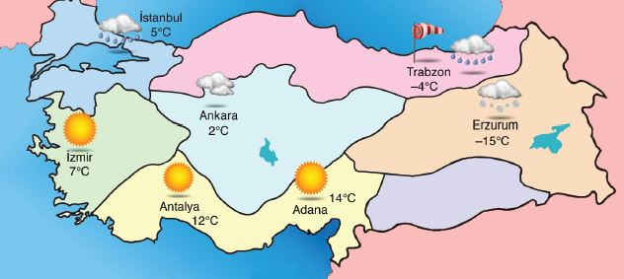

weather /// morning /// below /// cold /// 14

rainy /// sunny /// -15 /// cloudy ///degrees

Good …………………………… dear viewers.

Today the ……………………. is nice in Turkey. Ankara is ………………………….…and 2 degrees Celcius.

Erzurum is very …………..………… and the temperature is ……………… . İstanbul and Trabzon are …………………… but it is 5 degrees Celcius and Trabzon is 4 degrees …………………..…. zero.

İzmir,Antalya and Adana are ……………… .İzmir is 7 …………..…..Celcius and Antalya is 12 degrees Celcius. Adana is quite hot and ………….… degrees Celcius.

1- riding a bike

2- listening to music

3- singing

4- brushing his teeth

5- eating chicken

6- playing game

7- having picnic

8- watching tv

9- swimming

10- talking

**E)) Aşağıdaki resimler ile yandaki etkinlik isimleri ile eşleştiriniz. Numaraları resimlerin altına yazınız.10P**

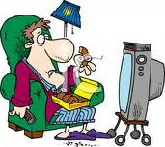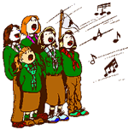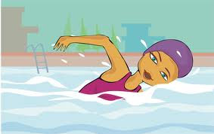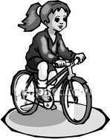

He is ……………….. They are …………… She is………………… We are ……………….. She is……………….

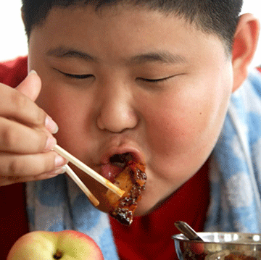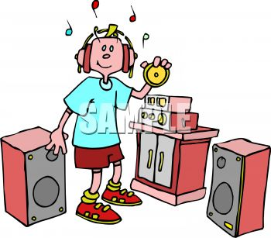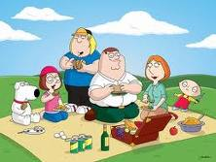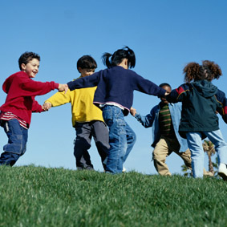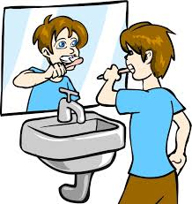

He is ……………… She is……………………… They are ……………. The kids are…………. He is………………….

**F)) Boşlukları parantez içinde verilen sıfatların “comperative” haliyle doldurunuz.10P**

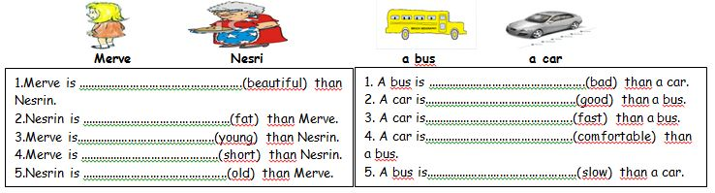

**5- Boşluğa hangi sıklık zarfı gelmelidir?**

*Ali is …………%100…………………. has breakfast.*

a) never b) seldom c) sometimes d) always

---------------------------------------------------------------

*6- I drink …………………….. every day.*

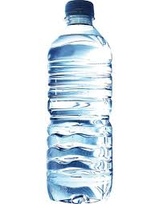

---------------------------------------------------------------

**7- Diyalogdaki soru ne olmalıdır?**

Ali: ………………………?

Murat: It is ten o’clock.

---------------------------------------------------------------

**8- Saatin okunuşu nasıldır?**

---------------------------------------------------------------

**H)) Boşluklara “a” ya da “an” yazınız.10P**

1- ………..olive 6-………..carrot

2- ………..cucumber 7-………..orange

3-……….. tomato 8-………..pepper

4-……….. apple 9-……….. egg

5-………..avocado 10-………..potato



**G)) TEST SORULARI 3x8:24P**

**Soruları resim ve cümlelere göre cevaplayınız.**

*1- The beach is …………………………than the swimming pool. There are hundreds of people.*

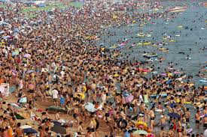 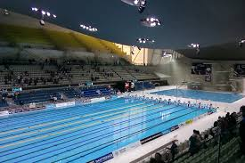

beach swimming pool

a) more expensive c) more handsome

b) more crowded d) more scared

---------------------------------------------------------------

*2- There are ……………………..people in the street.*

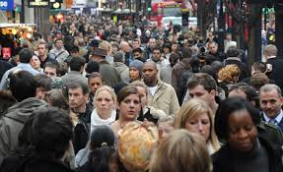

---------------------------------------------------------------

*3- The plane is…………………than the train.*

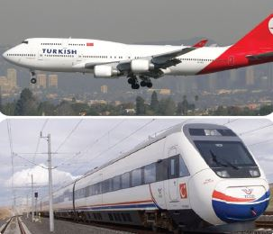

**4- Bu soruyu yukarıdaki resme göre cevaplayınız.**

*The train is …………..than the plane.*

a) more handsome b) thinner c) shorter d) slower

a) a bottle of water c) a cup of tea

b) a can of coke a) a glass of milk

a) It is five o’clock c) It’s half past five.

b) It’s quarter past five. d) It is nine.

**05:30**

a) What is this?

b) What is the time?

c) What is your name?

d) What are you doing?

a) longer

b) shorter

c) faster

d) fatter

a) a lot of

b) little

c) few

d) no