…………… EDUCATION YEAR NAMIK KEMAL SECONDARY SCHOOL 7th GRADE 1st TERM 2nd WRITTEN ENGLISH EXAM

Name-Surname: Number: Class: 7/ Mark:

A. Choose the correct option. (Doğru seçeneği işaretleyiniz.)

1) My favorite sport is _______
- Scuba Diving
- Climbing
- Scuba diving
- Cycling
GOOD LUCK!
Yasemin KARATEPE
ENGLISH TEACHER

2) Batın: What is she doing?
Emrah: __________.
- She is swimming.
- She swims everyday.
- He swam yesterday.
- I am swimming.

3) Toprak: Where was Aziz Sancar born?
Fidan: _____________.
- in 1945 B) on Friday
C) in Mardin D) Twice a week

4) Emin is ………………. He always tells the truth.
A) Fatter B) Taller
C) Uglier D) Thinner
- Generous B) Clumsy
C) Honest D) Forgetful

5) I ………… eat Sushi because i love it!
A) Usually B) Twice a year
C) Never D) Rarely
- Golf Team Sport
- Table tennis Indoor sport
- Skiing Outdoor Sport
- Football Team sport

6) Ali: _____ you hardworking last year?
Mehmet: No, I _______
- Was / wasn’t B) Weren’t / was
C) Were / wasn’t D) Were / weren’t
A)
Spectators
C)

7)
(7.ve 8. Soruları paragrafa göre cevaplayınız.)
My name is Gareth Bale .I live in Madrid. I always get up early every morning and have breakfast. Then, I usually have a training.But last week, I had an accident and injured my leg, so I can’t go out now. I am at home and I feel really bored.

7) Where does he live ?
- He lives in Germany.
- He lives in Barcelona.
- He moved to Berlin last year.
- He lives in Madrid.

8) Why can’t he go out ?
- Because he had an accident.
- He usually has breakfast.
- No, he can’t.
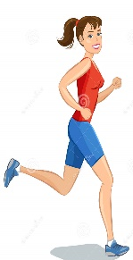
- He is very hardworking player.
9) Özge is __________ than Ali because she always eats healthy food does exercises everyday.

10) Hangi eşleştirme yanlıştır?
11) Resim ve eşleştirmelerden hangisi yanlıştır?
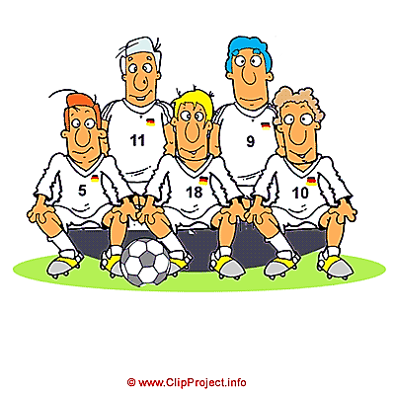
isi yanlıştır? Team
Team
D)
B)
Equipments
C.
Cup
12) How often does Neymar train?
He trains _________.
- Last week B) five days in a week
C) In Barcelona D) yesterday

13) _________________?
He is very generous and helpful.
- How old is your new English teacher?
- What does he look like?
- What is he like?
- What does he do in his free time?

14) Marie Curie _______ the element “radium” with her team and ______ two Nobel Prizes.
A) discover / won B) discovers / wins
C) discovered / win D) discovered / won
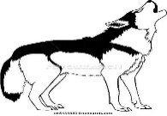
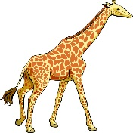
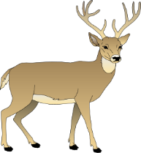
15) Hayvanların doğru sıralanışı nasıldır?
- Deer – Giraffe – Snake – Wolf
- Snake - Giraffe – Wolf - Deer
- Snake – Wolf – Giraffe – Deer
- Giraffe – Snake – Deer - Wolf

16) She ______ a hardworking student last year,
but she _______ hardworking now.

A) Were / are B) Weren’t / are C) Wasn’t / is D) is / wasn’t

17) Selma and Murat _______ last Sunday.
A) got married B) raised children
C) grew up D) moved

18)
18) Zeliha: ______ do tigers live?
Ayşe: They _____ in Asia.
A) What / lived B) Where / live C) Where / lives D) Which/ Live

A) What / lived B) Where / live
19) My wife _________ cook chicken last night.
She __________ meat.
A) doesn’t / cooks B) didn’t / cooked
C) wasn’t / cooked D) didn’t / cook

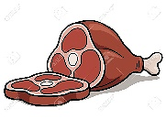
My wife _________ cook chicken last night.

Teacher of English Language
20)

- Chelsea is winning
- Beşiktaş is losing.
- It is a draw..
- Beşiktaş is winning

Beşiktaş 2
Chelsea 1

Which date is it? The fifth of June 1975

21)
- 15th June nineteen seventy three
- 5th June one thousand nine hundred seventy five
- 5th June nineteen seventy five
- 15th June ninety seventy five

22) My dad has curly ____ and ____.
A) hair / glasses
B) eyes / a beard
C) hair / a moustache
D) eyes / glasses

23) I need a ___.I want to play tennis.
A) glove B) helmet C) racket D)bat

24) When was Röntgen born?
A) He was born in Germany. B) He was born in 1845.
C) He died in 1923 D)No,he didn’t.

25) I ______ to shopping mall and l ______ new t-shirt yesterday.
- flew / came
- went / cried
- went / bought
- drank / slept

