GÜVERCİNLİK ŞEHİT HASAN GÜLHAN VOCATIONAL and TECHNICAL ANATOLIAN HIGH SCHOOL
2018-2019 ACADEMIC YEAR 1st TERM PRACTICE EXAM FOR 11th GRADES
Name-Surname: TOTAL:
Number:
Class:

- LISTENING
- Do this exercise while you listen. Which six activities do the speakers say they are going to do? Tick (✓) all the correct answers. (4x1=4 pts)

…………. snowboarding
…………. dirtboarding
…………. canyoning
…………. bungee jumping
…………. go up the Eiffel Tower
…………. visit Notre Dame cathedral
…………. visit the old parts of the city
…………. go round the Louvre
…………. go to the Musée D’Orsay
…………. visit Montmartre and look at the views

- Choose the correct option to complete the sentences.(8x2=16 pts)
- A dirtboard is ................................
- a board with wheels that you stand on.
- a board with no wheels that you stand on.
- a board that you sit on.

- To go canyoning you need ................................
- ropes and a helmet.
- a guide and special equipment.
- ropes and special equipment.

- Zip-wiring is ................................
- scary and difficult.
- easy and exciting.
- scary but exciting.

- Paris looks so beautiful ................................
- at night.
- on television.
- in the photos.

- The Impressionist paintings are in ......................
- the Louvre.
- the Musée D'Orsay.
- the Rodin Museum.

- The famous Rodin statue is called ....................
- The Worker.
- The Thinker.
- The Philosopher.

- The girl is going to Paris for ................................
- the weekend.
- 4 days.
- 5 days.

- She's going with ................................
- her friend.
- her boyfriend.
- her family.

- VOCABULARY
An app developer | An entrepreneur | A software engineer | A biotechnologist | An orthodontist
- Read the statements and complete them with the jobs. (5x2=10 pts)

- ..................................works in a lab and uses living organisms to produce drugs or other products.
- ................................... cures dental problems.
- .................................... writes and develops computer programmes.
- ..................................... starts business by taking risks to find a new opportunity.
- ..................................... designs applications for smart phones.
- READING
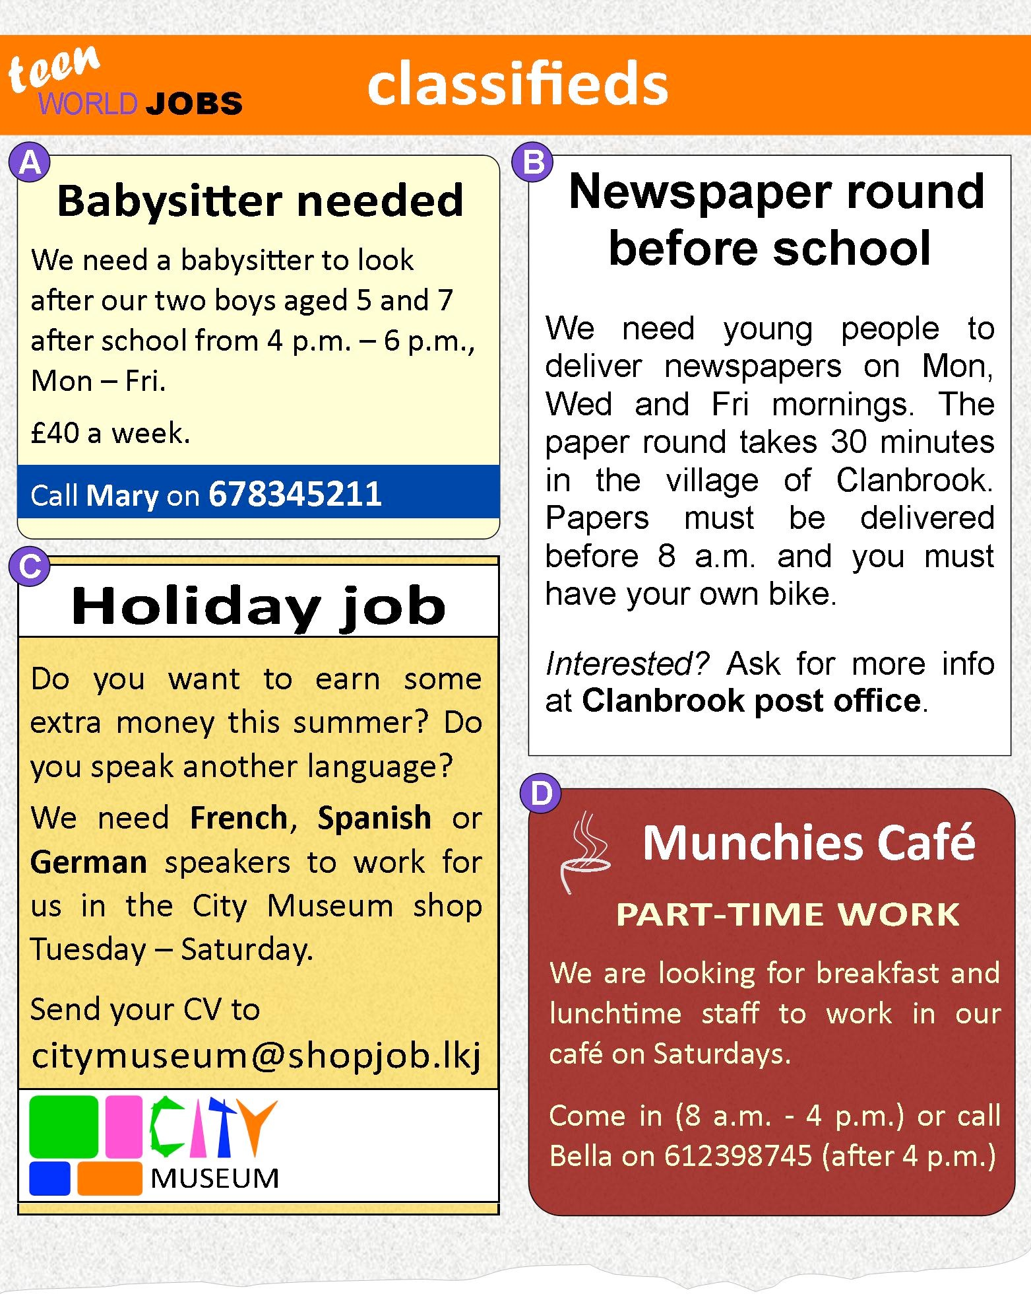
- Match the adverts with the job descriptions. (4x1=4 pts)
- _____advert A a. Working in a shop.
- _____advert B b. Working in a small restaurant
- _____advert C c. Delivering newspapers.
- _____advert D d. Looking after children.

- Answer the questions. ( question 1,2,3,4 2 pts question 5 3 pts)
- In which job do you have to work after school?
- In which job do you have to start work before 8 a.m.?
- In which job do you need to speak a foreign language?
- In which job do you only work during the summer holidays?
- In which job do you have to work for 2 hours every day after school? (3 pts)

- WRITING
- Write a paragraph about your interests and hobbies. (25 pts)

- SPEAKING
 |  | CONTENT | ORGANIZATION | VOCABULARY | FLUENCY | ACCURACY | TOTAL
1
2
3
4
5
6
7
8
9
10
11
12
13
14
15
16
17
18
19
20
21
22
23
24
25
26
- Talk about summer holiday plans (5x5=25 pts)

