EDUCATIONAL YEAR SECONDARY SCHOOL
1st TERM 2nd ELECTIVE ENGLISH EXAM FOR 7th GRADES
NAME/SURNAME: NUMBER: CLASS:
- Verilen sporları kategorilendiriniz. (10X2=20)
Individual Sports | Team Sports
- cycling
- athletics
- volleyball
- football
- scuba-diving
- basketball
- tennis
- swimming
- gymnastics
- rugby

B) Categorize the sports correctly.(Sporları doğru alana yazınız.) (8x2: 16.)
Running - Yoga - Basketball - Baseball - Tennis - Football - Hiking - Volleyball

INDIVIDUAL SPORTS: _______________ _______________ _______________ ________________
TEAM SPORTS: _______________ ________________ _________________ _________________
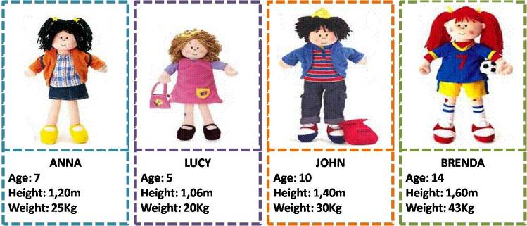
C). Tabloya bakınız ve cümleleri “True” ya da “False” olarak işaretleyiniz.(10x1=10 )

1. John is older than Anna. ______ 6. John is thinner than Anna._______
2. Anna is younger than Lucy._____ 7. Brenda is thinner than John.______
3. Brenda is younger than Lucy.____ 8. Anna is fatter than Lucy._________
4. John is shorter than Brenda.____ 9. John is taller than Brenda. _______
5. Anna is younger than Brenda.____ 10. Anna is shorter than Lucy. ______
- Boşlukları “should” ya da “shouldn’t” ile doldurunuz. (10X1=10)

- We ____________ feed birds.
- We ____________ overhunt animals.
- We ____________ provide shelter for animals.
- We ____________ protect the animals.
- We ____________ use chemicals.
- We ____________ stop wearing fur.
- We ____________ cut down trees.
- We ____________ hurt animals.

- We ____________ donate and work for wildlife.
- We ____________ provide water for animals.
E)Write the names of the wild animals(Vahşi hayvanların ismini doğru resmin altına yazınız.) (12x2=24.)
wolf - snake - crocodile - deer - tiger - giraffe - rhinoceros - lion - monkey - zebra - elephant - turtle

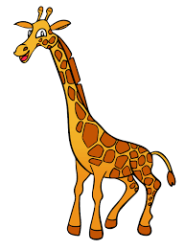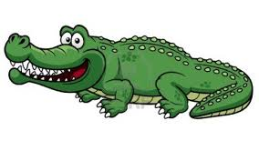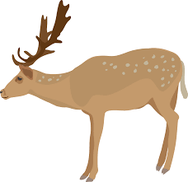
_____________ _______________ _______________ _______________ _______________ _____________
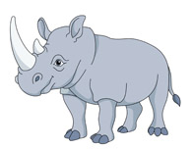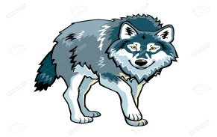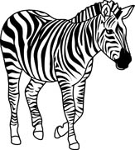
_____________ _______________ ________________ ______________ _______________ ______________
- Kelimeleri Türkçe anlamlarıyla eşleştiriniz.(10x2=20)
A | KORUMAK
B | VAHŞİ
C | TEHLİKE ALTINDA
D | BESLEMEK
E | NESLİ TÜKENMİŞ
F | AŞIRI AVLANMA
G | KÜRK
H | DOĞAL YAŞAM ALANI
I | BELGESEL
İ | EVCİLLEŞTİRİLMİŞ
HABİTAT
ENDANGERED
DOCUMENTARY
EXTINCT
FEED
DOMESTICATED
WILD
OVERHUNT
PROTECT
FUR

GOOD LUCK!

