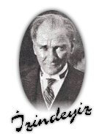

Name:………………………………… Surname:…………………………… Class:……………………………….

Number:………………………

Score:

**EZİNE GAZİ SECONDARY SCHOOL 2014-2015 EDUCATION YEAR 1st TERM 8th CLASSES ENGLISH LESSON 3rd EXAM QUESTIONS**

**B) Boşlukları**  “**too” ya da “enough” ile doldurunuz. (10p)**

1-He is ...................old to play football .

2- I am fine ………………. to go out with my friends. I am not ill.

3-My face is clean ................ to apply this cream.

4-The room is .............cold. I’ll close all the windows.

5-I don’t have ………………… time to go to cinema withyou.

**A) Aşağıdaki hikaye resimleriyle yandaki kelimeleri eşleştiriniz.(9P)**

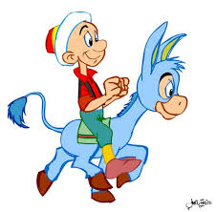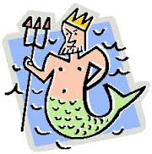

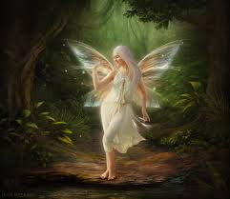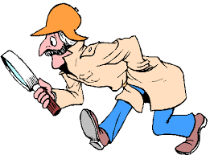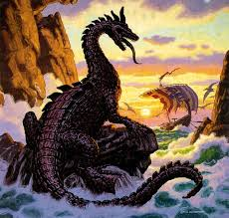

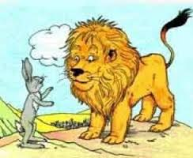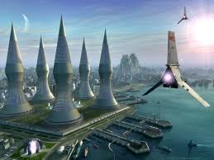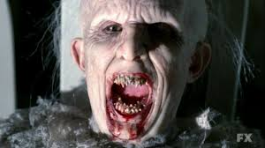

**1- fairy tale**

**2- folk tale**

**3- fabl**

**4- science fiction**

**5- legend**

**6- horror story**

**7- detective story**

**8- myth**

**9- love story**

**C) Aşağıdaki kelimeleri uygun resmin altına yazınız.12P**

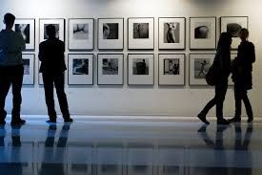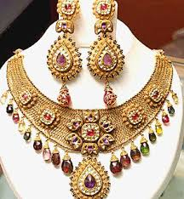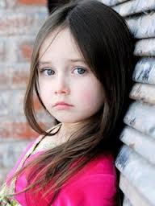

----------------------- ---------------------- ---------------------- ------------------ ------------------- -----------------------

footprints /// fingerprints /// cute /// exhibition /// jewellery /// robber

**D) Cümlelerin içindeki altı çizili kelime gruplarında doğru olanları yuvarlak içine alınız.(12p)**

1.When I ***saw / was seeing*** them, they ***walked / were walking*** to the home.

2.While I ***talked / was talking*** to him, my mother ***came / was coming*** into my room.

3.I  ***stopped / was stopped*** in the middle of the road while my sister ***ran / was running*.**

4.I ***drove / was driving*** to İnegöl when I ***crashed / was crashing*** car.

5.While they ***slept / were sleeping*,**the phone bell ***rang / was ringing*.**

6. When it ***started/was starting*** to rain, we ***played/were playing*** outside.

**E) İlk 5 soruda verilen tarihlerin okunuşlarını bulunuz. 6. soruda ise verilen tarihi yazınız.(12p)**

1. **1923: a)nineteen twenty third b)ninety twenty-three c)nineteen twenty-three**
2. **2001: a)two housand and one b)two double zero one c)twenty one**
3. **12th May: a)twelve of May b)twenty of May c)twelfth of May**
4. **1909: a)ninety nine b)nineteen oh nine c)nineteen ninety**
5. **1578: a) fifteen seventy eight b)one five seven eight c) fifty seventy eight**
6. **1st April, 1998: ……………………………………,………………………………………………………………………**

**Aşağıdaki 3soruda resimlere göre boşluklara ne gelir?**

***9) If you …………………………… in your dream, this means that you will make new friends.***

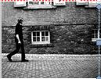

--------------------------------------------------------------

***10) Necati learns easily by watching his teachers. He is a .................................... .***

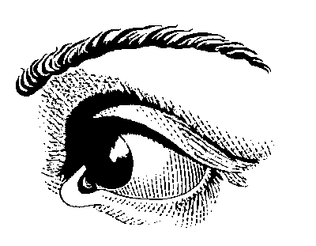

--------------------------------------------------------------

**11) I could ……………. when I was one year old.**

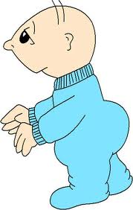

--------------------------------------------------------------

**12) Soru işaretli yere hangi kelime gelmelidir?**

**Adjective- Adverb**

**careful - carefully**

**slow – slowly**

**fast – fast**

**good -………?.......**

--------------------------------------------------------------

**13) Emel kişilik ile ilgili sıfatları düşünürken 4. sü aklına gelmemiştir. Sizce hangisi olur?**

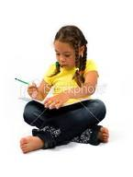

a) tall b) beautiful c) fat d) helpful

--------------------------------------------------------------

**14) Aşağıdaki listenin başlığı nedir?**

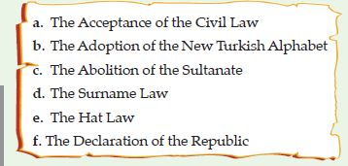

--------------------------------------------------------------

**15) Boşluğa resme göre ne gelmelidir?**

**Mustafa Kemal Atatürk ……………… on 19th May, 1919.**

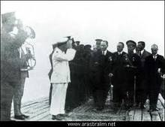

**PREPARED BY ……………..**

**I WISH YOU GOOD LUCK!**

**1) *Wendy got surprised and shocked when she saw birthday party.***

**Wendy bu durumda hangi sözü söylemiş olamaz?**



--------------------------------------------------------------

**Sıradaki beş soruda boşluklara ne gelmelidir?**

**2) Martin: *When is the Republic Day in Turkey?***

**Murat: *It is on ………………………….***

1. 29th October c) 23rd April

b) 19th May d) 10th November

--------------------------------------------------------------

***3) Mark: When is the ………………………in Turkey?***

***Melek: It is on 30th August.***

a) Children’s Day c) Youth and Sports Day

b) Labour Day d) Victory Day

--------------------------------------------------------------

***4)*** ***You should ………………………….. every day.***

--------------------------------------------------------------

***5) Stifler is a funny kid. He always makes jokes and smiles. I can say he .....................*** 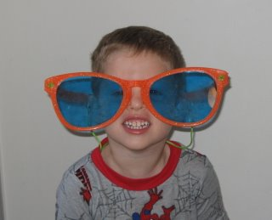

--------------------------------------------------------------

***6)*** ***M.Kemal Atatürk is ……………..of Turkish Republic.***

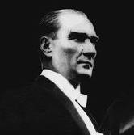

--------------------------------------------------------------

**7) Resme göre ne diyebiliriz?**

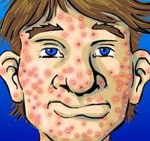

--------------------------------------------------------------

**8) Selim - A true friend should be helpful.**

**Sinem – A true friend should be honest.**

**Hikmet - A true freind should be selfish.**

**Yukarıda 3 kişi arkadaşlıkla ilgili fikirlerini belirtmiştir. Hangisi ya da hangilerinin fikirleri yanlıştır?**

a) Sadece Selim c) Sadece Hikmet

b) Selim ve Sinem d) Selim ve Hikmet

**F- MULTIPLE COICE QUESTIONS 15x3:45 P**

a) Oh my God!

b) See you later!

c) Incredible. You are joking.

d) Good heavens!

-

a) sing in the rain

b) walk alone in the street

c) win a lottery

d) fly in the sky

a) visual learner

b) kinesthetic learner

c) autidory learner

d) musical learner

a) read c) drive

b) fly d) walk

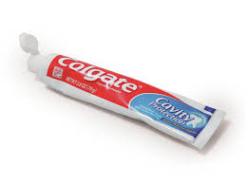

a) use perfume c) buy soap

b) use toothpaste d) take gel

1. good
2. goodly
3. well
4. better

a) has a good sense of humour.

b) is honest.

c) is reliable.

d) is very shy.

a) independence c) founder

b) teacher d) writer

a) Reforms of Atatürk

b) Principles of Atatürk

c) Life of Atatürk

d) Academic Life of Atatürk

a) Rıza has a tooth problem.

b) Rıza has acne problem.

c) Rıza has hair problem.

d) Rıza has a homework

a) founded Turkish Republic

b) opened TBMM.

c) landed in Samsun.

d) was born