2017-2018 EDUCATIONAL YEAR
TEVFİK İLERİ İMAMHATİP SECONDARY SCHOOL
8TH GRADES 1ST TERM 1ST ENGLISH EXAM
POİNT:
NAME:
SURNAME:
NUMBER:2

A)Aşağıdaki cümleleri yandaki kutulara gore gruplandırarak kutuların içine sayıları yazınız. (10x1=10 puan)
- That would be great.
ACCEPTING

REFUSING

INVITATION

- I’m sorry but I can’t.
- Would you like to join our party?
- Yes, I would.
- Sorry, I am going to study for the exam.
- Would you like to play soccer?
- Shall we dance?
- Sorry, but I’m busy then.
- I’d really love to.
- What about playing tennis together?
B )Kelimeleri eş anlamlarıyla eşleştirin (9x2=18) C) Aşağıda verilen kelimeleri uygun
1. rely on (……..) | a. for sure
2. relaxed (……..) | b. buddy, a friend
3. back up (……..) | c. laid-back
4. sleepover (……..) | d. really good
5. get (……..) | e. buy
6. mate (……..) | f. count on, trust
7. get on well (……..) | g. support, help someone
8. definitely (……..) | h. pyjamas party
9. awesome (……..) | i. have a good relationship
boşluklara yazınız.(7x2=14) .

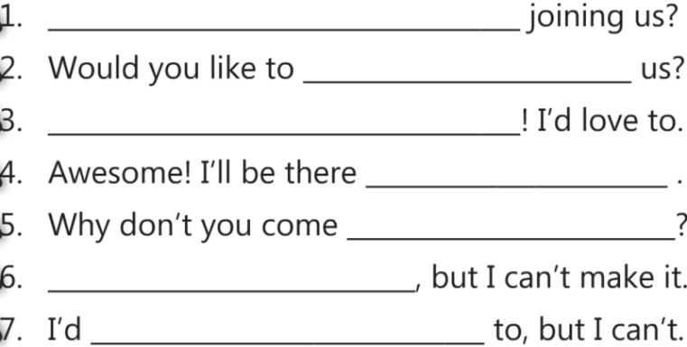

D)Boşlukları uygun kelimelerle doldurun.(10x1=10)
“do /have / wear /hang / go / try /chat /help / surf / play”
1. ____________ out with friends 6. ____________ online
2. ____________ to bed 7. ____________ computer games
3. ___________ the washing up 8. ____________ a uniform
4. ____________ barbecue party 9. ____________ the parents
5. ____________ the net 10. ____________ on
E)Aşağıdaki cümlelerdeki altı çizili olan kelimelerden doğru olanını yuvarlak içine alınız.(4x1=4)
1. Sandy always says that romances are boring. I don't think she like / likes them.
2. They are going to have / had a picnic at Central Park tomorrow.
3. She prefer cycle / cycling to the riverside every day.
4. Would you like to coming / come over for dinner.

F) Tabloya göre cümleler doğruysa True yanlışsa False yazınız. (5x1=5)
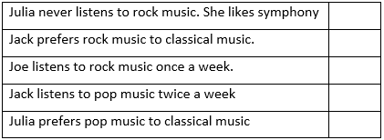
Aşağıdaki tablo Jack Julia ve Joe’ nun haftada kaç gün hangi müzik türünü tercih ettikleri hakkında bilgi verir.
 | POP MUSIC | ROCK MUSIC | CLASSICAL MUSIC
JACK | 2days | 5days | 0
JOE | 3days | 3days | 1day
JULIA | 3days | 0 | 4days
G)Aşağıdaki daveti okuyun ve sorulari tam cümle yazarak cevaplayinız.(6x2=12)

1.Who is the sender? 4.Where is the event?
2.Who is the reciever? 5. When is the event?
3.What is the event? 6. What time is the event?
H) Fill in the blanks with the words below. (5x1=5 puan)
Count on get on well with back up best secrets
Esma is my friend. I can always her. She never tells my to anyone, always trust

her. She also me , and I always support her. I with her.

I)Sorularla cevaplari eslestirin(6x2=12)
-------1.What is she eating? a)I brush my teeth twice a day.
-------2.What kind of music do you prefer? b)Im going to go to Paris next week.
-------3.How often do you brush your teeth? c)She is eating chicken.
-------4.When are you going to go to Paris? d)I prefer rock music.
-------5.What time does she sleep? e)Because I love books.
-------6.Why do you read books? f) She sleeps at ten
J)Kelimelerin Türkçe karşılıklarını yazınız.(10x1=10)
1) unbearable
2) accept
3) tournament
4) disadvantage
5) hang out
6) self-conscious
7) ridiculous
8)neighbourhood
9) serious
10) impressive

