[](http://www.google.com.pe/imgres?q=PICTURE+FOR+COLORING+ABOUT+A+CHICK&um=1&hl=es&sa=N&rlz=1W1AURU_esPE499&biw=1024&bih=641&tbm=isch&tbnid=VWq4wYxXi4zrcM:&imgrefurl=http://eastercolouring.blogspot.com/2011/02/cute-easter-chick-colouring-in-sheet.html&docid=R1rhMazoddZ-VM&imgurl=http://4.bp.blogspot.com/_Kh0CZuWd0T8/TU0eZ9KCTnI/AAAAAAAAJhQ/7oK3xPaBJ2M/s1600/chick+coloring+page.jpg&w=494&h=674&ei=e3hKUMqgHsLl0QGvh4HwBQ&zoom=1&iact=hc&vpx=789&vpy=247&dur=485&hovh=262&hovw=192&tx=101&ty=149&sig=117405430092150629177&page=3&tbnh=151&tbnw=107&start=44&ndsp=22&ved=1t:429,r:15,s:44,i:259)

**WORKSHEET N°7**

NAME: __________________________________________

TEACHERS: MEDALID CASTRO/GIANNINA GAMBINI VIVAR

SCORE

* 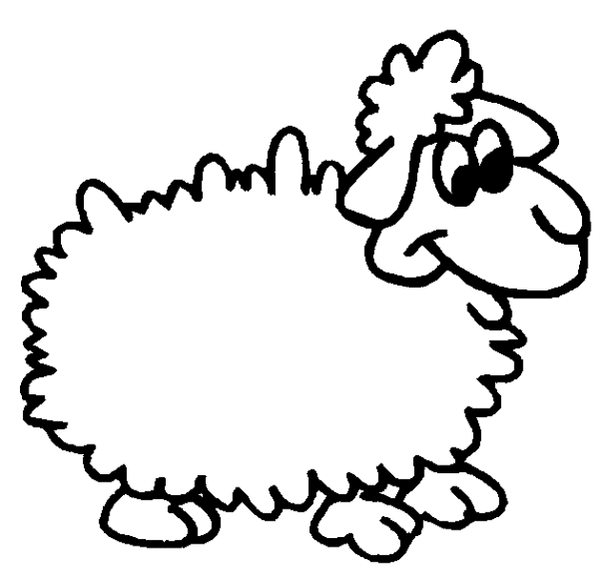Identify the correct pets and stick cotton over them.

[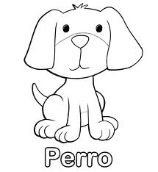](http://www.google.com.pe/imgres?q=dibujo+para+colorear+de+un+perro&um=1&hl=es&sa=G&rlz=1W1AURU_esPE499&biw=1024&bih=642&tbm=isch&tbnid=UXnfGvpzgNP1wM:&imgrefurl=http://www.vivajuegos.com/dibujos-de-animales/colorear-dibujo-de-perro.html&imgurl=http://www.vivajuegos.com/dibujos/colorear-dibujo-de-perro.gif&w=505&h=550&ei=WuE_UKjIMqqu6gG3yYBA&zoom=1&iact=hc&vpx=190&vpy=156&dur=1499&hovh=234&hovw=215&tx=131&ty=131&sig=117405430092150629177&page=1&tbnh=123&tbnw=110&start=0&ndsp=21&ved=1t:429,r:1,s:0,i:139)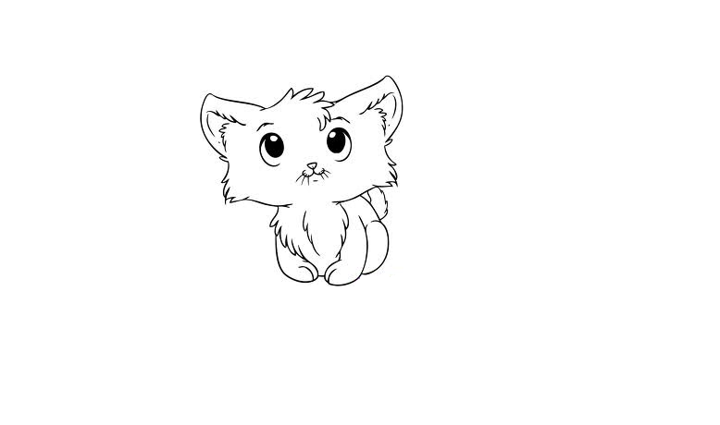

**HOMEWORK N°7**

* **COLOR THE PETS AND WRITE THEIR NAMES GOING OVER THE LETTERS WITH PENCIL.**

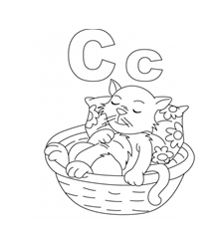[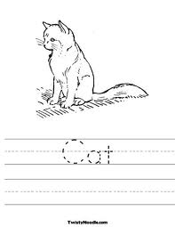](http://www.google.com.pe/imgres?q=handwriting+worksheets+about+A+CAT&um=1&hl=es&sa=G&rlz=1R2AURU_esPE499&biw=1024&bih=641&tbm=isch&tbnid=8RtyCp8bYxV-HM:&imgrefurl=http://twistynoodle.com/cat-3-worksheet/&docid=A2romA0OSqetWM&imgurl=http://twistynoodle.com/media/img/r/cat-3/cat-3/cat-3_worksheet_jpg_468x609_q85.jpg&w=468&h=605&ei=kltKUP7yIIbo9ATTyYCoBA&zoom=1&iact=hc&vpx=512&vpy=50&dur=751&hovh=255&hovw=197&tx=104&ty=129&sig=117405430092150629177&page=1&tbnh=132&tbnw=102&start=0&ndsp=19&ved=1t:429,r:3,s:0,i:79)

