**Meyveleri tamamlayın ve İngilizce olarak yazınız.**

**Apple / Orange / Strawberry / Grapes / Banana / Watermelon / Peach / Melon**

**7)**

**8)**

**6)**

**5**

**3)**

**4)**

**2)**

**1)**

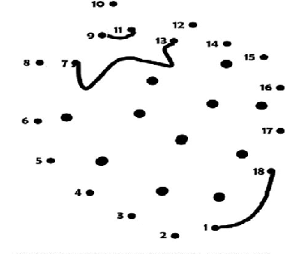

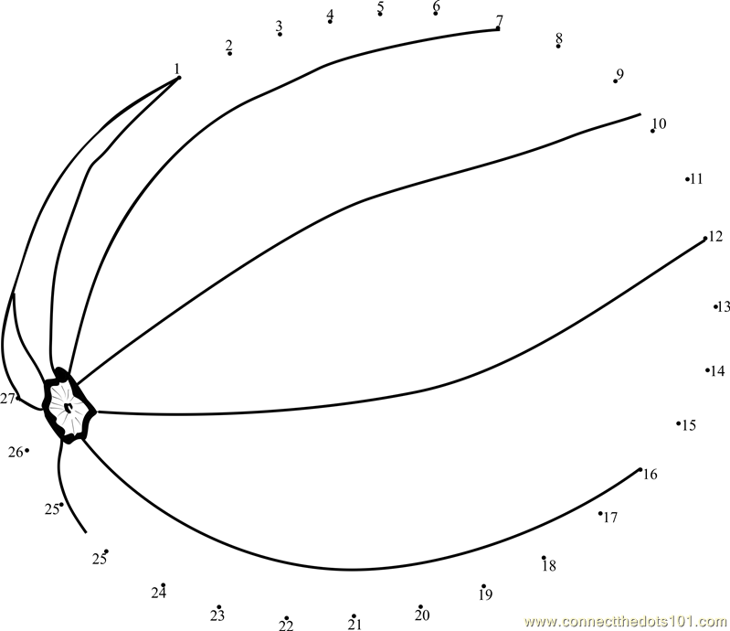



[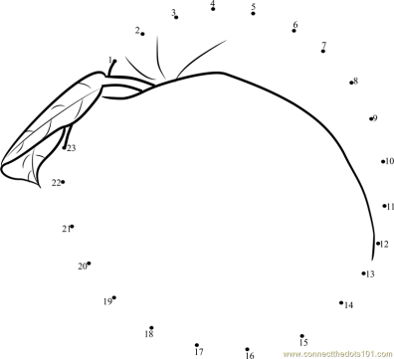](http://www.google.com.tr/url?sa=i&rct=j&q=&esrc=s&frm=1&source=images&cd=&cad=rja&uact=8&docid=q1NGyVmbaXvceM&tbnid=ew0xeH_ZzBT4uM:&ved=0CAUQjRw&url=http://connectthedots101.com/connect_the_dot/id_1224/Nectarine/Nectarine_Peach&ei=QGI0U-LUFIfX0QXP_4HQBw&psig=AFQjCNGvFXFCBa6ovJIoxNOhZPgjM82mFQ&ust=1396028308148065)

