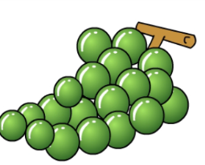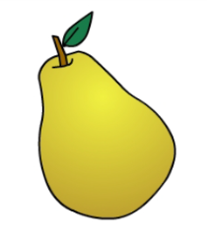

**a**. I like grapes.

**b**. I don’t like strawberry.

**c**. I don’t like grapes.

**a**. I like pear

**b**. I like lemon

**c**. I don’t like pear



**a**. I like strawberry.

**b**. I like watermelon.

**c**. I don’t like watermelon.

**a**. I like pear.

**b**. I like orange.

**c**. I don’t like orange.

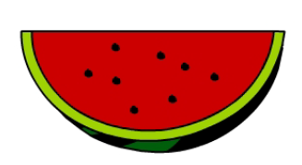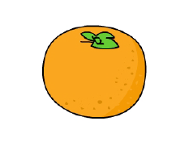

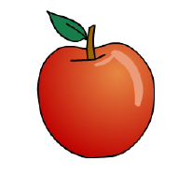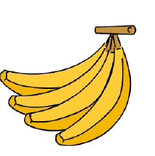

**a**. I like pear.

**b**. I like apple.

**c**. I don’t like apple.

**a**. I don’t like banana.

**b**. I like banana.

**c**. I don’t like apple.



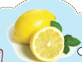

**a**. I like strawberry.

**b**. I don’t like watermelon.

**c**. I don’t like strawberry.

**a**. I like pear.

**b**. I like lemon.

**c**. I don’t like lemon.

