WEATHER AND EMOTİONS

SNOWY

[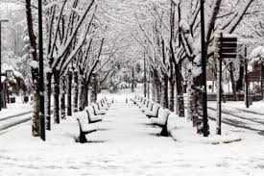](https://www.google.com.tr/imgres?imgurl=http://www.haberexen.com/d/other/bursadan-kar-manzaralari-IHA-20130109AW000469-6-t.jpg&imgrefurl=http://www.haberexen.com/bursadan-kar-manzaralari-206578h.htm&h=313&w=470&tbnid=qcPf5oWwjR5_iM:&docid=pLPKWk2EVgB0bM&ei=JSKdVtSQK8HksgGXzYfgCw&tbm=isch&ved=0ahUKEwiUt6_S8rPKAhVBsiwKHZfmAbw4ZBAzCBQoETAR)

RAİNY

[](https://www.google.com.tr/imgres?imgurl=http://im.hthayat.com/2013/10/01/ver1398671666/1016779_620x413.jpg&imgrefurl=http://www.hthayat.com/moda/haber/1016779-islevsel-semsiyelerle-yagmurun-keyfini-cikarin&h=413&w=620&tbnid=DRdTf9a9JrqvbM:&docid=ty_j3HK0OiUdYM&ei=ECOdVtrrJsSYsgG20LWADg&tbm=isch&ved=0ahUKEwjas7LC87PKAhVEjCwKHTZoDeAQMwhPKC0wLQ)

WİNDY

[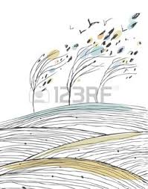](https://www.google.com.tr/imgres?imgurl=http://us.123rf.com/450wm/silm/silm1303/silm130300189/18371838-a%2525C4%25259Fa%2525C3%2525A7lar-ve-alanlar-yaprak-sonbahar-g%2525C3%2525B6r%2525C3%2525BCnt%2525C3%2525BC-r%2525C3%2525BCzgar-ku%2525C5%25259Flar-ya%2525C4%25259Fmur-do%2525C4%25259Fa-resim-ile-sonbahar-man.jpg&imgrefurl=http://tr.123rf.com/photo_18371838_a%25C4%259Fa%25C3%25A7lar-ve-alanlar-yaprak-sonbahar-g%25C3%25B6r%25C3%25BCnt%25C3%25BC-r%25C3%25BCzgar-ku%25C5%259Flar-ya%25C4%259Fmur-do%25C4%259Fa-resim-ile-sonbahar-man.html&h=350&w=275&tbnid=vKQ4R7Lj9XLCcM:&docid=MwN0DFYmCJoYsM&ei=XiOdVrqfF4PnswG10amoCw&tbm=isch&ved=0ahUKEwi6xrvn87PKAhWD8ywKHbVoCrUQMwhVKDMwMw)

FOGGY

[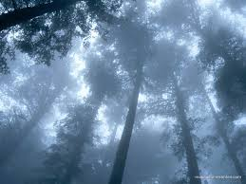](https://www.google.com.tr/imgres?imgurl=http://img03.blogcu.com/images/y/a/p/yaprakhisarli/8d3dc14705eaed1605227c641e71c2c4_1290331071.jpg&imgrefurl=http://yaprakhisarli.blogcu.com/sis-nedir-ve-sis-nasil-olusur/9189496&h=600&w=800&tbnid=MvwD-n81oEPvcM:&docid=OmWxU9KDmuLCVM&ei=VCSdVomoJcKsswGLkqiYDA&tbm=isch&ved=0ahUKEwiJovDc9LPKAhVC1iwKHQsJCsMQMwhUKB0wHQ)

SUNNY

[](http://www.google.com.tr/url?sa=i&rct=j&q=&esrc=s&source=images&cd=&cad=rja&uact=8&ved=&url=http%3A%2F%2Fwww.dreamstime.com%2Fstock-images-hazy-blue-summer-sky-background-image38277124&bvm=bv.112064104,d.bGg&psig=AFQjCNGbiw61m_ongmjESYnt8Ag26MLcrw&ust=1453225784217890)

ÜNİTE KELİMELERİ

