 Finde die Wörter!   
 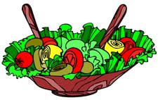 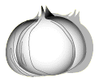



Lebensmittel

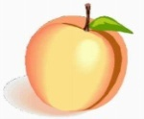 

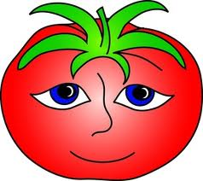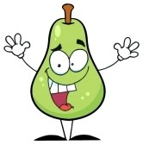



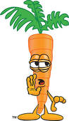

|  |  |  |  |  |  |  |  |  |  |  |  |  |  |  |  |  |  |
| --- | --- | --- | --- | --- | --- | --- | --- | --- | --- | --- | --- | --- | --- | --- | --- | --- | --- |
| **A** | **B** | **R** | **O** | **K** | **K** | **O** | **L** | **I** | **A** | **T** | **O** | **M** | **A** | **T** | **E** | **Y** | **Z** |
| **F** | **R** | **R** | **H** | **R** | **D** | **L** | **N** | **F** | **F** | **O** | **T** | **R** | **A** | **K** | **F** | **K** | **C** |
| **G** | **O** | **J** | **I** | **E** | **N** | **B** | **E** | **X** | **C** | **Z** | **P** | **S** | **I** | **A** | **L** | **N** | **U** |
| **H** | **T** | **W** | **M** | **A** | **I** | **S** | **B** | **Q** | **Ä** | **W** | **J** | **W** | **M** | **R** | **V** | **O** | **Y** |
| **A** | **I** | **H** | **B** | **G** | **F** | **E** | **U** | **D** | **C** | **A** | **I** | **M** | **B** | **O** | **A** | **B** | **M** |
| **M** | **B** | **A** | **E** | **G** | **N** | **A** | **A** | **O** | **J** | **S** | **K** | **I** | **L** | **T** | **M** | **L** | **A** |
| **B** | **L** | **U** | **R** | **P** | **P** | **Ö** | **R** | **O** | **A** | **S** | **A** | **L** | **A** | **T** | **N** | **A** | **R** |
| **U** | **U** | **B** | **E** | **R** | **S** | **I** | **T** | **L** | **P** | **E** | **T** | **C** | **U** | **E** | **İ** | **U** | **M** |
| **R** | **M** | **E** | **E** | **P** | **I** | **L** | **Z** | **I** | **X** | **R** | **Z** | **H** | **Y** | **V** | **Ü** | **C** | **E** |
| **G** | **E** | **R** | **W** | **Z** | **A** | **W** | **N** | **Z** | **B** | **M** | **C** | **O** | **G** | **D** | **K** | **H** | **L** |
| **E** | **N** | **G** | **J** | **I** | **I** | **A** | **H** | **E** | **A** | **E** | **G** | **N** | **U** | **F** | **I** | **E** | **A** |
| **R** | **K** | **I** | **K** | **E** | **T** | **L** | **E** | **R** | **M** | **L** | **N** | **I** | **R** | **O** | **R** | **Ö** | **D** |
| **D** | **O** | **N** | **B** | **Y** | **V** | **N** | **Ü** | **D** | **U** | **O** | **T** | **G** | **K** | **Ä** | **S** | **E** | **E** |
| **P** | **H** | **E** | **Z** | **Ä** | **H** | **Q** | **W** | **B** | **A** | **N** | **A** | **N** | **E** | **S** | **C** | **R** | **P** |
| **F** | **L** | **X** | **Y** | **O** | **Z** | **A** | **B** | **E** | **E** | **E** | **N** | **C** | **D** | **E** | **H** | **F** | **F** |
| **I** | **L** | **L** | **B** | **U** | **T** | **T** | **E** | **R** | **K** | **J** | **A** | **I** | **H** | **P** | **E** | **I** | **G** |
| **R** | **G** | **G** | **I** | **J** | **M** | **N** | **B** | **E** | **O** | **Ö** | **N** | **P** | **P** | **R** | **T** | **S** | **U** |
| **S** | **C** | **B** | **R** | **A** | **Z** | **S** | **Ä** | **E** | **W** | **Q** | **A** | **U** | **F** | **Z** | **Y** | **C** | **Ü** |
| **I** | **D** | **E** | **N** | **F** | **E** | **E** | **F** | **F** | **A** | **K** | **S** | **G** | **H** | **E** | **I** | **H** | **J** |
| **S** | **T** | **Ü** | **E** | **U** | **K** | **O** | **K** | **O** | **S** | **N** | **U** | **S** | **S** | **Y** | **L** | **Z** | **K** |
| **C** | **Ö** | **O** | **M** | **S** | **C** | **H** | **O** | **K** | **O** | **L** | **A** | **D** | **E** | **N** | **S** | **R** | **P** |
| **H** | **Q** | **W** | **X** | **P** | **A** | **P** | **R** | **I** | **K** | **A** | **J** | **Q** | **F** | **X** | **D** | **Ü** | **Y** |

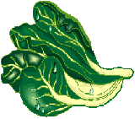





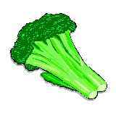



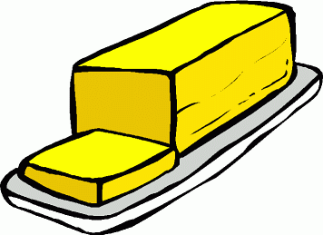



 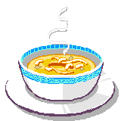 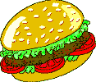 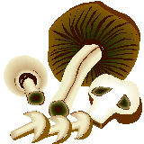





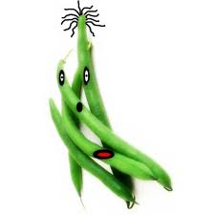



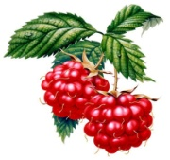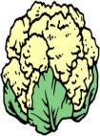 



|  |  |  |  |  |  |  |  |  |  |  |  |  |  |  |  |  |  |
| --- | --- | --- | --- | --- | --- | --- | --- | --- | --- | --- | --- | --- | --- | --- | --- | --- | --- |
| **A** | **B** | **R** | **O** | **K** | **K** | **O** | **L** | **I** | **A** | **T** | **O** | **M** | **A** | **T** | **E** | **Y** | **Z** |
| **F** | **R** | **R** | **H** | **R** | **D** | **L** | **N** | **F** | **F** | **O** | **T** | **R** | **A** | **K** | **F** | **K** | **C** |
| **G** | **O** | **J** | **I** | **E** | **N** | **B** | **E** | **X** | **C** | **Z** | **P** | **S** | **I** | **A** | **L** | **N** | **U** |
| **H** | **T** | **W** | **M** | **A** | **I** | **S** | **B** | **Q** | **Ä** | **W** | **J** | **W** | **M** | **R** | **V** | **O** | **Y** |
| **A** | **I** | **H** | **B** | **G** | **F** | **E** | **U** | **D** | **C** | **A** | **I** | **M** | **B** | **O** | **A** | **B** | **M** |
| **M** | **B** | **A** | **E** | **G** | **N** | **A** | **A** | **O** | **J** | **S** | **K** | **I** | **L** | **T** | **M** | **L** | **A** |
| **B** | **L** | **U** | **R** | **P** | **P** | **Ö** | **R** | **O** | **A** | **S** | **A** | **L** | **A** | **T** | **N** | **A** | **R** |
| **U** | **U** | **B** | **E** | **R** | **S** | **I** | **T** | **L** | **P** | **E** | **T** | **C** | **U** | **E** | **İ** | **U** | **M** |
| **R** | **M** | **E** | **E** | **P** | **I** | **L** | **Z** | **I** | **X** | **R** | **Z** | **H** | **Y** | **V** | **Ü** | **C** | **E** |
| **G** | **E** | **R** | **W** | **Z** | **A** | **W** | **N** | **Z** | **B** | **M** | **C** | **O** | **G** | **D** | **K** | **H** | **L** |
| **E** | **N** | **G** | **J** | **I** | **I** | **A** | **H** | **E** | **A** | **E** | **G** | **N** | **U** | **F** | **I** | **E** | **A** |
| **R** | **K** | **I** | **K** | **E** | **T** | **L** | **E** | **R** | **M** | **L** | **N** | **I** | **R** | **O** | **R** | **Ö** | **D** |
| **D** | **O** | **N** | **B** | **Y** | **V** | **N** | **Ü** | **D** | **U** | **O** | **T** | **G** | **K** | **Ä** | **S** | **E** | **E** |
| **P** | **H** | **E** | **Z** | **Ä** | **H** | **Q** | **W** | **B** | **A** | **N** | **A** | **N** | **E** | **S** | **C** | **R** | **P** |
| **F** | **L** | **X** | **Y** | **O** | **Z** | **A** | **B** | **E** | **E** | **E** | **N** | **C** | **D** | **E** | **H** | **F** | **F** |
| **I** | **L** | **L** | **B** | **U** | **T** | **T** | **E** | **R** | **K** | **J** | **A** | **I** | **H** | **P** | **E** | **I** | **G** |
| **R** | **G** | **G** | **I** | **J** | **M** | **N** | **B** | **E** | **O** | **Ö** | **N** | **P** | **P** | **R** | **T** | **S** | **U** |
| **S** | **C** | **B** | **R** | **A** | **Z** | **S** | **Ä** | **E** | **W** | **Q** | **A** | **U** | **F** | **Z** | **Y** | **C** | **Ü** |
| **I** | **D** | **E** | **N** | **F** | **E** | **E** | **F** | **F** | **A** | **K** | **S** | **G** | **H** | **E** | **I** | **H** | **J** |
| **S** | **T** | **Ü** | **E** | **U** | **K** | **O** | **K** | **O** | **S** | **N** | **U** | **S** | **S** | **Y** | **L** | **Z** | **K** |
| **C** | **Ö** | **O** | **M** | **S** | **C** | **H** | **O** | **K** | **O** | **L** | **A** | **D** | **E** | **N** | **S** | **R** | **P** |
| **H** | **Q** | **W** | **X** | **P** | **A** | **P** | **R** | **I** | **K** | **A** | **J** | **Q** | **F** | **X** | **D** | **Ü** | **Y** |