2

1

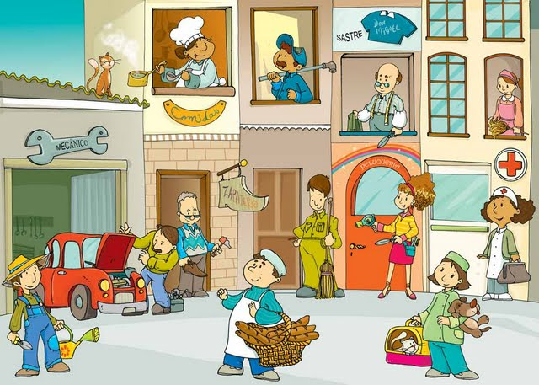

12

11

10

9

8

7

5

5

3

4

**Schreib das richtige Wort für jeden Beruf.**

1. .....................................
2. .....................................
3. ....................................
4. ....................................
5. ....................................
6. ....................................
7. ....................................
8. ....................................
9. ....................................
10. ....................................
11. ....................................
12. .....................................

**Schreib 10 andere Berufe, die du kennst.**

1. .....................................
2. .....................................
3. ....................................
4. ...................................
5. .....................................
6. ....................................
7. ....................................
8. ...................................
9. ....................................
10. ..................................