Diese Leute sind nicht sehr glücklich mit ihrer aktuellen Situation. Stell dir vor, was sie in Zukunft machen werden. Sei originell. Schreib Sätze in der Zukunft.
3.Wenn ich meinen Führerschein habe...
2. Wenn ich wieder zu Hause bin...
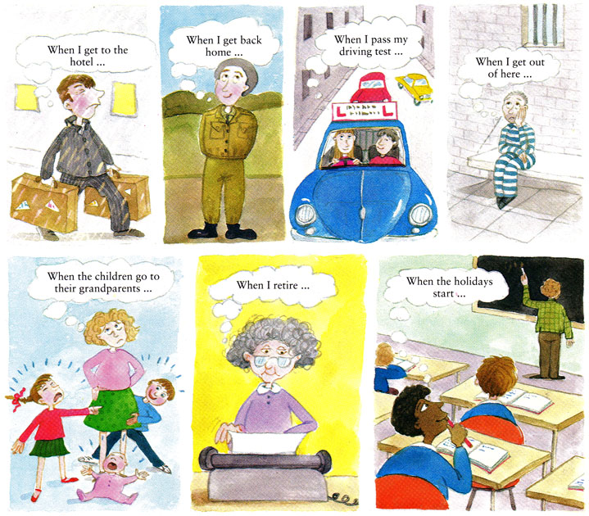
5.Wenn die Kinder zu den Groβeltern gehen...
7.In den Ferien...
1. Wenn ich im Hotel ankomme,....
4.Wenn ich wieder frei bin...
6.Wenn ich in Pension bin...

1.____________________________________________________________________________
_____________________________________________________________________________
2.____________________________________________________________________________
_____________________________________________________________________________
3.____________________________________________________________________________
_____________________________________________________________________________
4.____________________________________________________________________________
_____________________________________________________________________________
5.____________________________________________________________________________
_____________________________________________________________________________
6.____________________________________________________________________________
_____________________________________________________________________________
7. ____________________________________________________________________________
______________________________________________________________________________

