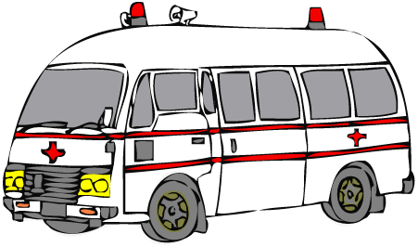



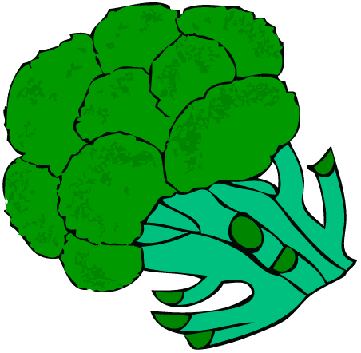

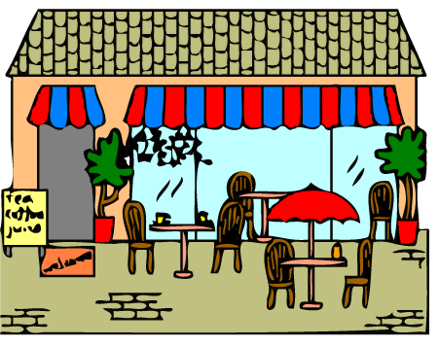



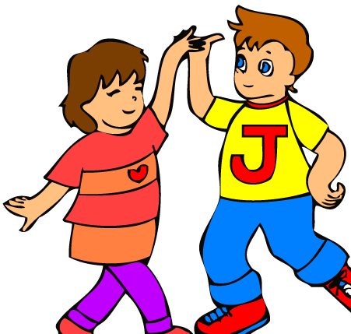



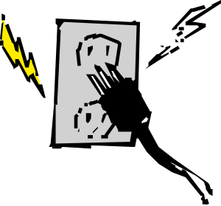

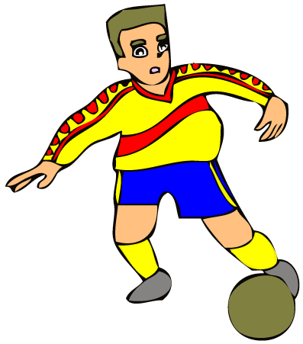

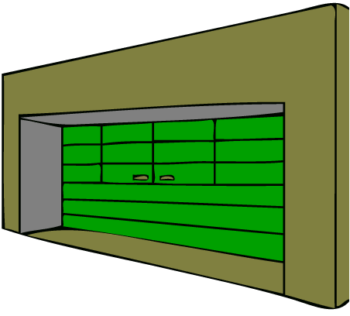





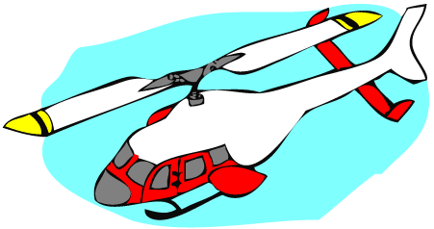





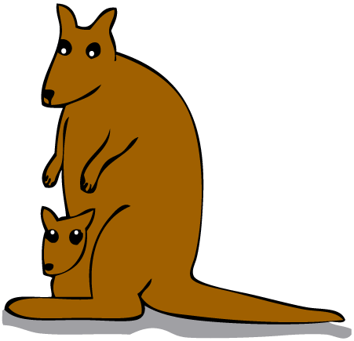

[](http://www.google.com.tr/url?url=http://wondersofdisney.webs.com/pals/minnie/mininternational.htm&rct=j&frm=1&q=&esrc=s&sa=U&ei=Ttu9U6_ZLsm3O77HgfAI&ved=0CDoQ9QEwEw&usg=AFQjCNFPJojfoiArJZ8YzMr73lXYzc3FqA)

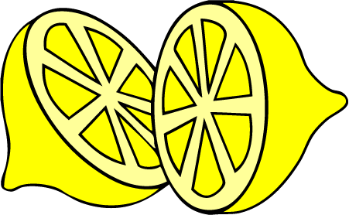



[](http://www.google.com.tr/url?url=http://www.gograph.com/stock-illustration/negative-sign.html&rct=j&frm=1&q=&esrc=s&sa=U&ei=2N-9U66qDomYPevmgKgJ&ved=0CB4Q9QEwBQ&usg=AFQjCNE2InLB6z07Bifj6udAb7GxqKY7Bg)

[](http://www.google.com.tr/url?url=http://becuo.com/children-orchestra-clipart&rct=j&frm=1&q=&esrc=s&sa=U&ei=cwHfU4iDL-OF4gTx6oDgAQ&ved=0CB4Q9QEwBTjIAQ&usg=AFQjCNEbl8wj39v_5UuhinEnGmXWRMgC-A)

[](http://www.google.com.tr/url?url=http://www.clker.com/clipart-oval-4.html&rct=j&frm=1&q=&esrc=s&sa=U&ei=VwLfU_OGDLCL4gS6j4C4Ag&ved=0CBQQ9QEwAA&usg=AFQjCNFD9W2nSA1GGBCbFi1V-4rHe5hdhQ)

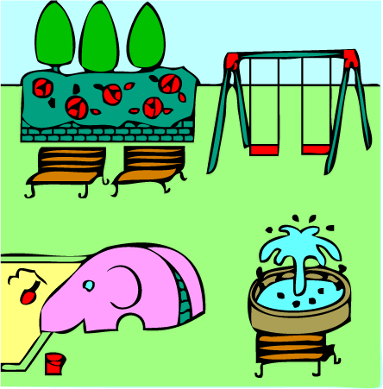

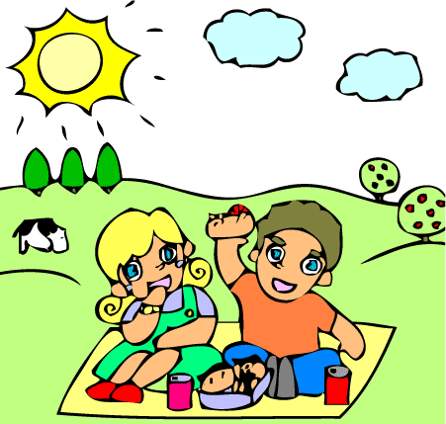

[](http://www.google.com.tr/url?url=http://www.gograph.com/stock-illustration/quiz.html&rct=j&frm=1&q=&esrc=s&sa=U&ei=MQXfU9yHM47U4QT4roGgAw&ved=0CC4Q9QEwDQ&usg=AFQjCNGgvh4PW-sQ06X1EHgnTUXn4LWXvw)





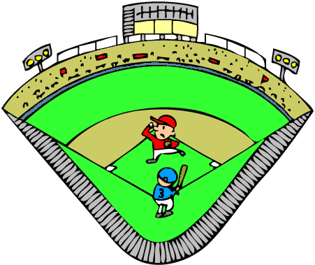

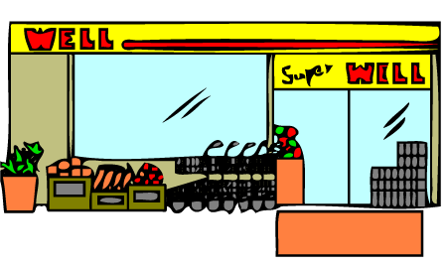







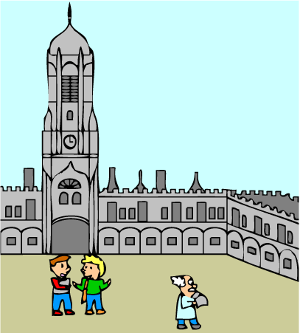

[](http://www.google.com.tr/url?url=http://www.clipartpanda.com/categories/vet-20clipart&rct=j&frm=1&q=&esrc=s&sa=U&ei=rwrfU_79FMb14QTf9YCgAg&ved=0CBYQ9QEwAQ&usg=AFQjCNGQA18bsruNuIRqPUPtNy1CYRDA2g)

[](http://www.google.com.tr/url?url=http://www.clipartbest.com/wagon-clip-art&rct=j&frm=1&q=&esrc=s&sa=U&ei=KgvfU_34IaWG4gTw84CIAg&ved=0CDQQ9QEwEDgU&usg=AFQjCNGe94h5kNAaocS4vLqpnW3omAxZUA)

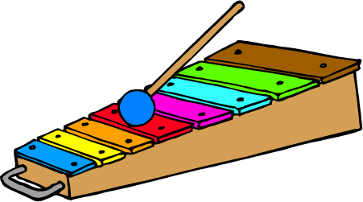

[](http://www.google.com.tr/url?url=http://classroomclipart.com/clipart-view/Clipart/Food/Dairy_Clipart/yogurt_jpg.htm&rct=j&frm=1&q=&esrc=s&sa=U&ei=hwzfU7W9KMXd4QT9l4GQAg&ved=0CBwQ9QEwAw&usg=AFQjCNHBGMo4qCOn6UdZtyRu_AVMEBtDDg)



[www.eegtimim.com](http://www.eegtimim.com)

