Complète les colones avec des phrases.
volley, violon, patinage, tennis, théâtre, batterie, échecs, marche,
basket, jardinage, piano, luge, chant, escalade, boxe, vélo, guitare, ski,
cartes, cinéma, foot, danse, lecture, musée, basket, télé, gymnastique, handball, natation, cuisine, promenades, monuments, monopoly
faire + loisirs  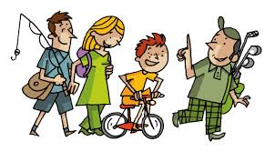 | jouer + sports | jouer + instruments  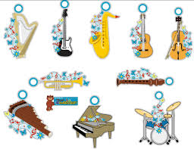
Je fais du volley  ………………………………...........  …………………………………………  …………………………………………  …………………………………………  …………………………………………  …………………………………………  ………………………………...........  ………………………………………… | ………………………………...........  …………………………………………  …………………………………………  …………………………………………  …………………………………………  …………………………………………  ………………………………...........  …………………………………………  ………………………………………… | ………………………………...........  …………………………………………  …………………………………………  …………………………………………  …………………………………………  …………………………………………  ………………………………...........  …………………………………………  …………………………………………
pratiquer + loisirs | aimer, adorer, préférer, détester + loisirs
………………………………...........  …………………………………………  …………………………………………  …………………………………………  …………………………………………  …………………………………………  ………………………………...........  ………………………………………… | ………………………………...........  …………………………………………  …………………………………………  …………………………………………  …………………………………………  …………………………………………  ………………………………...........  ………………………………………… | ………………………………...........  …………………………………………  …………………………………………  …………………………………………  …………………………………………  …………………………………………  ………………………………...........  …………………………………………

