
English – Level I
Name: __________ Surname: __________ Number: ___ Class: ___ Form: ___ Date: _________________________________________________________


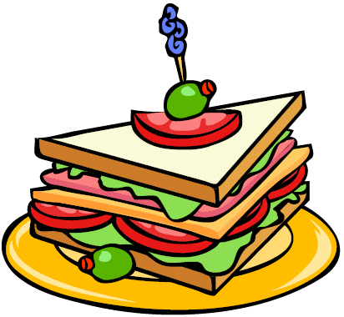
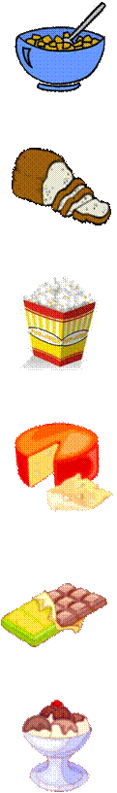
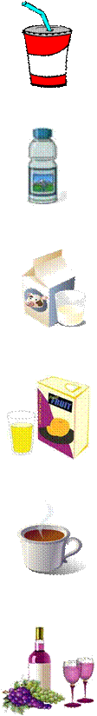
HOT DOG
HAMBURGER
CHEESEBURGER
BREAD
POPCORN
CHEESE
CHOCOLATE
FISH
HAM
EGGS
STEAK
COKE
WATER
MILK
COFFEE
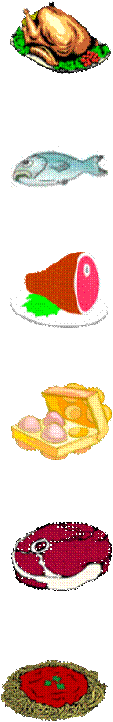

SANDWICH
CEREAL
CHICKEN


PIZZA

JUICE

CHIPS
ICE-CREAM
WINE
SPAGHETTI

