Write the opposite of:

1. large 2. ugly 3. in 4. slow 5. dirty 6. dry 7. summer 8. white

9. give 10. long 11. gold 12. soft 13. sharp 14. old 15. go 16. stop

17. die 18. up 19. above 20. left 21. full 22. warm 23. new 24. whisper

25. round 26. late 27. sunny 28. high 29. strong 30. windy 31. noisy 32. slim

33. king 34. end 35. sour 36. sad 37. lie 38. woman 39. girl 40. yes

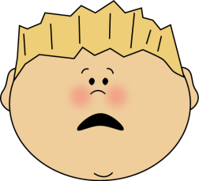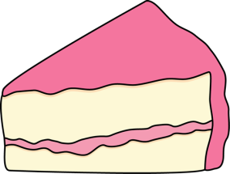

38

13

9

4

3

2

1

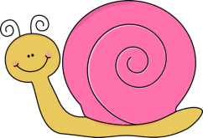

20

5

16

7

14

6

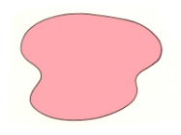

22

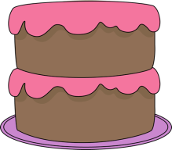

11

21

10

19

18



25

23

12

17



31

28

32

30

27

24

15



37

36

33

29

26

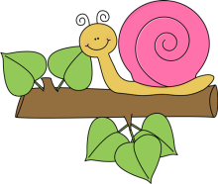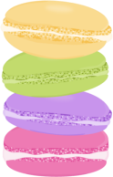

40

39

35

34