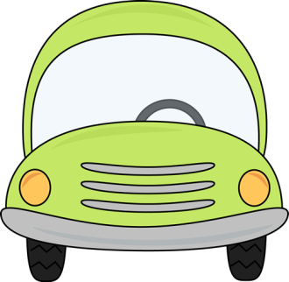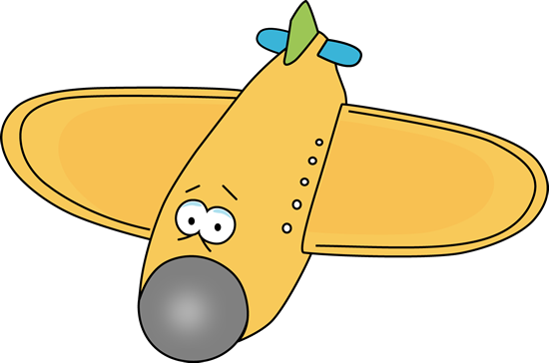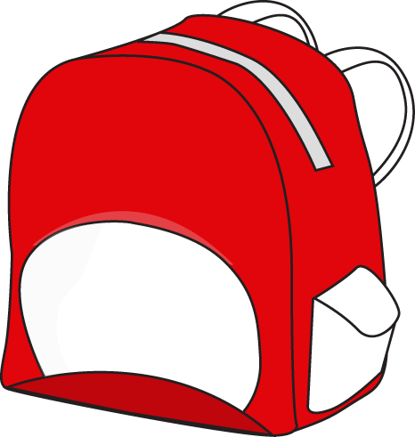

Here you find a set of cards to be used with the game called OUTBURST. They can be used in different ways. One is that students pair up and challenges each other in pairs. Who can mention the most words within the category that are mentioned on the card –in 60 seconds?

VERBS BEGINNING WITH T

**think**

**talk**

**take**

**thunder**

**tease**

**tumble**

**treat**

**try**

**turn**

**trick**

SCHOOL STUFF

**pencil**

**pen**

**eraser/rubber**

**pencil case**

**paper**

**ruler**

**book**

**school bag**

**lunchbox**

**colouring pens**

DAIRY PRODUCTS

**cheese**

**milk**

**butter**

**buttermilk**

**eggs**

**ice cream**

**cream**

**sour cream**

**yoghurt**

**cottage cheese**

FRUITS

**apple**

**orange**

**strawberry**

**pineapple**

**coconut**

**banana**

**melon**

**grapefruit**

**grapes**

**pear**

VEHICLES

**car**

**train**

**bicycle**

**motorcycle**

**lorry**

**truck**

**airplane**

**bus**

**helicopter**

**space ship**

VEGETABLES

**carrot**

**cauliflower**

**mushroom**

**potato**

**onion**

**eggplant**

**lettuce**

**cucumber**

**corn**

**spinach**