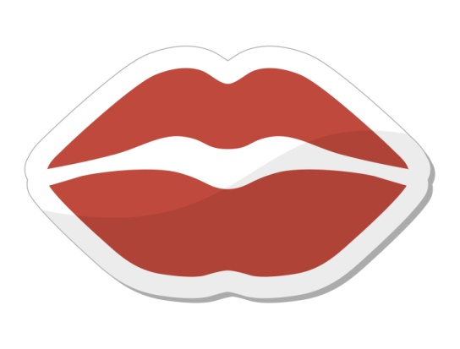

7. Do you consider yourself an animal lover? Why/ why not?

7. Mention 10 dangerous animals from anywhere in the world!

6. What is the idea of having zoos?

5. What do you think of hunting?

6. What do you think of keeping wild animals in captivity?

5. What is your attitude on eating meat?

4. What do you think of using animals for scientific research?

4. Do you think it is acceptable to test cosmetics on animals?

3. Do you know any animals that are endangered?

2. What are some “wild” animals that live in your country?

1. What are the pros and cons of keeping a pet?

2. What do you think is the best pet to own? Why?

3. What is an animal you are afraid of? Why are you afraid of it?

1. Tell me about a pet you have or have had!