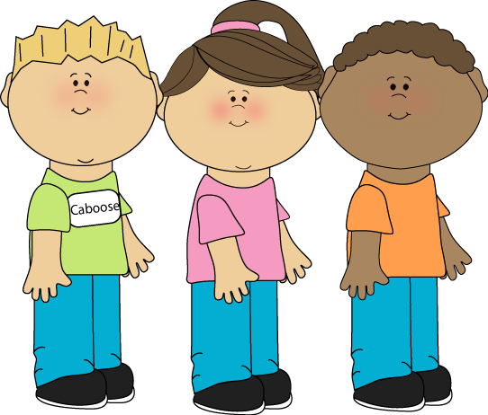

**What good habits do you most admire –and why?**

**Which habit do you think is the most difficult one to get rid of?**

**Where do we learn our habits?**

Do you cut people off in the middle of their stories and conversations?

**What bad habits bother you the most?**

**What are bad study habits?**

**What are healthy eating habits?**

**What bad habits do you have?**

**Instructions:**

**1. Cut the cards out and laminate them if you want them to last longer.**

**2. Pair students in twos.**

**3. Give them some cards and have them walk from one point to another. One leg = one card.**