NAME :
CLASS: B
2015-2016 Academic Year,
Huseyin Corum Vocational and Technical Anatolian High School
- Term,English Lesson,10/A-B-C 1. Quiz

1-) Fill in the gaps with a , an , the ( ……….. / 15 points)
1.There was ……. man and …….. woman in the room. ……. man was English but …….. woman looked foreign.She was wearing ………fur coat.
2………. moon goes round ……… earth every 27 days.
3.Cheetah is …….. fastest animal in …….. world.
4.Many people were killed in the plane crash.The bodies of ……. dead were taken away. ………. injured were taken to hospital.
5.Julius Ceasar was …….. powerful Roman general.
6.Do you know ……. people who live next door?
7.Maria should tell everything to …….. police about …….. accident.

2-) Fill in the blanks with much, many, a lot of ( ……….. / 15 points)

1. Is there______________water in the jug?
2. There aren't __________eggs in the fridge, but there is__________butter.
3. Are there____________tomatoes in the basket?
4. There aren't__________desks, but there are______ students in the classroom.
5. There are_________vegetables, but there isn't__________fruit.
6. There are___________boys, but there aren't_____________girls in this class

3-) Fill in HOW MUCH, HOW MANY, A FEW, A LITTLE, SOME or ANY
1. A: ……………………………. bananas would you like, sir?
B: Just …………………………. , please.
2. A: Can I have …………………………… milk?
B: Sorry, we haven’t got ……………………….. milk.
3. A: ………………………… bread would you like?
B: Just ……………………….. , please.
4. A: ……………………… carrots do we have?
B: We have only …………………………. .
5. A: ……………………….. oranges do we need?
B: We don’t need ……………………….. oranges.
6. A: …………………….sugar would you like in your coffee?
B: Just ………………………, please.
7. A: Could I have ……………………. tea, please?
B: Of course. Would you like ………………………. biscuits, too?
8. A: Is there ………………………. wine in the fridge?
B: No, we need to buy ……………………. .
9. A: ……………………. flour does she need?
B: Just …………………….. .
10. A: Have you got ……………………… potatoes?
B: Yes. …………………………. would you like?
4-) LOOK AT THE PICTURE AND COMPLETE WITH THE RIGHT
PREPOSITION OF PLACE

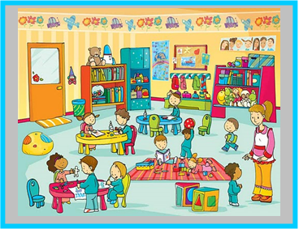

BEHIND / IN / ON / BETWEEN / NEXT TO / IN FRONT OF / UNDER

1- THE BLOCKS ARE ……………………. THE BOY
2- THERE ARE TOYS ………………….THE MAT
3- THERE IS A BOOKCASE ………………..THE CUPBOARD AND THE BIN
4- THE BIN IS …………………THE BOOKCASE
5- THERE ARE POSTERS …………………….THE WALL
6- THERE ARE BOOKS …………………..THE BOOKCASE
7- THERE IS A BOY STANDING …………………… THE TEACHER AND THE BLOCKS
8- THERE IS A DOORMAT……………………… THE DOOR.
9- THERE IS A TEDDY BEAR……………………THE BOOKCASE.
10- THERE IS A BALL ……………………..THE TABLE.

Yasemin CANER Selda ÖNDER
ELT ELT

