www.eegitimim.com

A / AN
............... AMBULANCE ..................... GORILLA
............... LEMON ..................... ORANGE
................ STADIUM ..................... APPLE
................. ELEPHANT ..................... TELEVISION
MATCH
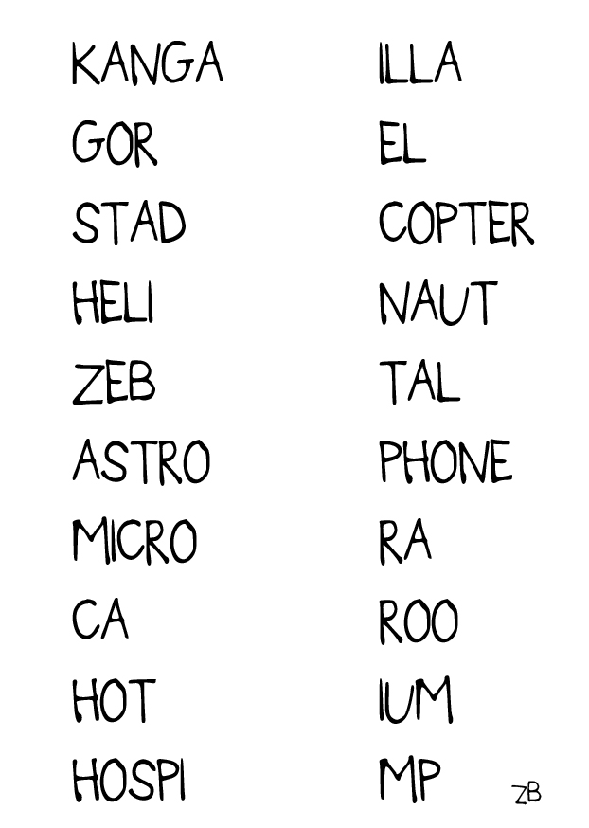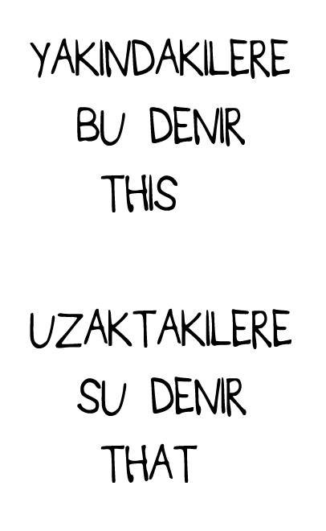
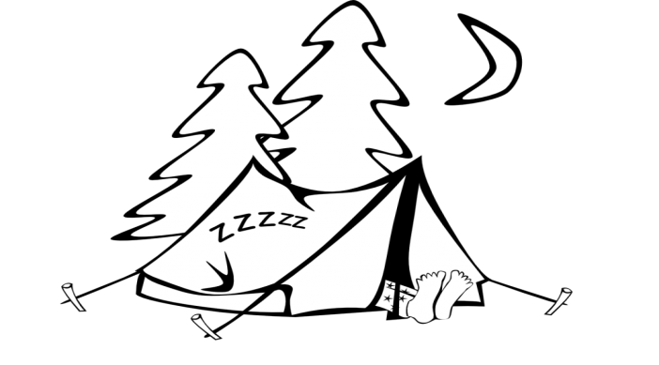
THIS IS / THAT IS
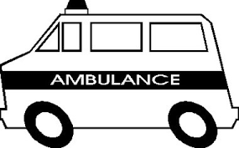
........... ..... AN AMBULANCE
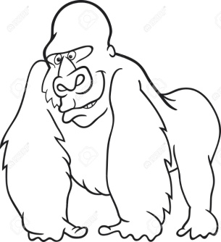
........ ....... A GORILLA
........ ....... A TELEVISION
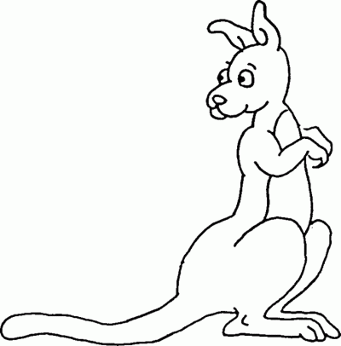
....... ....... A KANGAROO

