A | W | U | H | P | J | E | L | T | R | A | I | N | S | Y
M | E | I | S | F | A | D | X | B | R | E | H | Y | J | P
B | Z | F | P | D | C | V | Q | W | O | Z | E | B | R | A
U | C | D | E | S | K | U | P | C | P | R | F | A | U | D
L | E | A | N | E | E | J | A | A | T | F | Q | P | T | V
A | Y | M | G | C | T | O | H | K | I | G | X | G | J | M
N | Q | E | U | X | J | F | G | E | L | R | V | K | U | Z
C | D | A | I | O | U | U | N | B | S | M | P | A | Q | D
E | X | E | N | Z | P | L | E | M | O | N | Y | N | G | E
V | H | T | H | Q | F | C | R | I | F | O | T | G | K | D
R | E | S | T | A | U | R | A | N | T | U | F | A | O | K
L | A | G | X | P | G | T | C | B | C | G | D | R | E | J
X | Q | B | C | B | A | L | L | O | O | N | E | O | D | I
O | V | E | F | G | V | M | O | C | D | J | A | O | T | R
P | D | O | C | T | O | R | T | E | G | L | K | M | J | X
Www
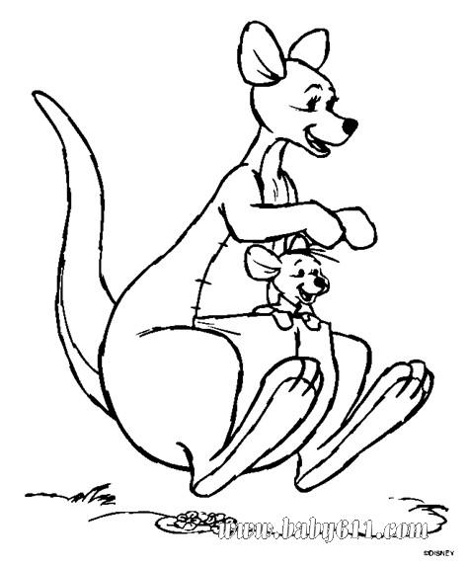
………………………………….
………………………………
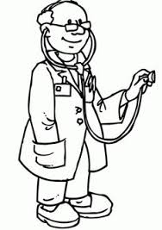
…………………………………
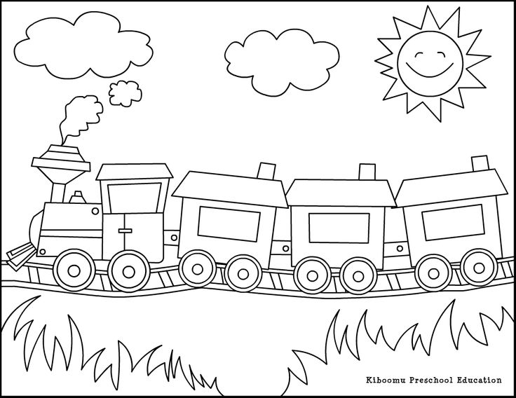
………………………………..
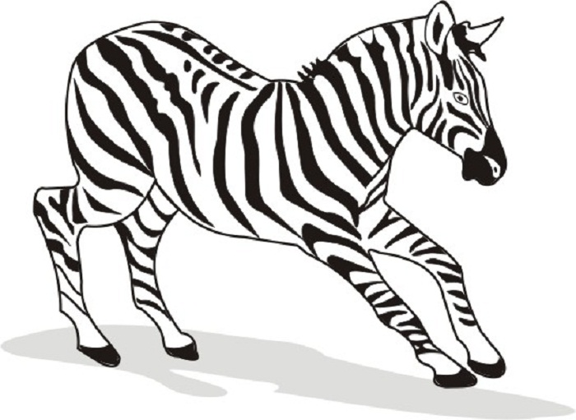
……………………………….
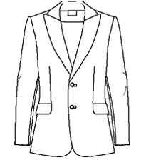
……………………………
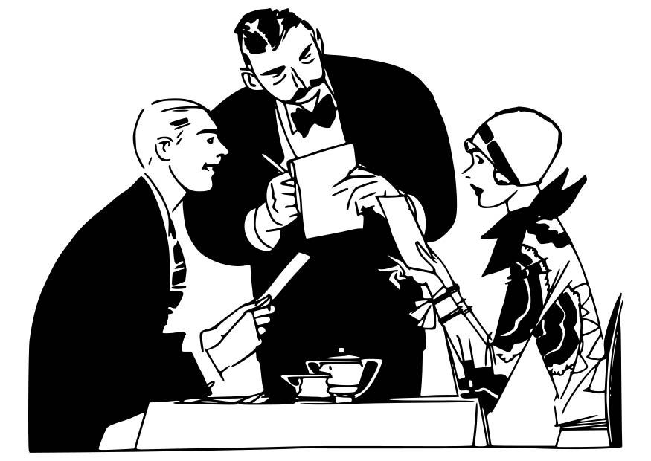
………………………………
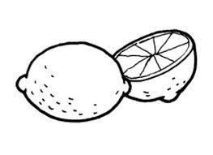
………………………………..
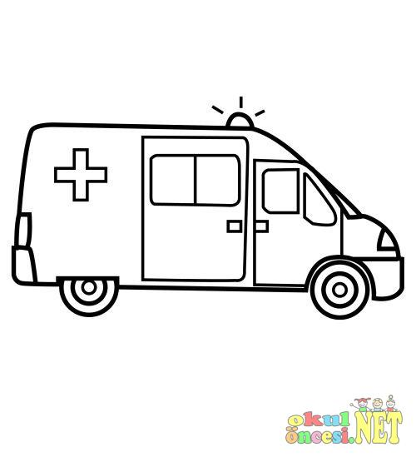
………………………………..
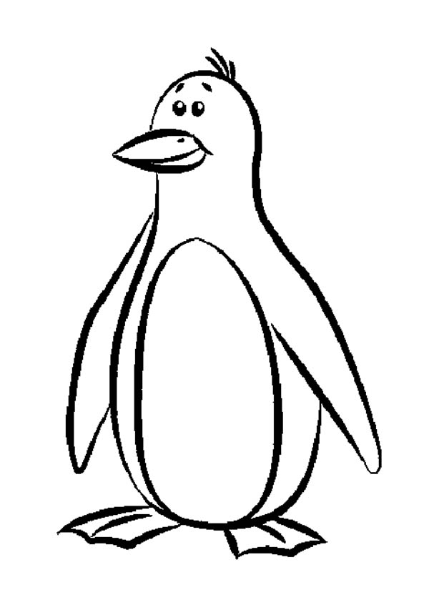
……………………………….
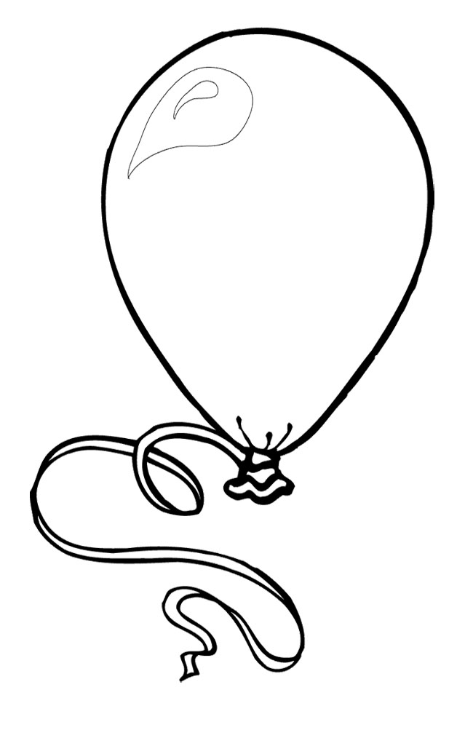
………………………………….
RESİMLERDE GÖRDÜĞÜNÜZ NESNELERİN İNGİLİZCE YAZILIŞLARINI BULMACADAN BULUP, RESİMLERİN ALTLARINA YAZINIZ. VE RESİMLERİ BOYAYINIZ.

www.eegitimim.com

