[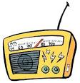](http://www.google.com.tr/url?url=http://www.freemake.com/blog/top-5-radio-apps-for-iphone-to-listen-to-radio-stations-free/&rct=j&frm=1&q=&esrc=s&sa=U&ei=3vs2VJDmBoXqyQPpq4G4Cg&ved=0CBgQ9QEwAg&usg=AFQjCNEJOzT6l6RvKP61gFdKzohuXsjxZw)[](http://www.google.com.tr/url?url=http://www.trans-high.com/product/green-apple_4.html&rct=j&frm=1&q=&esrc=s&sa=U&ei=m_s2VIiLPKnlywPJhoDYBQ&ved=0CCgQ9QEwCg&usg=AFQjCNGMaqi7iIzslMK-BQw9JMNQQObvfQ)[](http://www.illustrationsof.com/royalty-free-rf-cheeseburger-clipart-illustration-by-amy-vangsgard-stock-sample-12128.jpg)[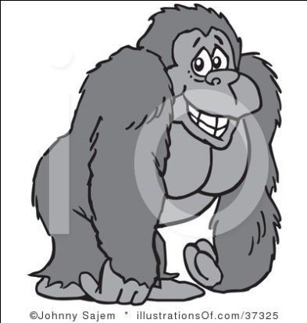](http://www.illustrationsof.com/royalty-free-rf-gorilla-clipart-illustration-by-johnny-sajem-stock-sample-37325.jpg)

**What is that?**

What is that?

That is a cake.

What is that?

That is a radio.

What is that?

That is an apple.

What is that?

That is a television.

What is that?

That is a hamburger

What is that?

That is a hotel.

What is that?

That is an ambulance

What is that?

That is a gorilla.



[www.eegitimim.com](http://www.eegitimim.com)

