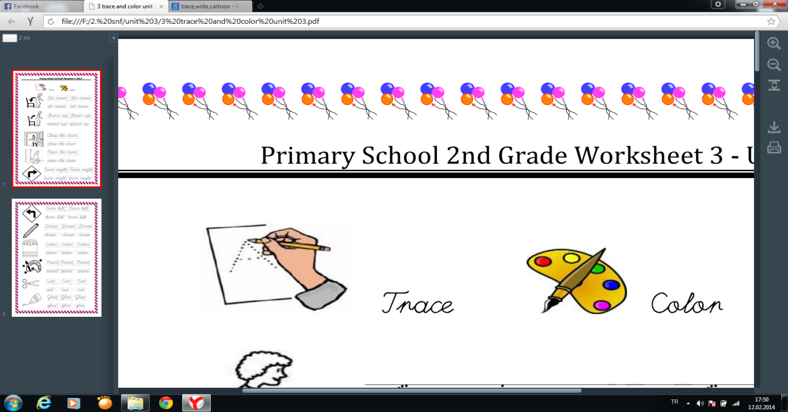

[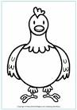](https://www.google.com.tr/url?q=http://www.activityvillage.co.uk/chicken-colouring-page&sa=U&ei=lP9QU6vCDpCV0QXP14DQDQ&ved=0CEAQ9QEwCQ&usg=AFQjCNFyPt5of4zHB4iJboi8fnHJWn95Wg)

Chicken

[](https://www.google.com.tr/url?q=http://photobucket.com/images/cute%20cow&sa=U&ei=mwhRU__VOMXoywPJh4CYAw&ved=0CFIQ9QEwEjg8&usg=AFQjCNFkvDTaKu_dOkQhJEm8M65NHp53AA)

Cow

Duck

[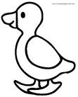](https://www.google.com.tr/url?q=http://www.bestcoloringpages.net/cute-coloring-pages.html&sa=U&ei=cQxRU_LAPMO84ATH_IDgAw&ved=0CEIQ9QEwCjgU&usg=AFQjCNGqddzQPytGa1kz_-v7E6fbZQJzfw)

[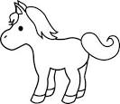](https://www.google.com.tr/url?q=http://sweetclipart.com/cute-pony-line-art-34&sa=U&ei=AA1RU7CaOIGH4ATn7oGIAQ&ved=0CEYQ9QEwDA&usg=AFQjCNHzt5AWd-BNJQaCUAp1n5D_9qgKzw)

Horse

[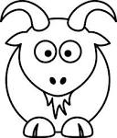](https://www.google.com.tr/url?q=http://www.clipartbest.com/animal-line-drawings&sa=U&ei=hQ1RU_7WPMPjywOGzIC4Bg&ved=0CFQQ9QEwEzhk&usg=AFQjCNESPnE3DHdaTt1a234Kw0-8fa5EeA)

Goat

Donkey

[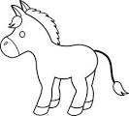](https://www.google.com.tr/url?q=http://sweetclipart.com/cute-donkey-line-art-1474&sa=U&ei=EQ9RU6LEKojQ0QWd3YGgCg&ved=0CC4Q9QEwAA&usg=AFQjCNHtonCF884b923q8VS3ecA9_qqysQ)

[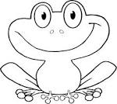](https://www.google.com.tr/url?q=http://photographsofanimals.info/cute-cartoon-frogs-coloring-pages/&sa=U&ei=eg9RU9HZBY2o0AX-9YGwBQ&ved=0CEQQ9QEwCw&usg=AFQjCNGmqDFHqrTTTKwsPR-egjgqJztyyA)

Frog

Hi! I am a ………………

[](https://www.google.com.tr/url?q=http://sweetclipart.com/cute-donkey-line-art-1474&sa=U&ei=EQ9RU6LEKojQ0QWd3YGgCg&ved=0CC4Q9QEwAA&usg=AFQjCNHtonCF884b923q8VS3ecA9_qqysQ)

Doğru seçeneği işaretleyiniz.

**1.**[](https://www.google.com.tr/url?q=http://www.activityvillage.co.uk/chicken-colouring-page&sa=U&ei=lP9QU6vCDpCV0QXP14DQDQ&ved=0CEAQ9QEwCQ&usg=AFQjCNFyPt5of4zHB4iJboi8fnHJWn95Wg)A) dog B) Monkey C) chicken **4.**[](https://www.google.com.tr/url?q=http://www.bestcoloringpages.net/cute-coloring-pages.html&sa=U&ei=cQxRU_LAPMO84ATH_IDgAw&ved=0CEIQ9QEwCjgU&usg=AFQjCNGqddzQPytGa1kz_-v7E6fbZQJzfw)A) Duck B) Horse C) Donkey

**2.**[](https://www.google.com.tr/url?q=http://photobucket.com/images/cute%20cow&sa=U&ei=mwhRU__VOMXoywPJh4CYAw&ved=0CFIQ9QEwEjg8&usg=AFQjCNFkvDTaKu_dOkQhJEm8M65NHp53AA)A) Turtle B) cow C) horse **5.** [](https://www.google.com.tr/url?q=http://sweetclipart.com/cute-pony-line-art-34&sa=U&ei=AA1RU7CaOIGH4ATn7oGIAQ&ved=0CEYQ9QEwDA&usg=AFQjCNHzt5AWd-BNJQaCUAp1n5D_9qgKzw)A) horse B) Dog C) Rabbit

**3.** Verilenlerden eşleştirmelerden hangisi **6.** Aşağıdaki boşluğa hangisi gelmelidir?

yanlıştır?

a) [](https://www.google.com.tr/url?q=http://www.bestcoloringpages.net/cute-coloring-pages.html&sa=U&ei=cQxRU_LAPMO84ATH_IDgAw&ved=0CEIQ9QEwCjgU&usg=AFQjCNGqddzQPytGa1kz_-v7E6fbZQJzfw) cat b) [](https://www.google.com.tr/url?q=http://www.clipartbest.com/animal-line-drawings&sa=U&ei=hQ1RU_7WPMPjywOGzIC4Bg&ved=0CFQQ9QEwEzhk&usg=AFQjCNESPnE3DHdaTt1a234Kw0-8fa5EeA) goat c) [](https://www.google.com.tr/url?q=http://photographsofanimals.info/cute-cartoon-frogs-coloring-pages/&sa=U&ei=eg9RU9HZBY2o0AX-9YGwBQ&ved=0CEQQ9QEwCw&usg=AFQjCNGmqDFHqrTTTKwsPR-egjgqJztyyA) frog a) cow b) goat c) donkey